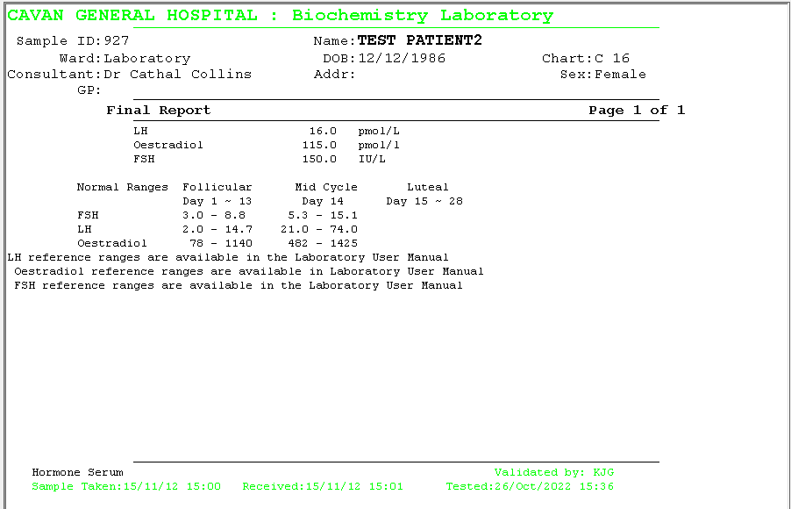

77 - 921

139 - 2381

77 - 1140

1.4 – 5.5

2.5 – 16.7

3.0 – 8.1



1.8 – 11.8

7.6 – 89.1

0.6 – 14.0



4 - 50