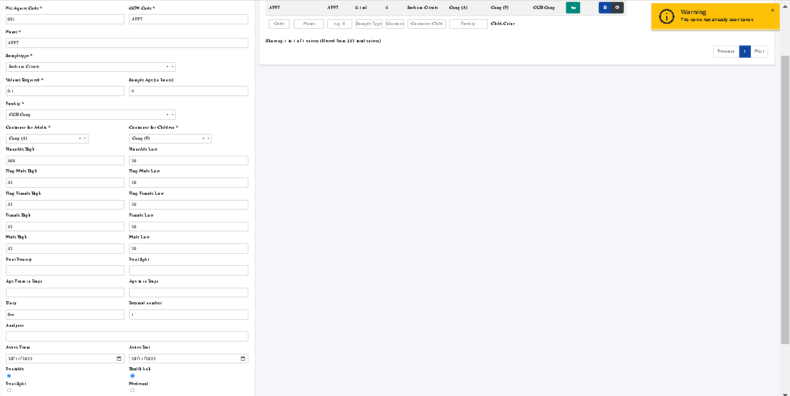

Unable to update a test and unable to introduce age related ranges change facility name