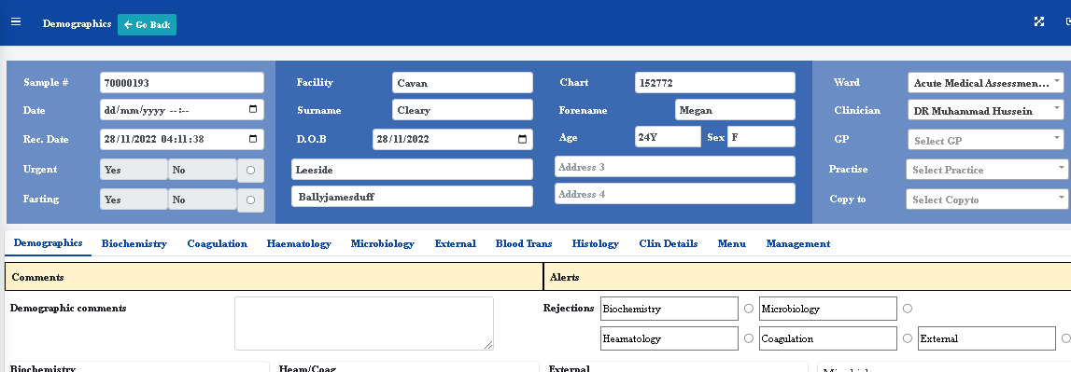

Sample date time is missing – Time should be 24 hour clock with no seconds for both sample date time and received date time