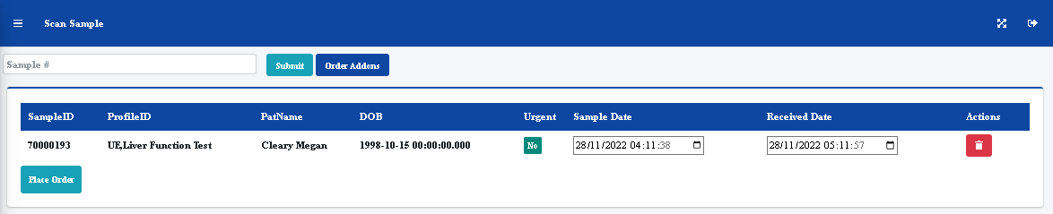

Seconds not required and should be 24 hour clock