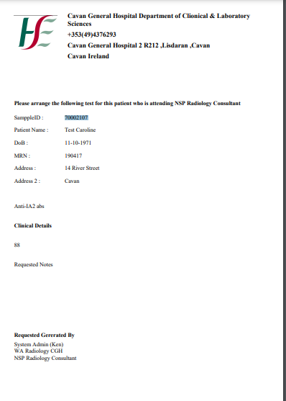

Performing Lab name and address

Add ward and consultant here

Sample date time required

Tests requested

Sample