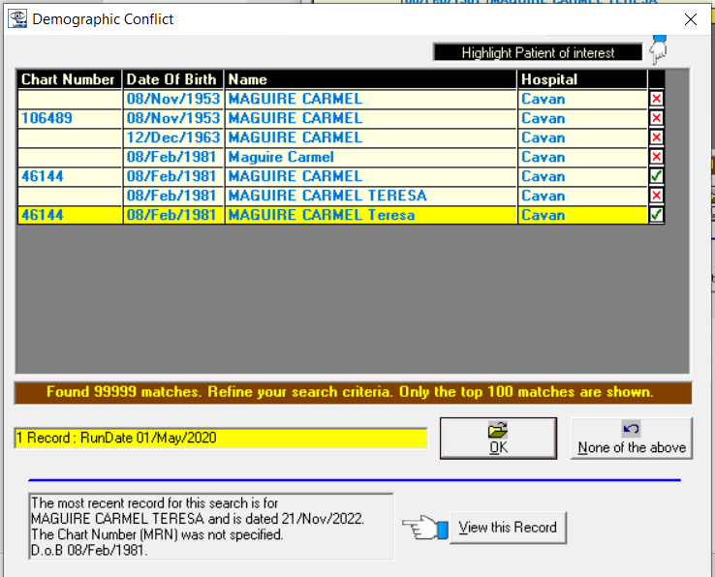

I have selected all entries with MRN 46144, and look back 999 days.

The transfusion icon is there when screen opens but then disappears

When I enter by putting in the MRN there is a record available

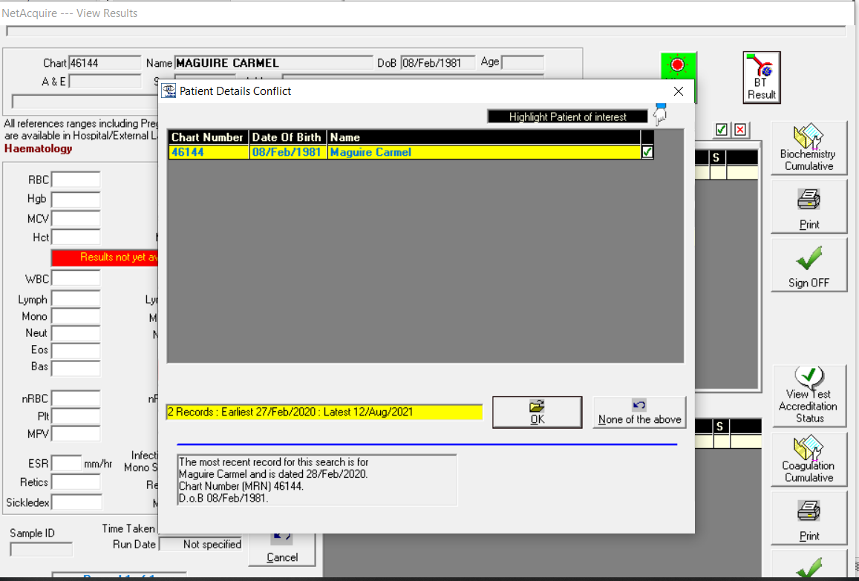

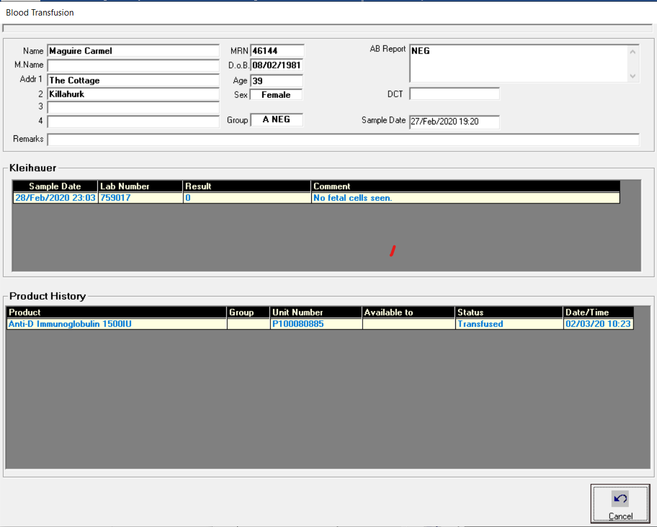

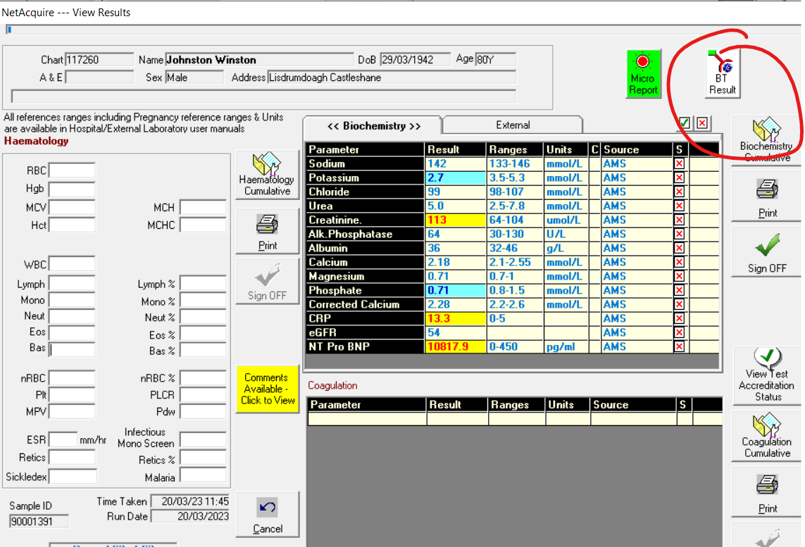

There is no record of transfusion for this patient so the icon should not appear