External comment New WE

External comment not highlighted

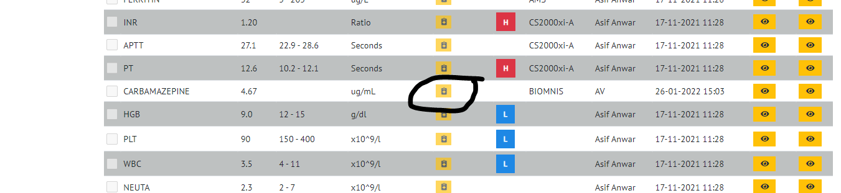

Nothing to highlight to user that there is a comment

