NVRL results missing from OCM

90006423

Thomas Reilly 177624

NA

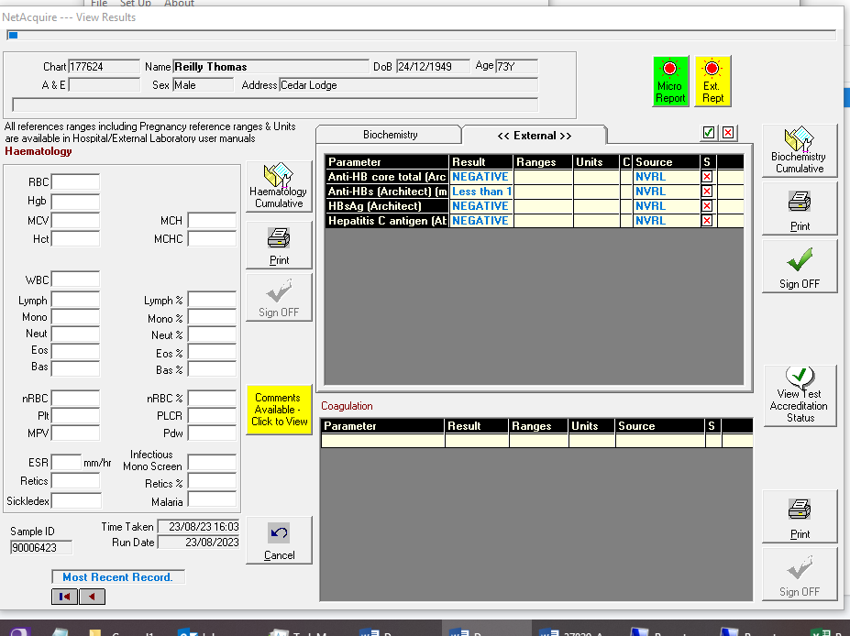

Comments in OCM but not results

