Current Dart Button- available via Go to Worksheet Option for Lab Users

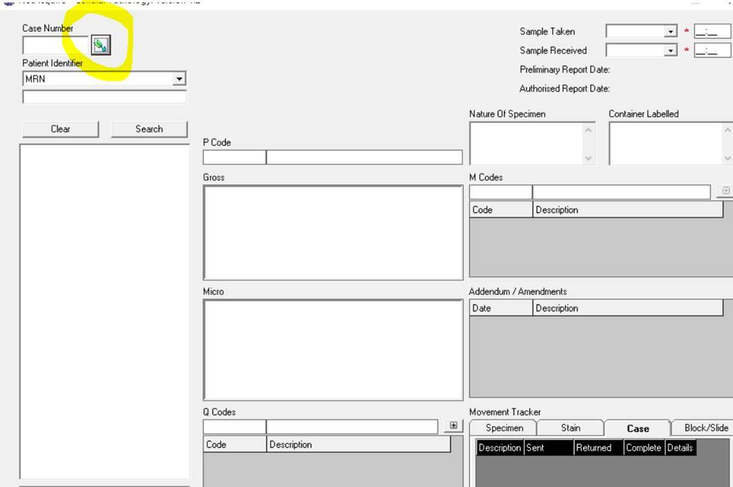

The change is to add this to the search field which Lookup users have to

