O Rh Positive Units to RhD negative or Unknown patient

Currently O RhD positive red cell cannot be issued to Unknown or Rh D negative patient. As below

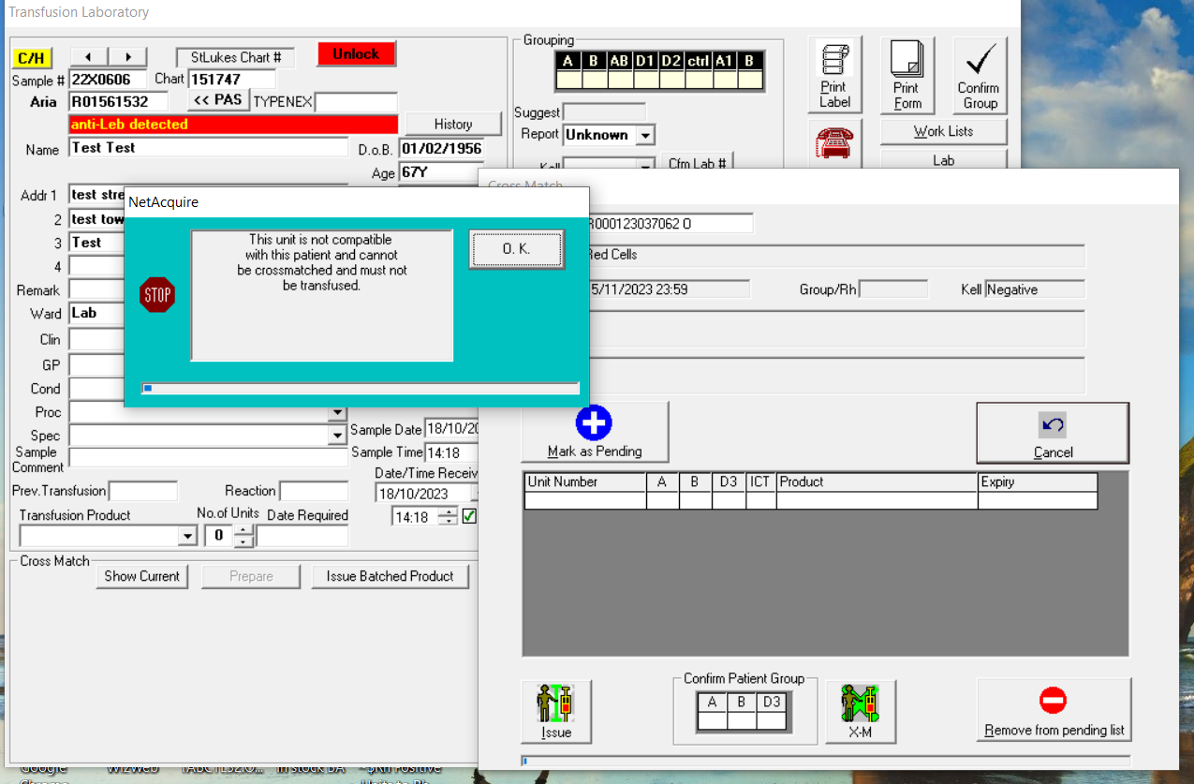

Action: Rule based on blood group, age and sex-based to enable the issue of O RhD positive red cells rule to RhD negative or Unknown blood groups.

1. RhD negative or Unknown group, Male and < 18 years: Cannot be issued. Alert as above
2. Rh D negative or Unknown group, Male and ≥18 years: Can issue but warning appears

“This unit can only be issued as an emergency. This unit is not RhD compatible. Inform Consultant Haematologist.”

1. RhD negative or Unknown group, Female and < 18 years: Cannot be issued. Alert as above
2. RhD negative or Unknown group, Female and 18-55 years: Can issue but warning appears:

“This unit can only be issued as an emergency. This unit is not RhD compatible. Inform Consultant Haematologist. Consider issue Anti-D Ig”.

1. RhD negative or Unknown group, female and >55 years: Can issue but warning appears

“This unit can only be issued as an emergency. This unit is not RhD compatible. Inform Consultant Haematologist.”