

Typed MRN in search box. Clicked on Product History tab. This should not be working.

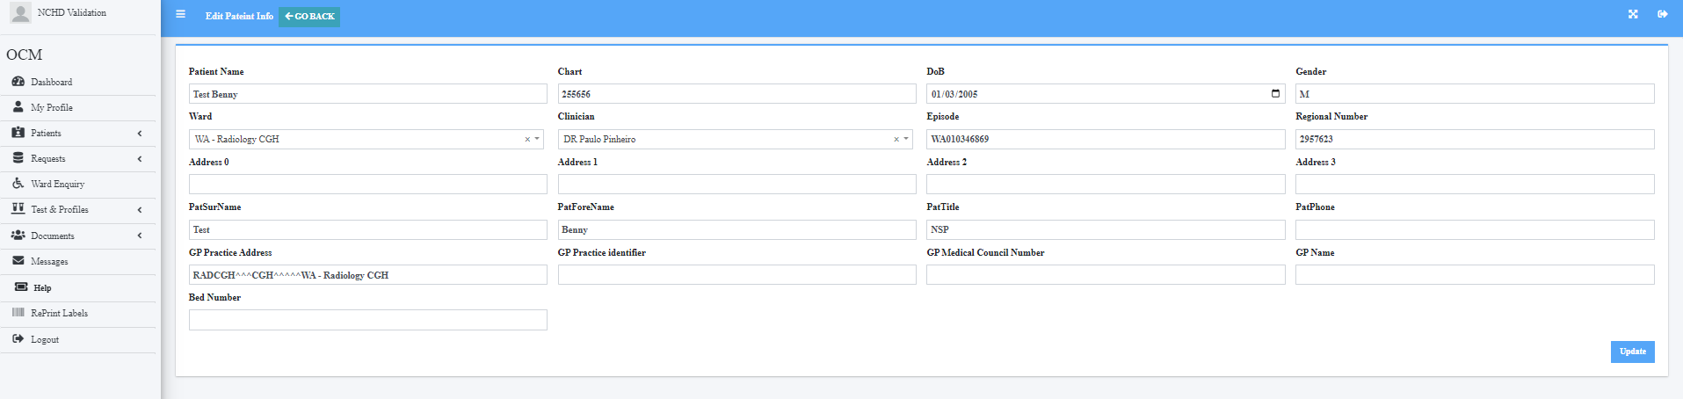

Patient details in tab

Clicked to go back

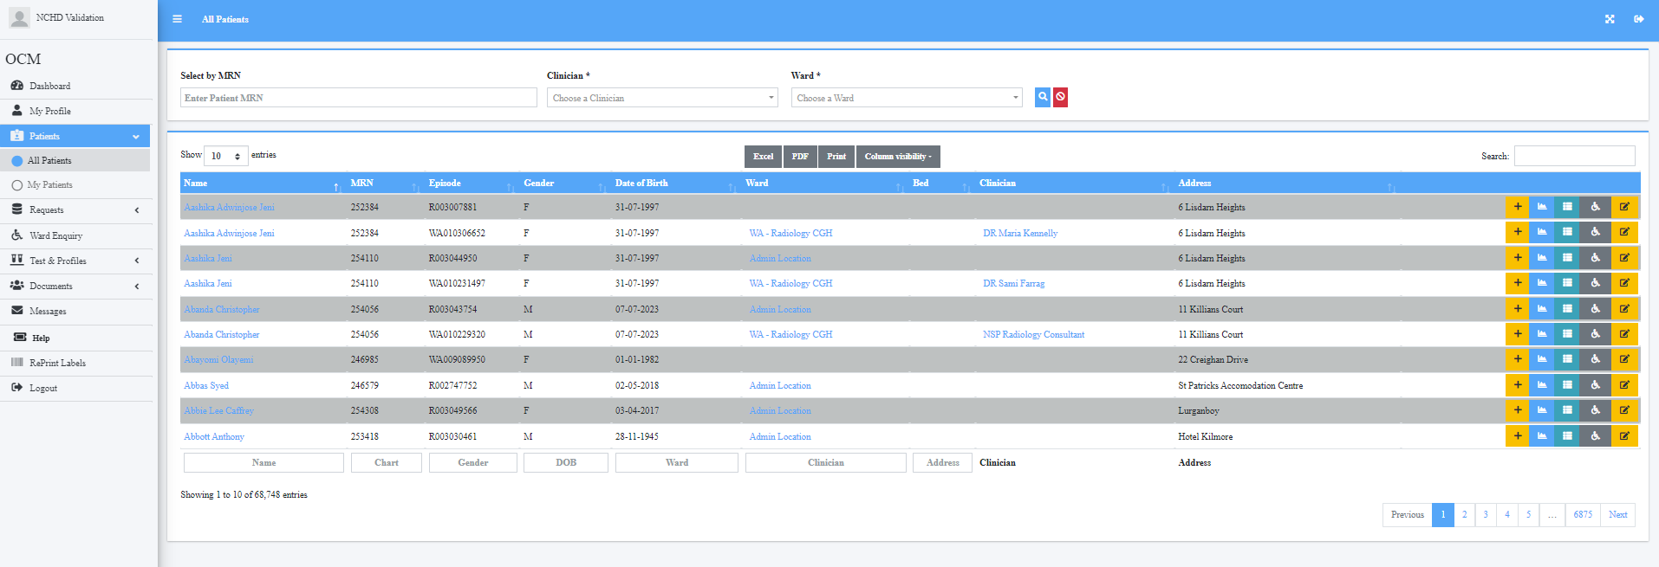

Back to All Patient tab- Should it not go back to Patient tab i.e Test Benny?

Have to search MRN again to go back

