WardEnq231117(Test1).exe Current LIVE

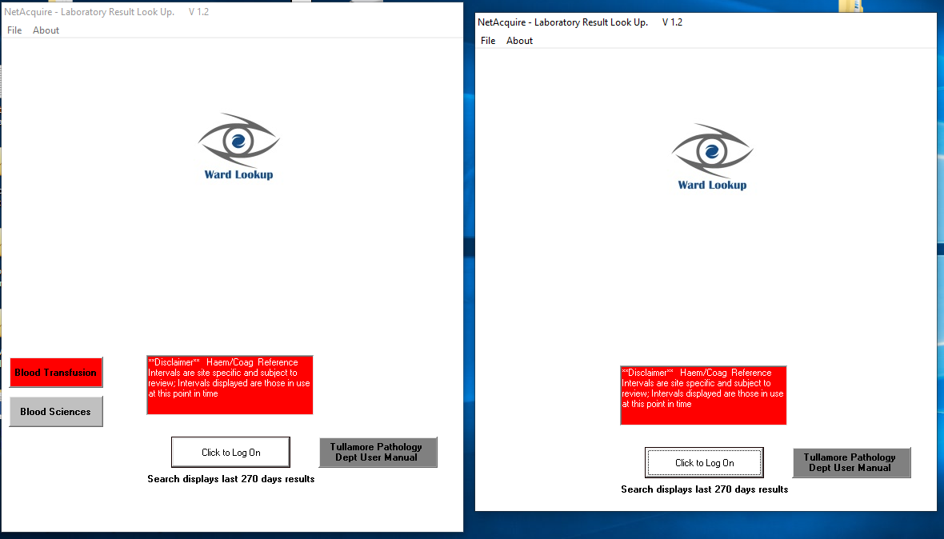

**Remove these**

WardEnq231117(Test1).exe

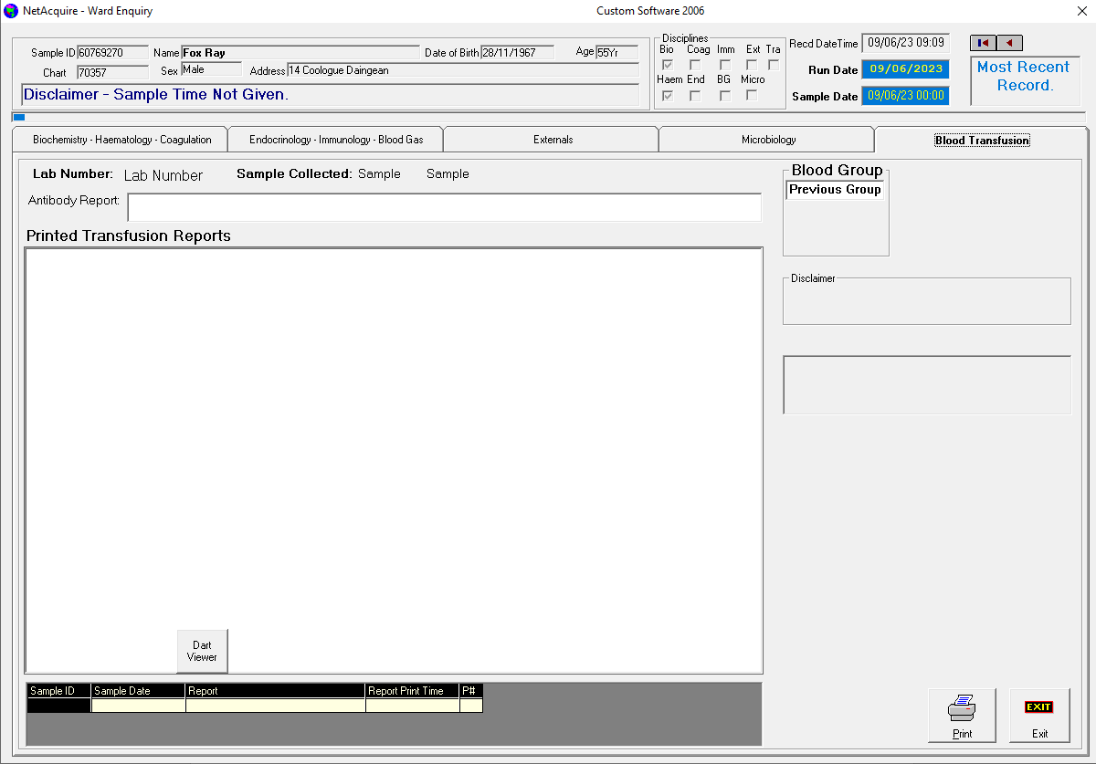

**Remove Blood Transfusion Tab**

WardEnq231117(Test1).exe

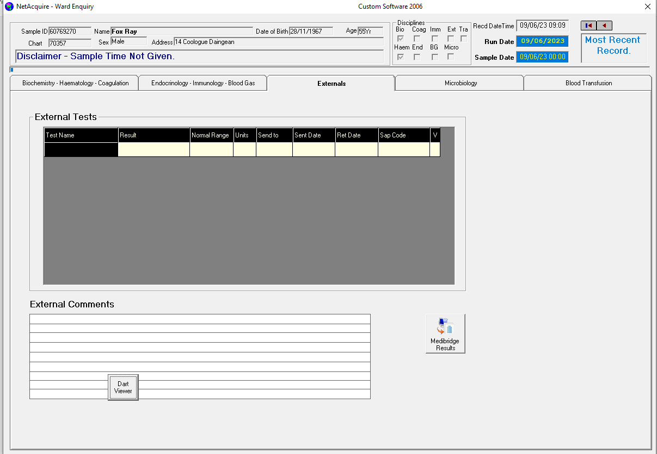

**Reposition so it is not blocking the comments box**

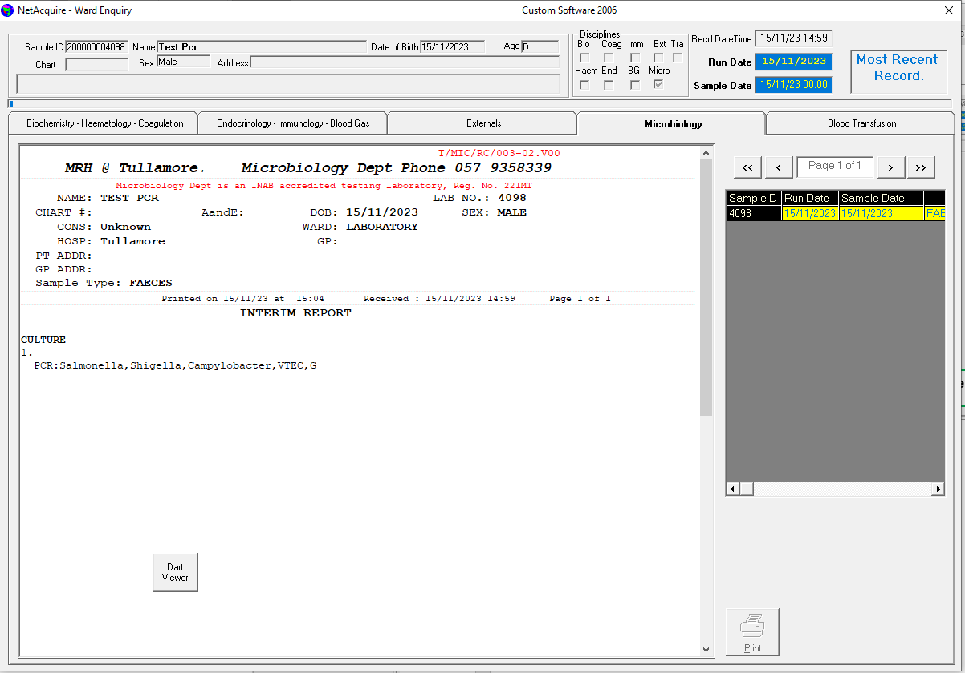

**Reposition so it is not blocking the report**