First open application - ok

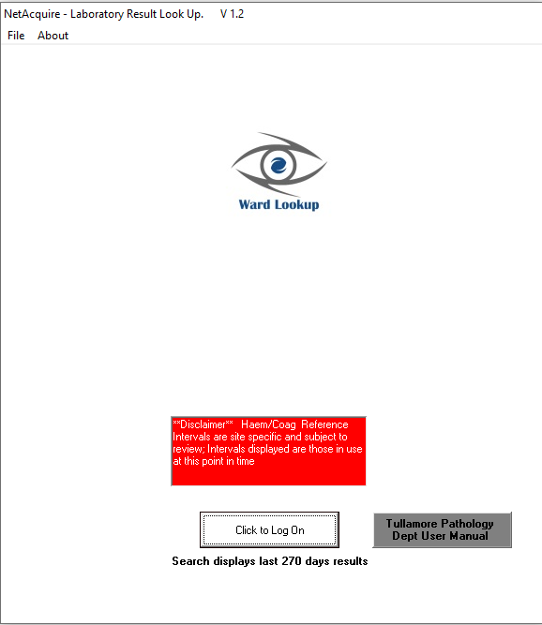

Log in

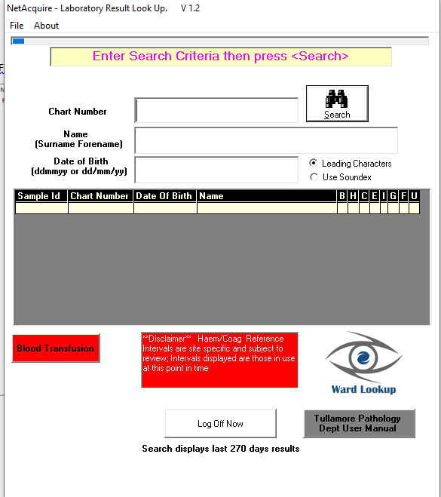

**Remove this**

Click blood transfusion – search function for transfusion is still available – **remove this**

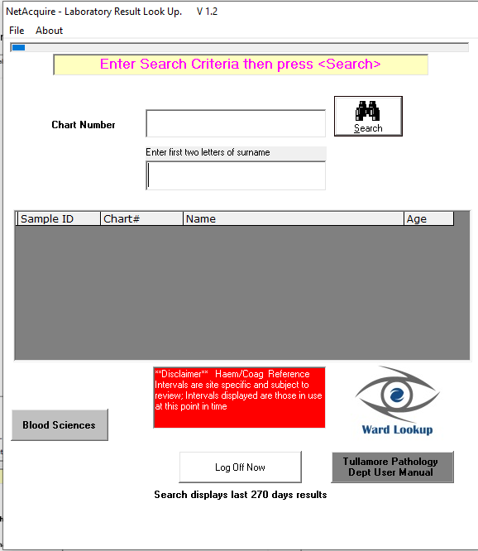

**Remove this**

Click blood sciences – back to usual search screen – **we want this screen only after log in**



**Remove this**

Search patient – all looks ok

Dart viewer – works as requested.

**Could we put an icon beside the wording like the print and cumulative buttons have?**

 like this, called DartViewer. I can send you the icon image by email/ticket.