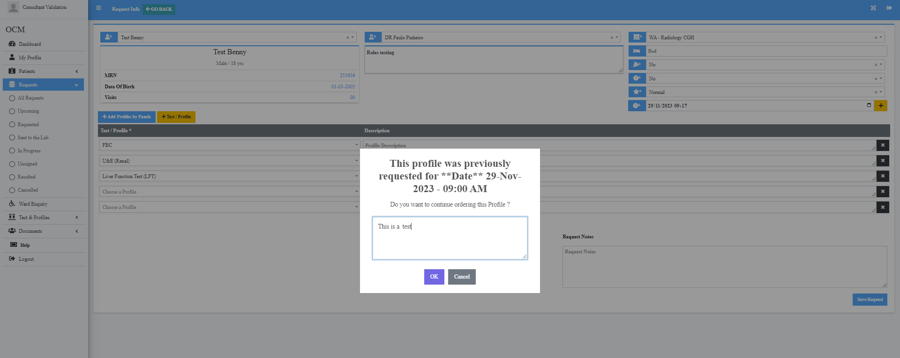

Ordered FBC, U&E, LFT on MRN 255656 Test Benny at 09.17 on 29/11/23 and tab came up to say it was previously ordered on this date. It had been ordered on 28/09/23- Date is incorrect on pop up tab- It had been ordered on 28/09/23

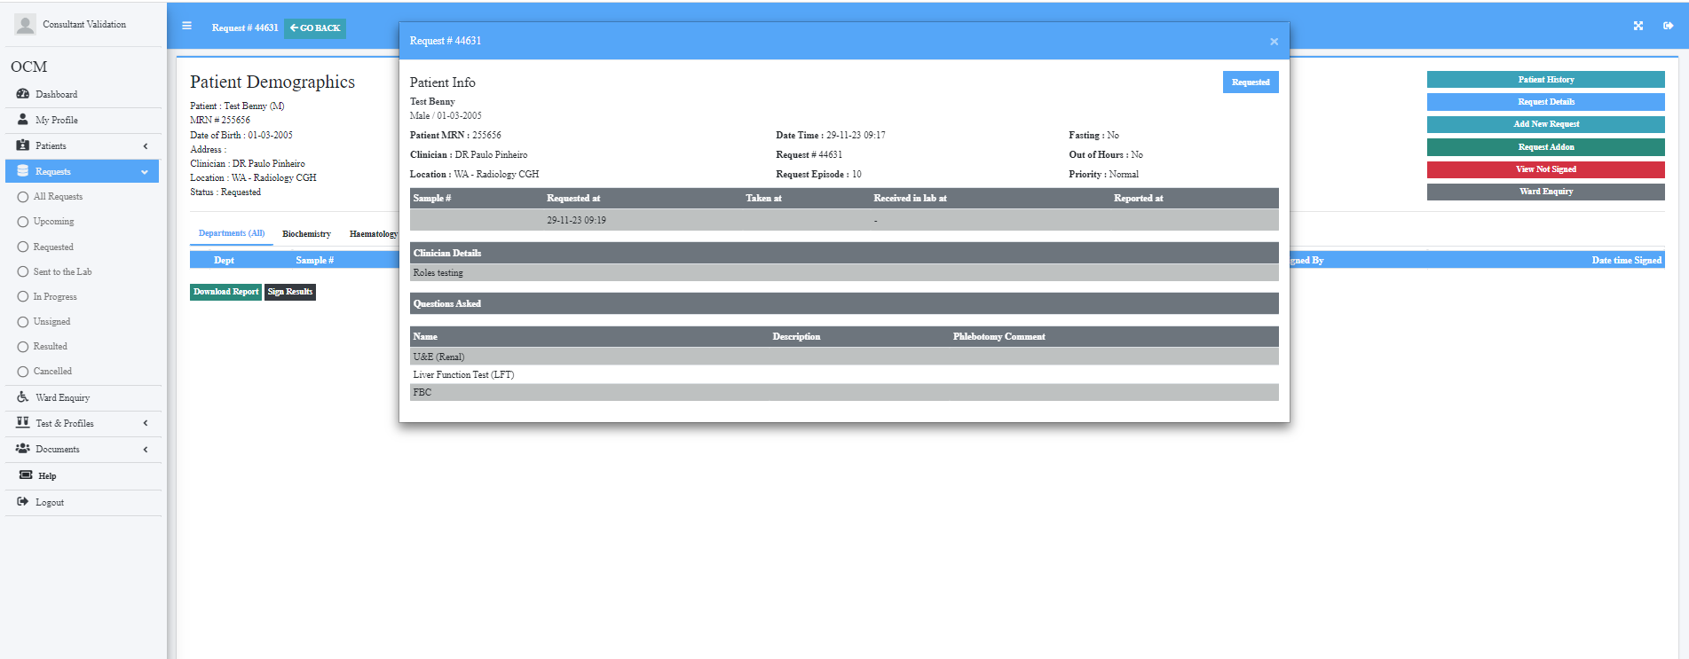

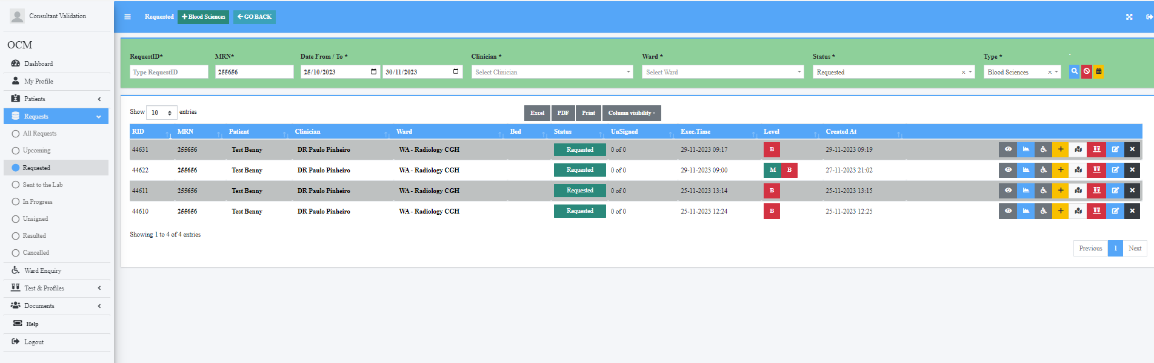

Created time is at 09:19, executed time is at 09:17