User role Phlebotomist

Collected a sample on MRN 255657 Bridie Test

Once I clicked exit it goes back to requested page which is correct but the requested list is empty which is incorrect.

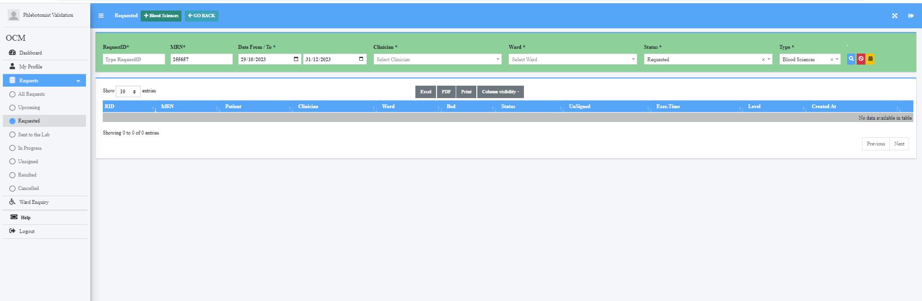

Also in sent to lab this episode is not 1st on the list. It is the most recent collection therefore should be top of the list

