Partial collection on MRN 255656 Test Benny

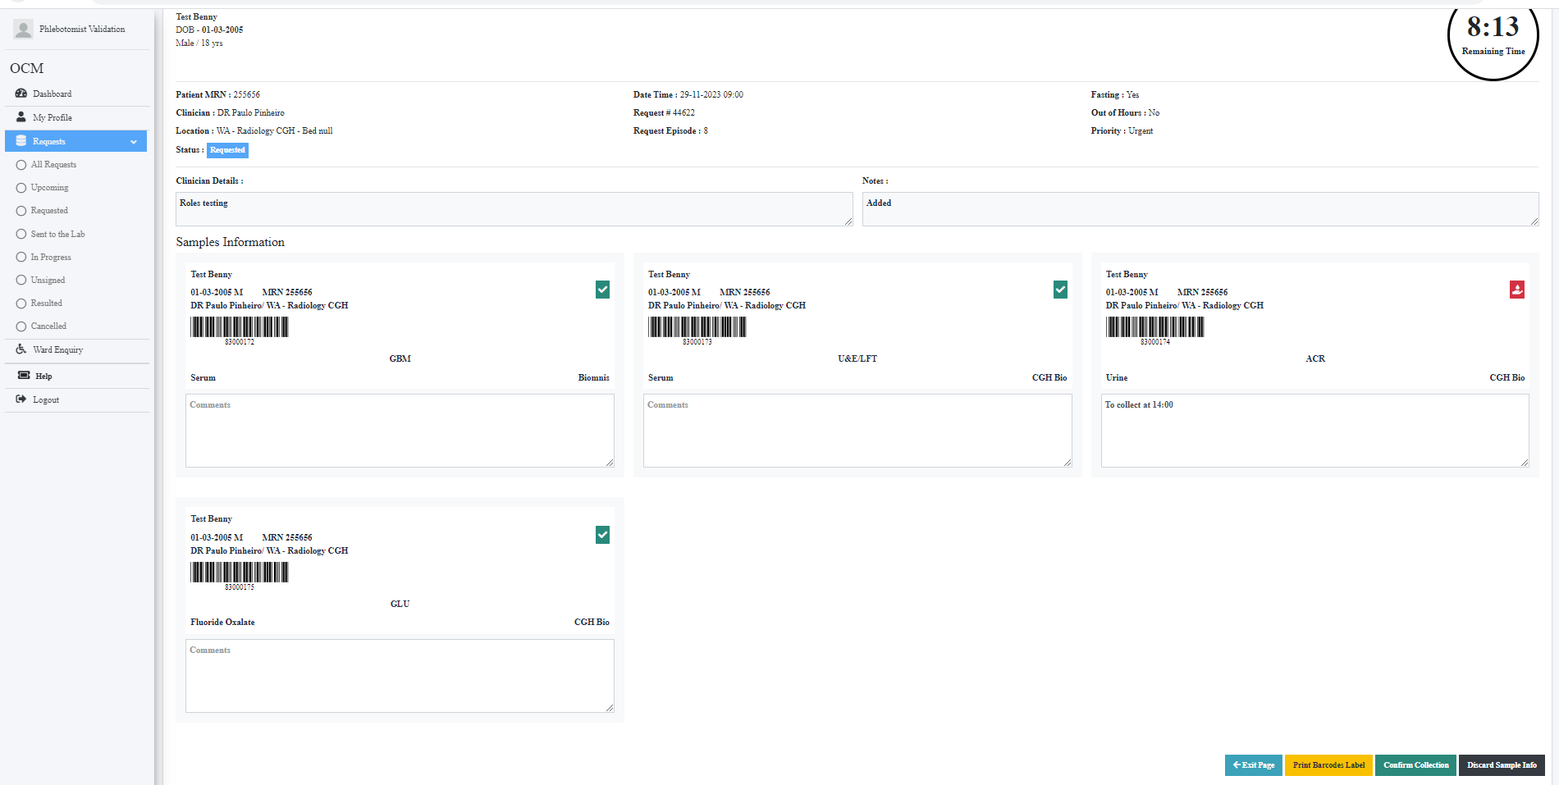

Collected 3 samples. Leaving ACR (urine sample)

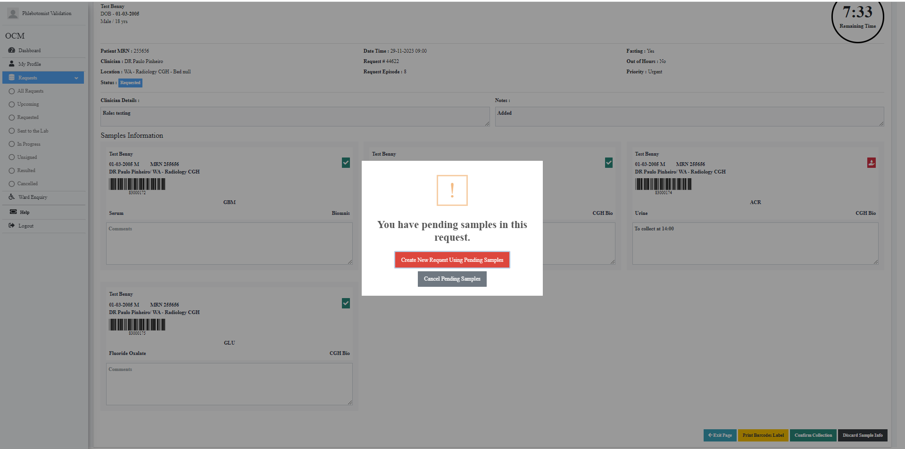

Clicked on Create new Request Using Pending Samples

Tested on Phlebotomist Role & Nurse Role both not working

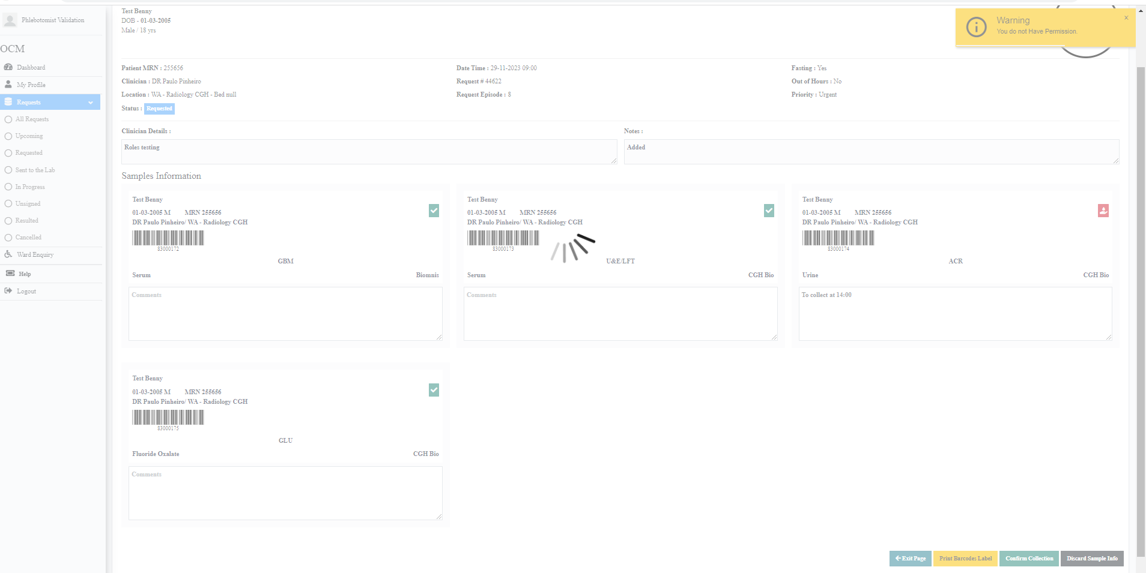

Does not give permission and stays in spin. Cannot exit tab