Coag results tab is blanked out – there are validated results here, we just can’t see them. However, looking at the same record onward Enquiry will show the result.

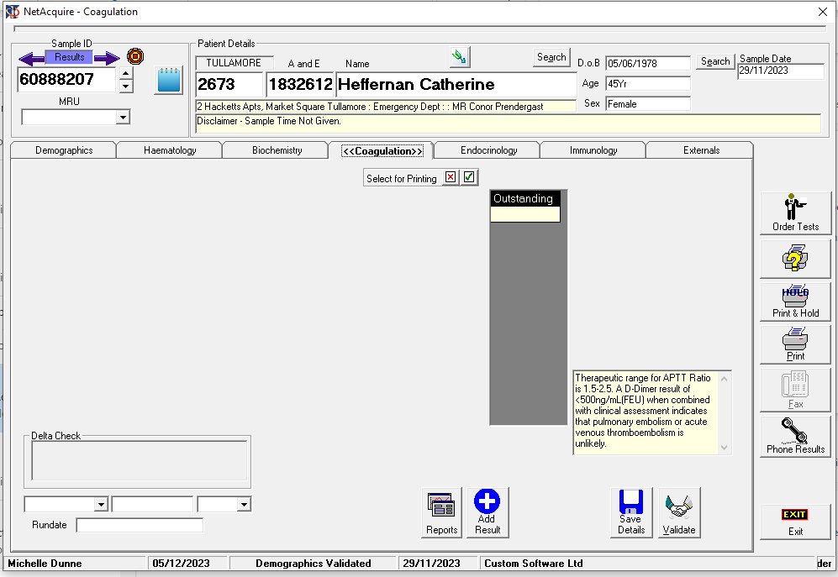

If you click through the records back and forth, the tabs are all blank now

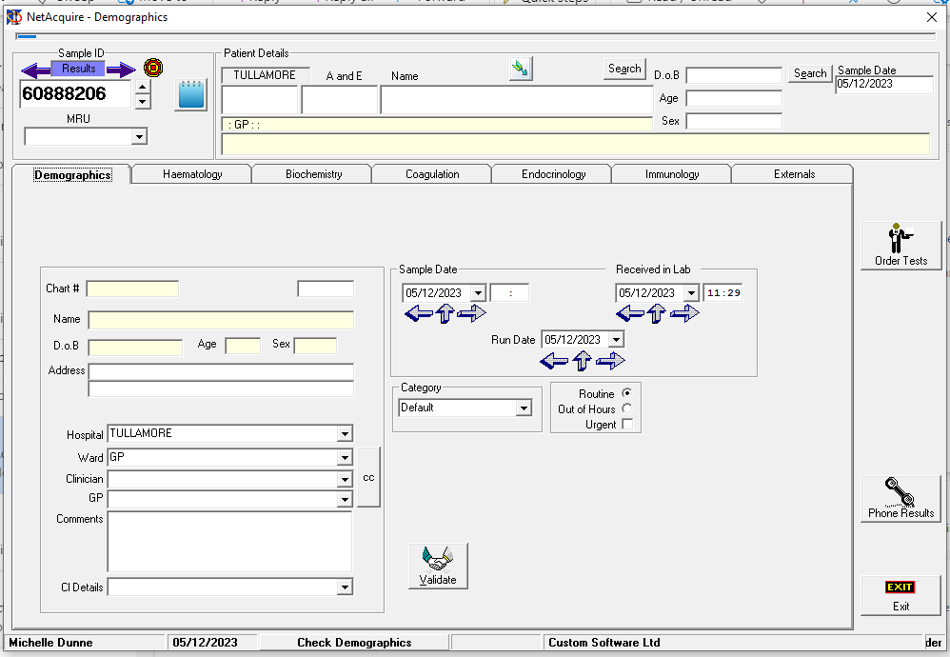

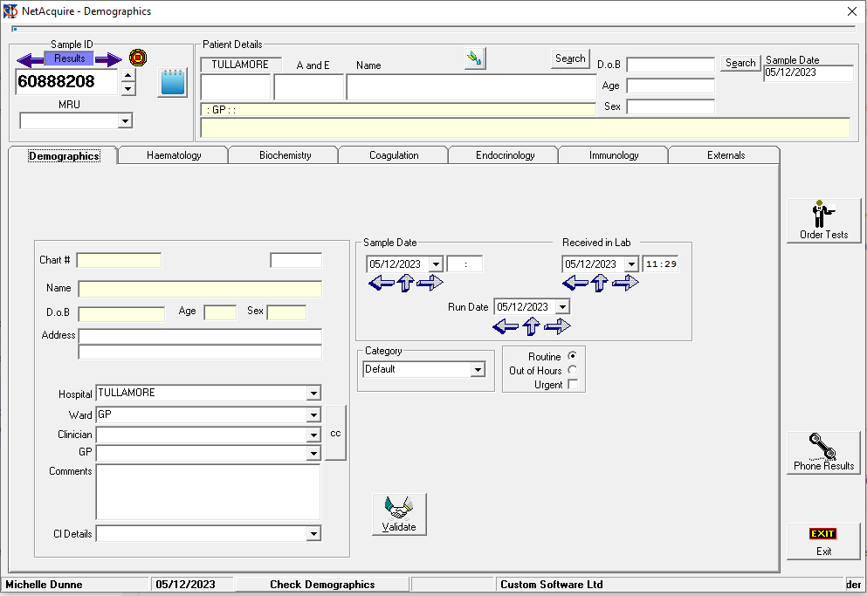

This is what is should look like…. To see this, I have to close down the application fully and restart

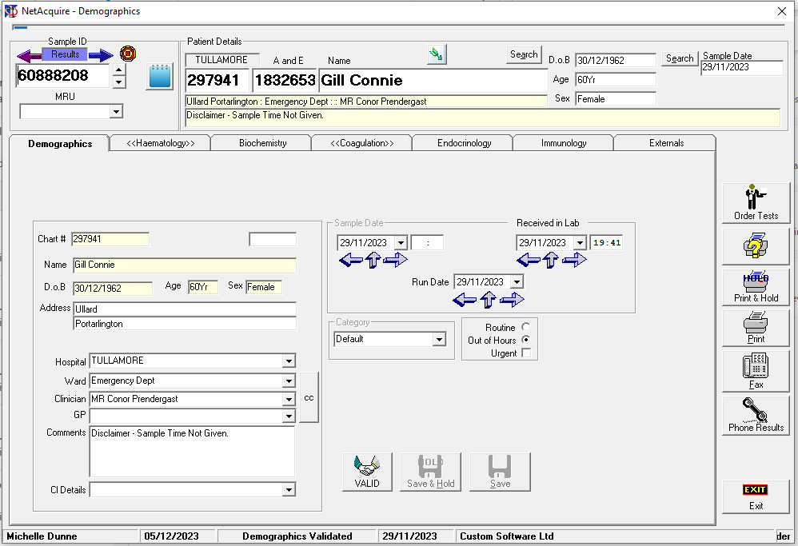

View from search screen = blank

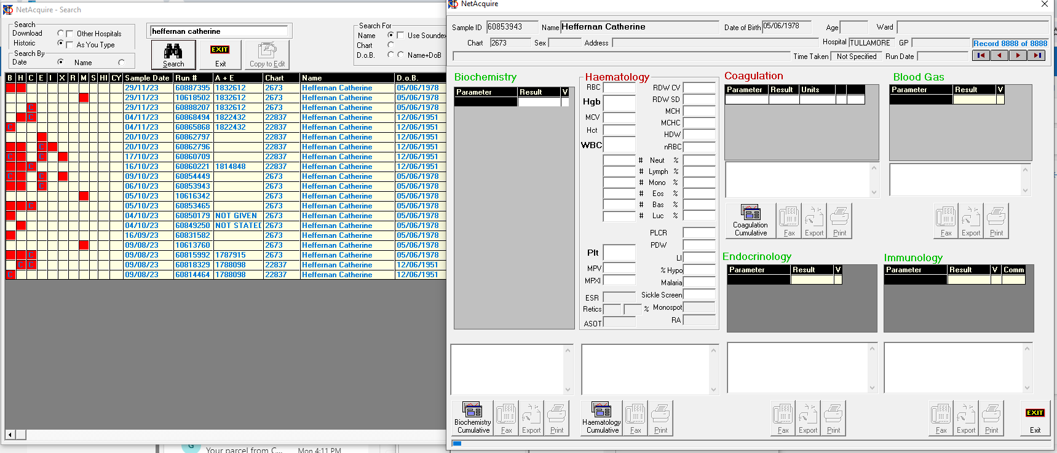

Have to close down application after clicking this as everything is blank then

Try to create a test patient with 05/06/1978 as DOB will blank out the clinician, ward, GP lists and if you arrow through previous records – they are ow blank too. Have to close down application and restart to see records again.

