ESR under filled comment not coming across. Sample resulted

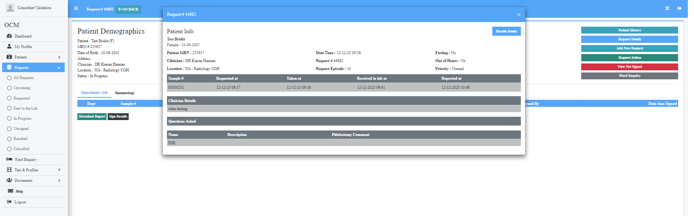

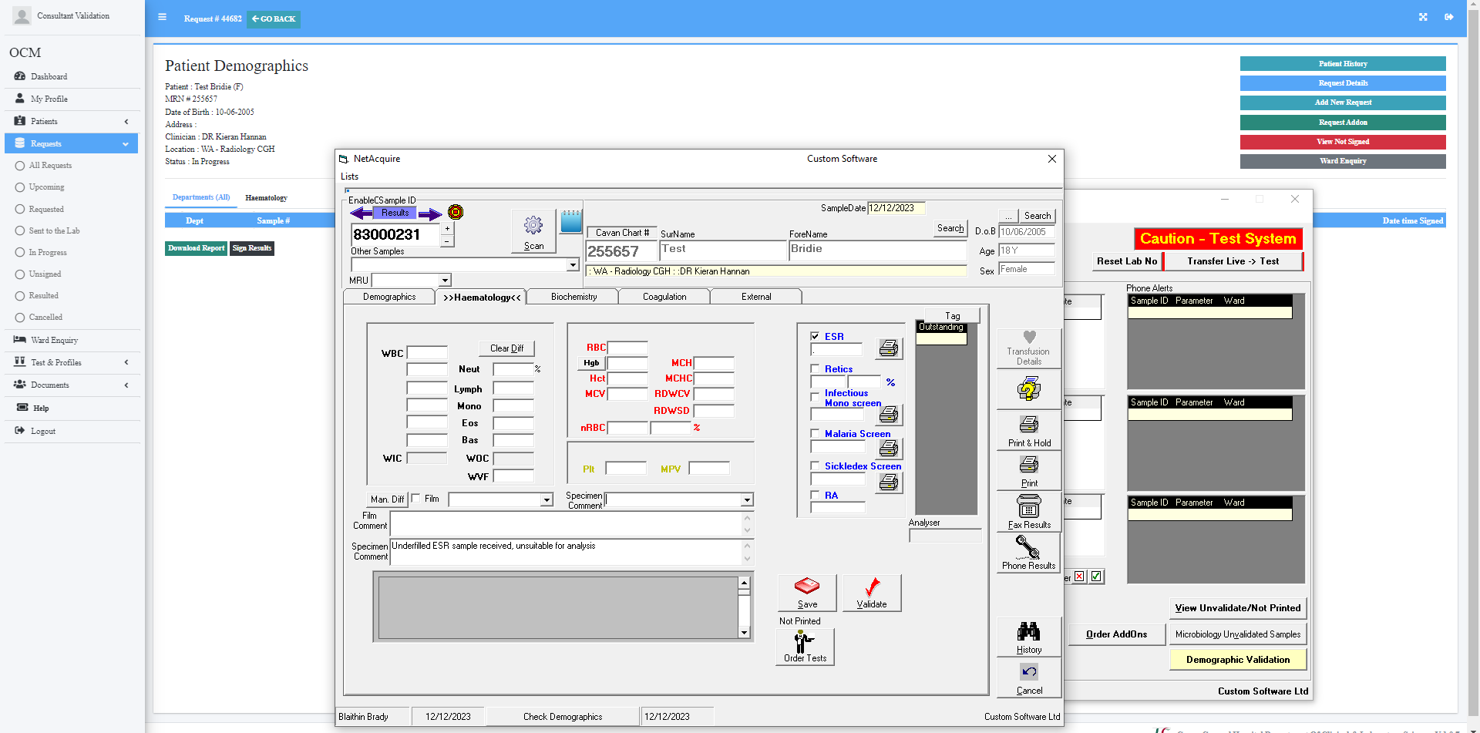

No comment box. Flagged as low result. Should have comment under filled sample

