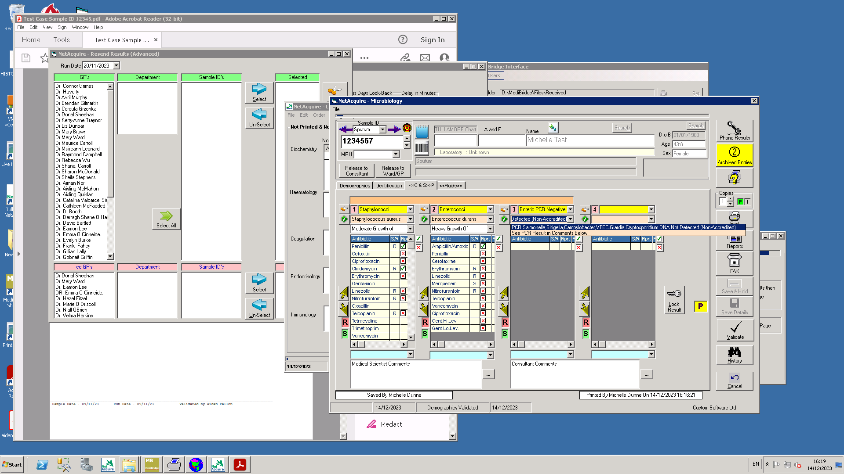

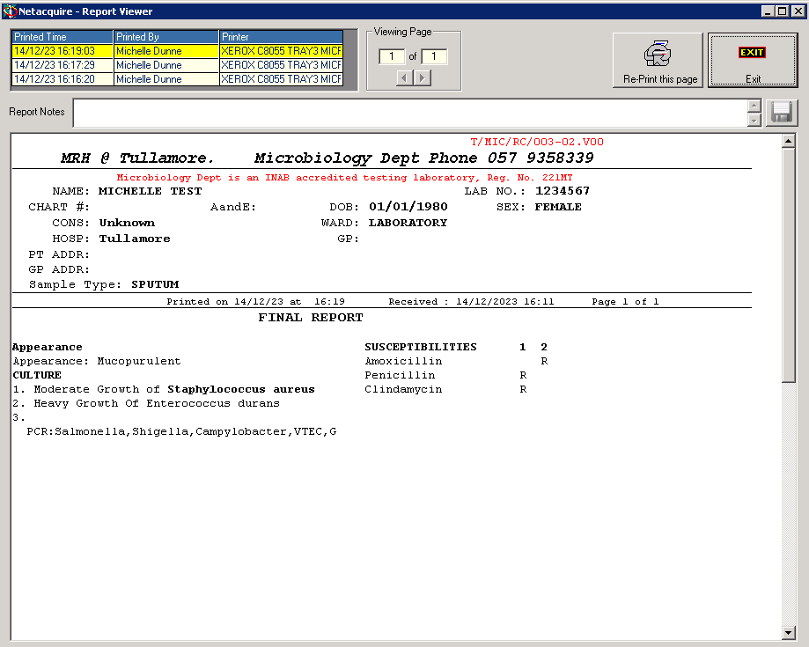

**Widen this area/allow text to fill full line across page**

**Move Susceptibilities down underneath culture results AND**

**Need more reporting fields so we can report more Susceptibilities - limited to 10 at the moment**

**See sample id 10617649 – has multiple results – need Susceptibilitie under all possible results**

**See sample id 4101 also**