|  |  |  |  |  |  |
| --- | --- | --- | --- | --- | --- |
| 64f9d375470b5 | 27. Units and batch products with a final fate such as transfused, destroyed, return to supplier and dispatched can be marked as pending to a patient | Completed | High | Fail | Pass. Transfused and Return to Supplier.  Fail. Destroyed and Dispatched go into funny loop  Fail. Expired can’t marked as pending  Same algorithm to be applied to Destroyed, dispatched and expired whereby only an administrator can mark as pending |

A R000123123999 H Dispatched..

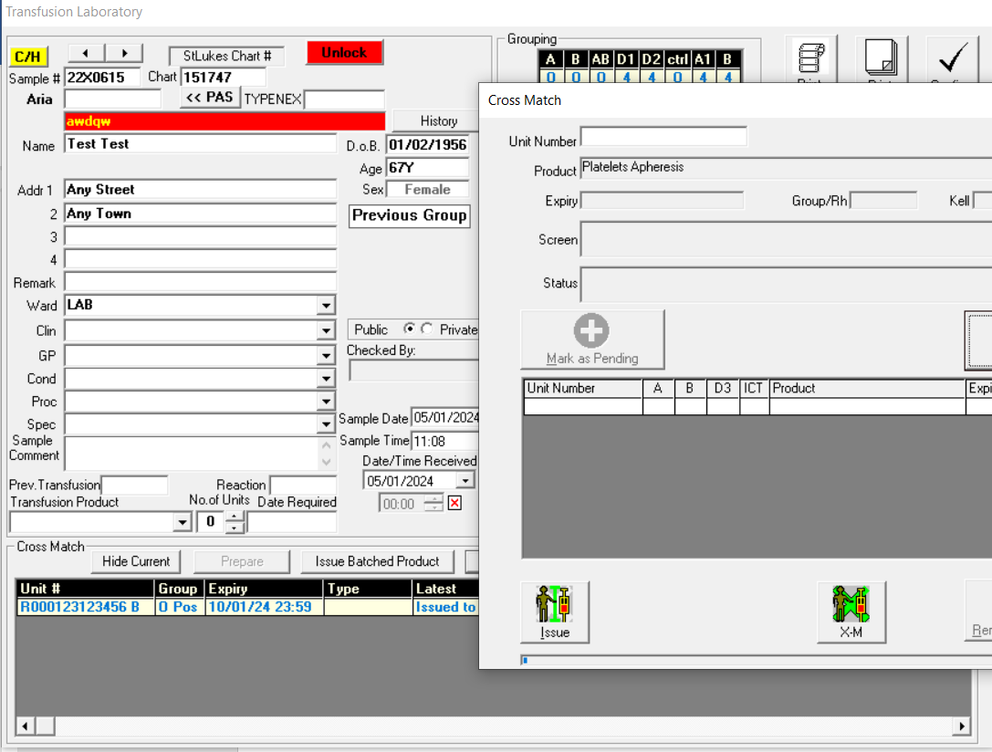

B R000123456444 H Destroyed

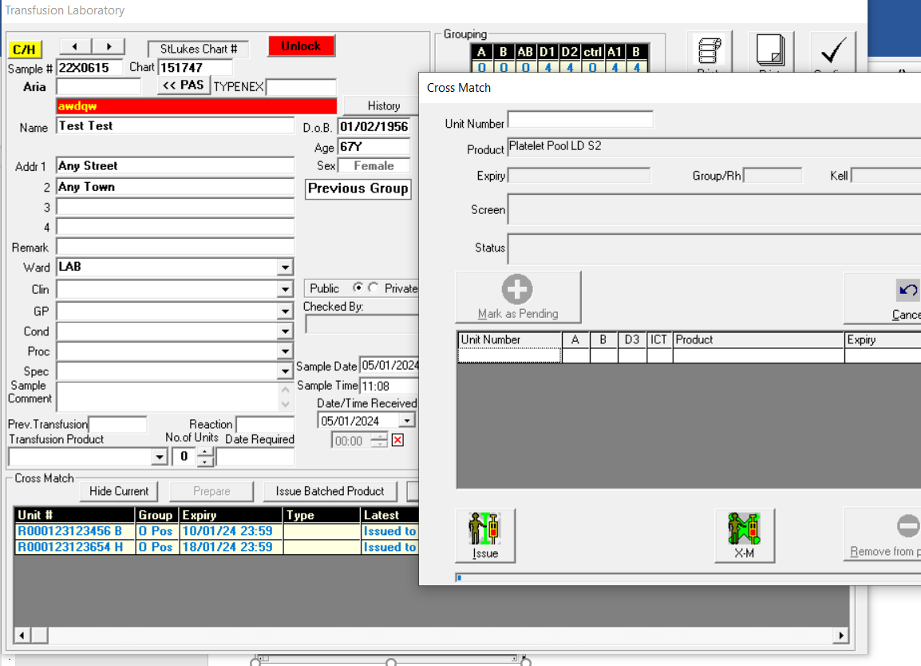

C R000123456777 H Expired

