Create Pending List not working since Add request timer was added. Was working yesterday.

Testing partial collection, MRN 255659 RID 44796

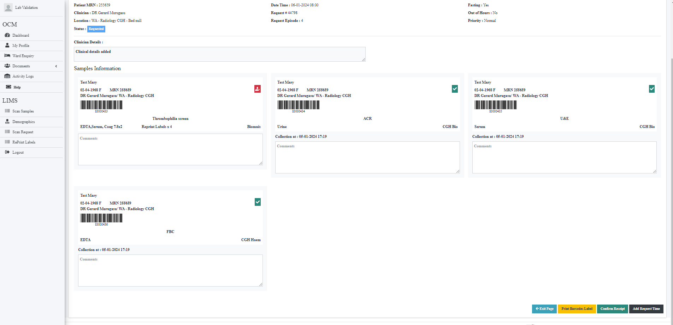

Clicked exit and reverted back to dashboard. As one sample was not collected create pending tab should appear.