NetAcquire – exe uploaded on OCM on 11.12.23 (6576f7e60ce25.exe)

Comments in peach box not present…

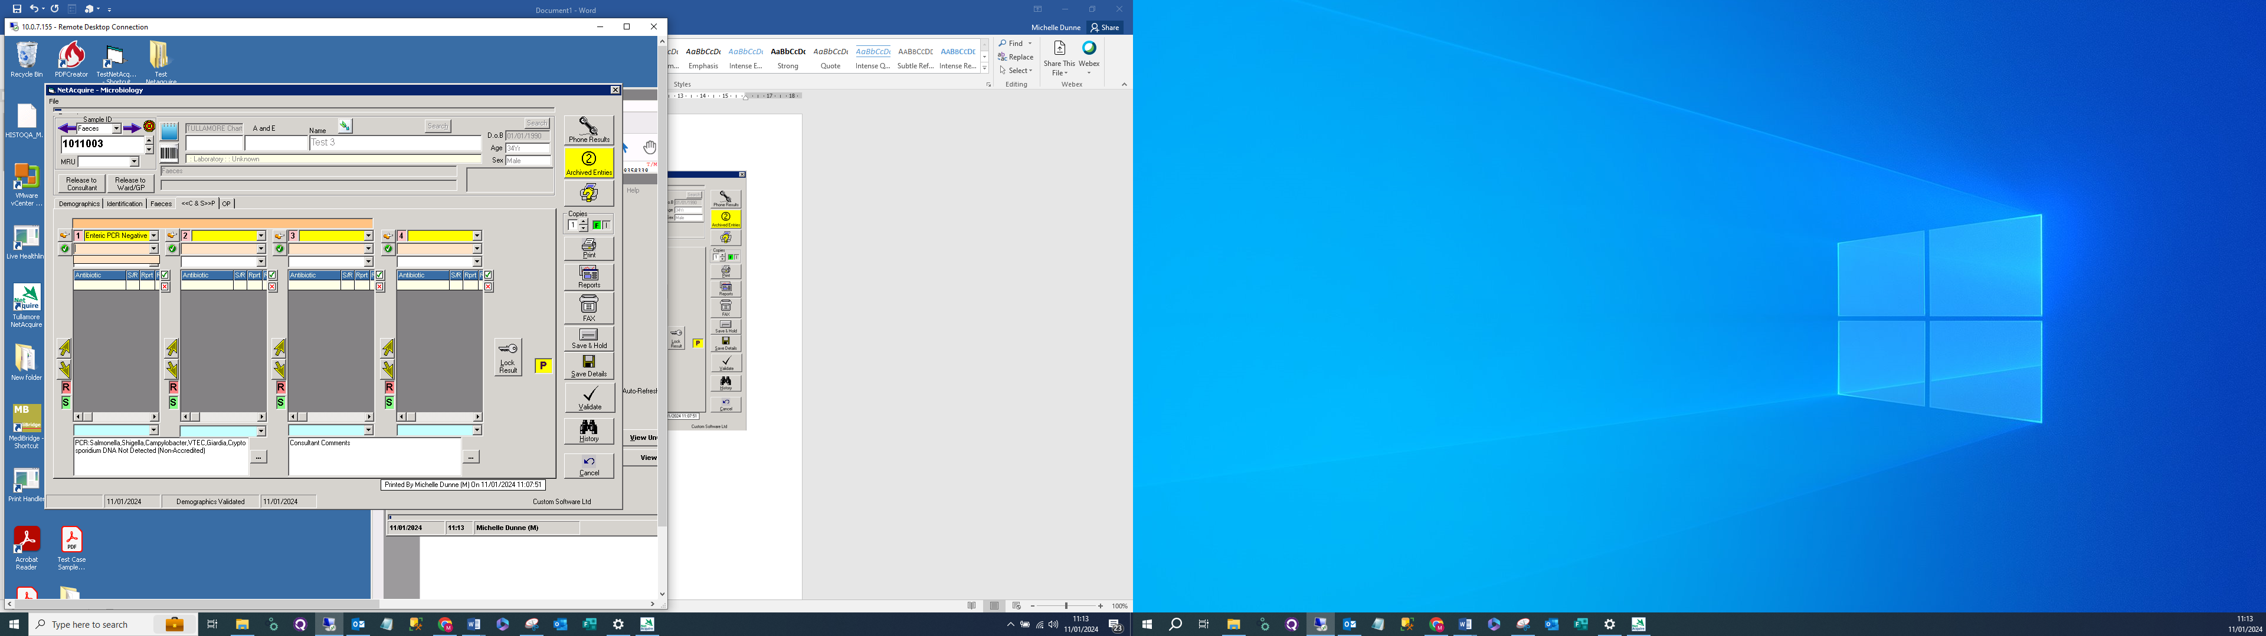

Comment highlighted not printing – see below

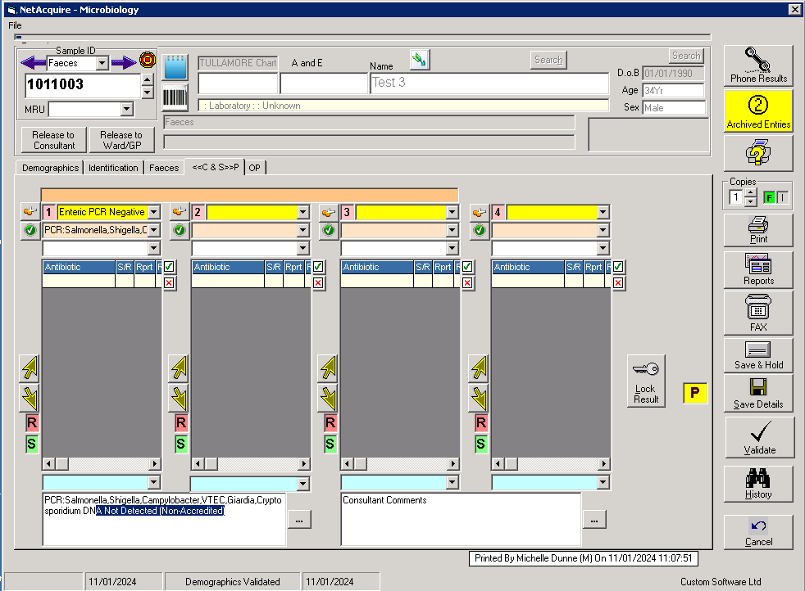

Print Handler 659dc4d892e82.exe 09.01.24

