**NetAcquire – exe uploaded on OCM on 11.12.23 (6576f7e60ce25.exe)**

Comments in peach box not present…

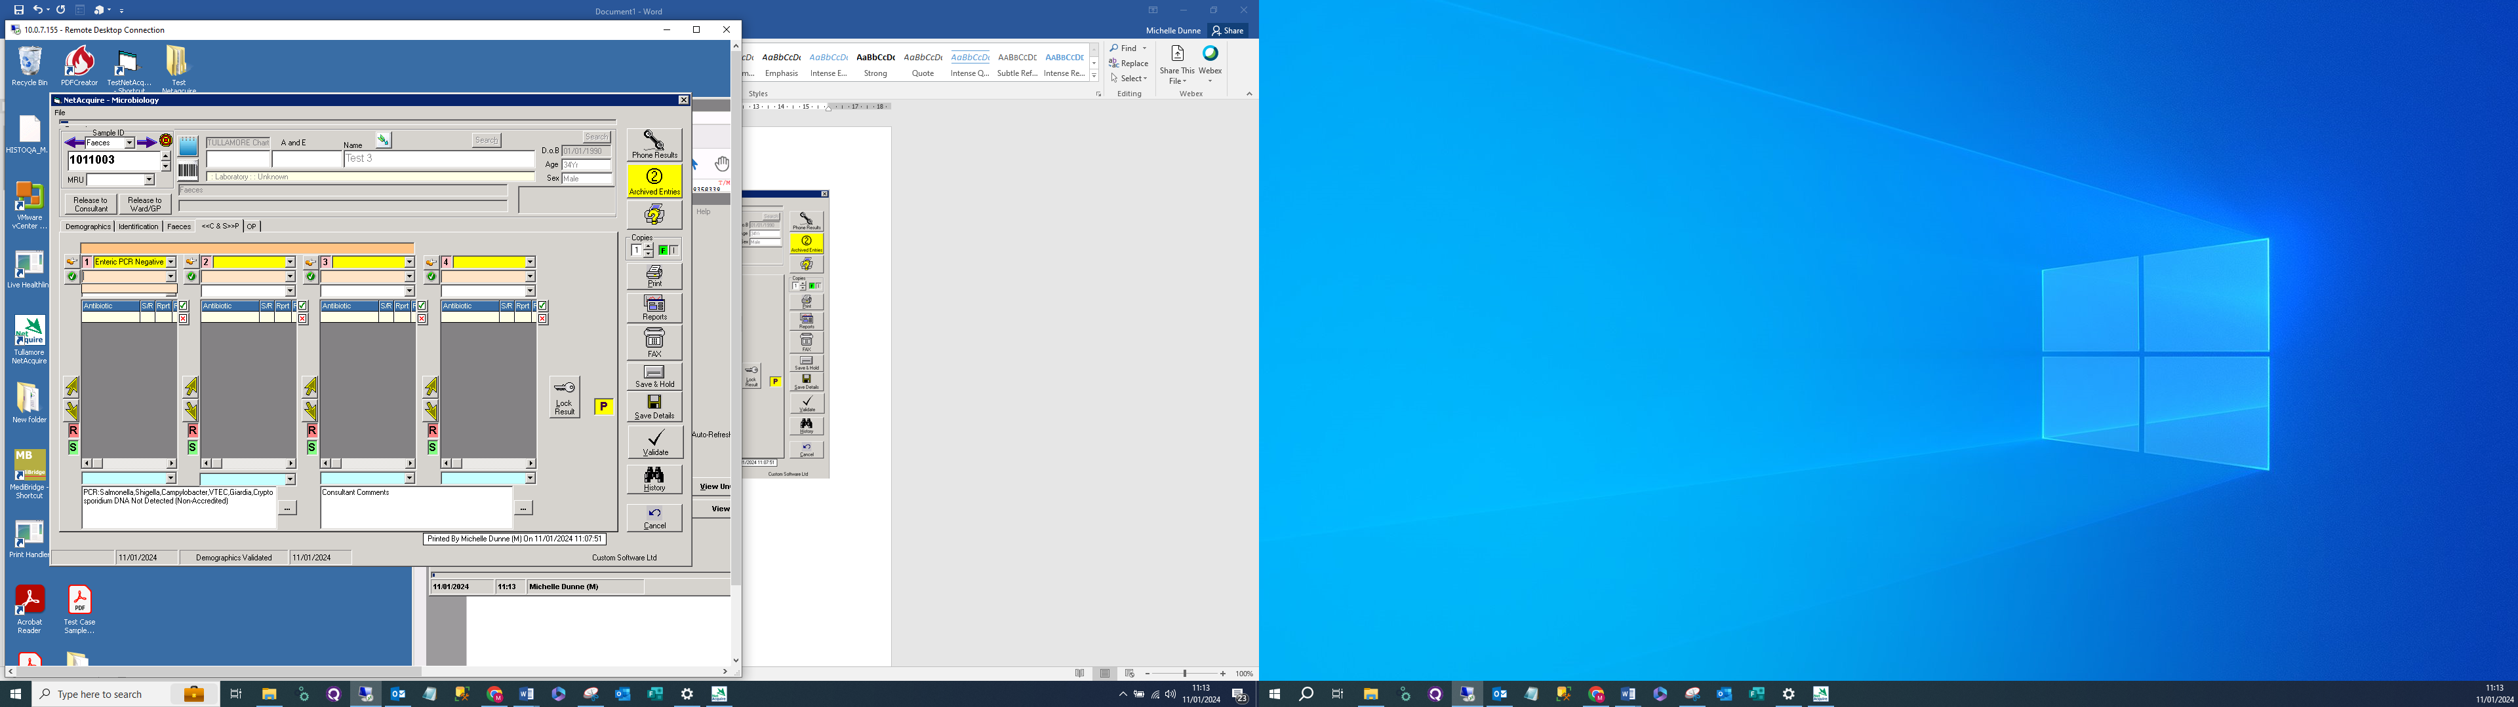

Comment highlighted not printing – see below

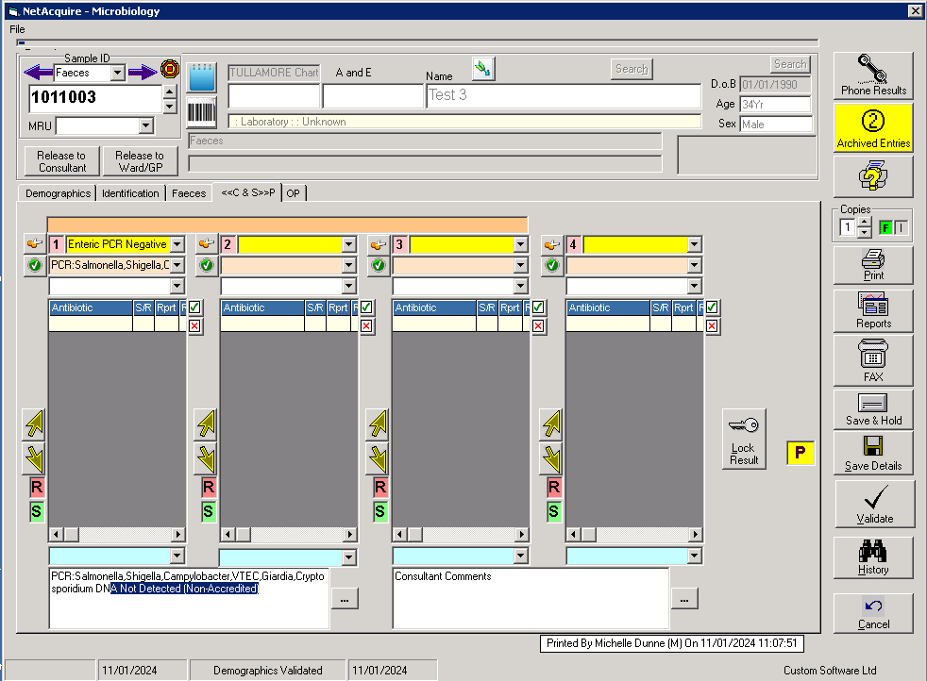

**Print Handler 659dc4d892e82.exe 09.01.24**

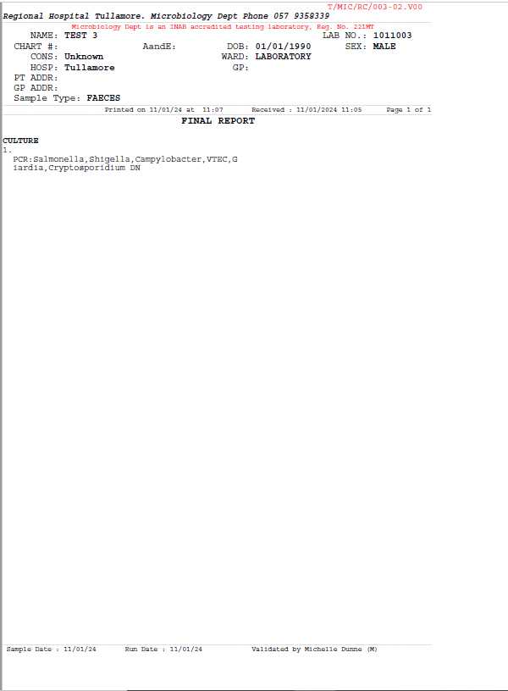

Move full word to next line – do not allow G then iardia to be split across two lines

Line incomplete