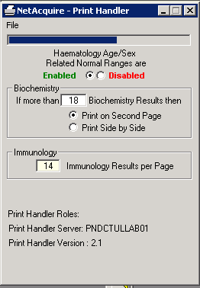 Print Handler Role not appearing

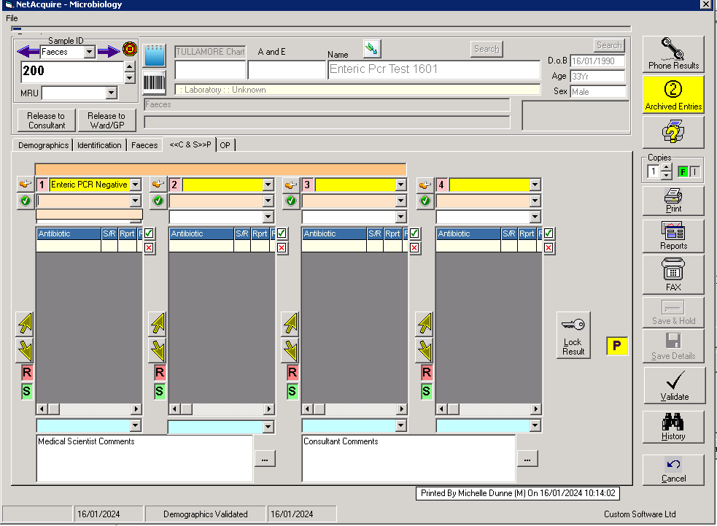

Still no option in drop down to select comment to print

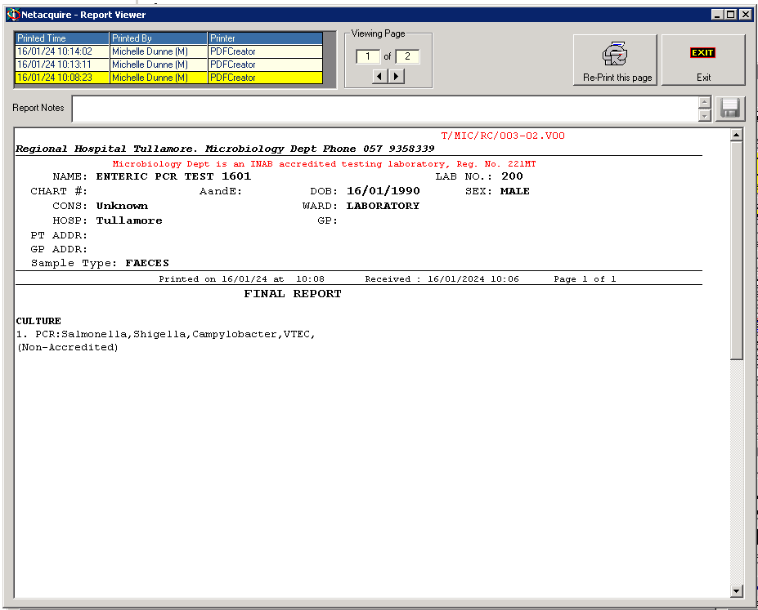

First print after I copied and pasted in the comment – the line is still cut off

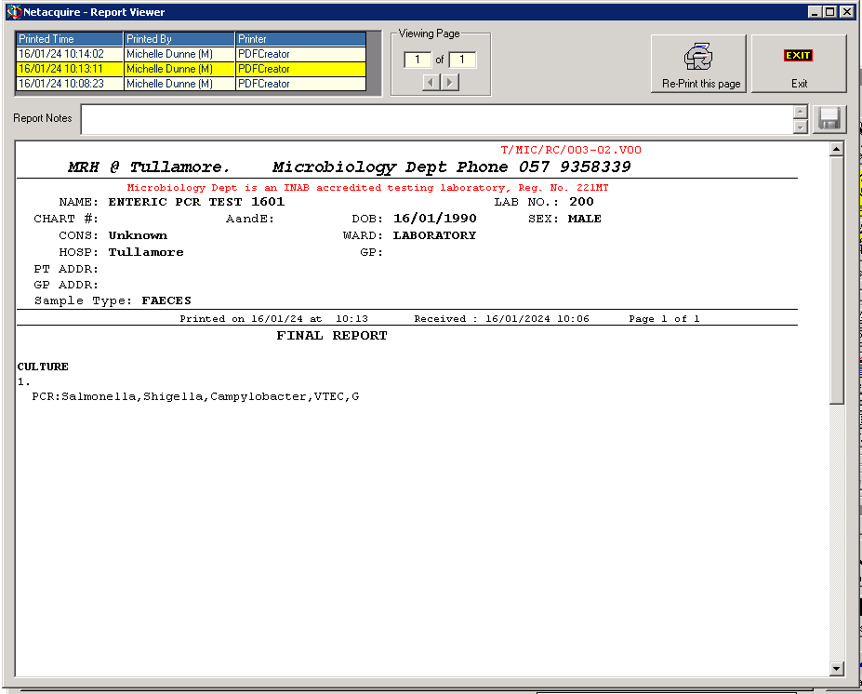

Second print – do not know what changed but the comment moved down a line and is cut off and incomplete

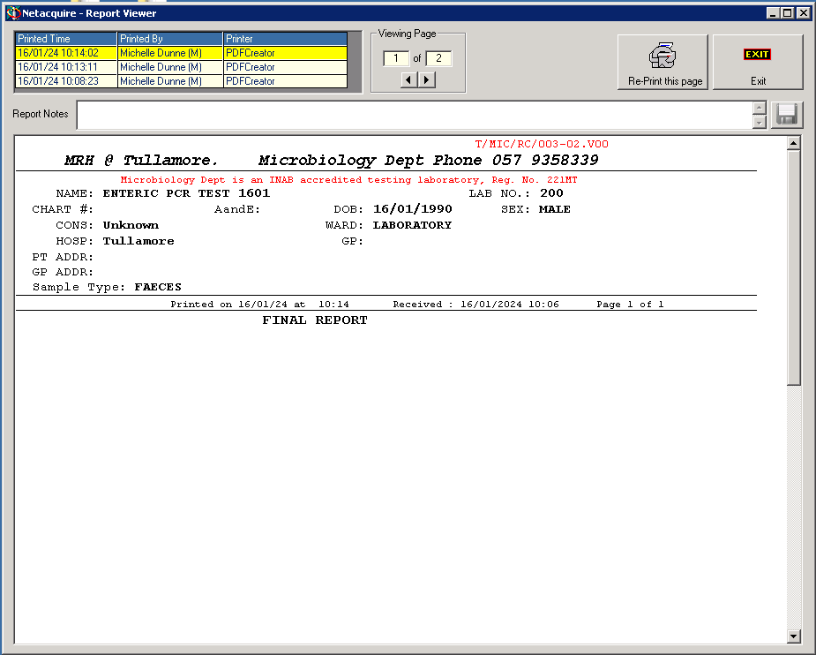

3rd print after I deleted the comment but results was Enteric PCR Negative