**5007**

**Entered demographics OK**

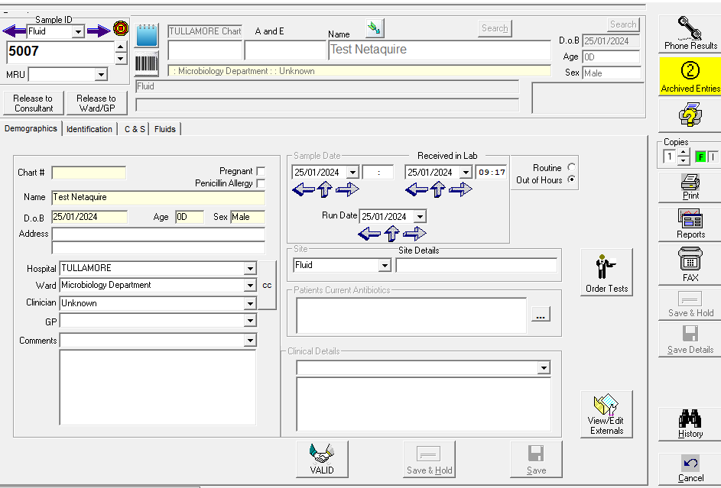

**Entered some results in Fluids Tab and clicked Validate**

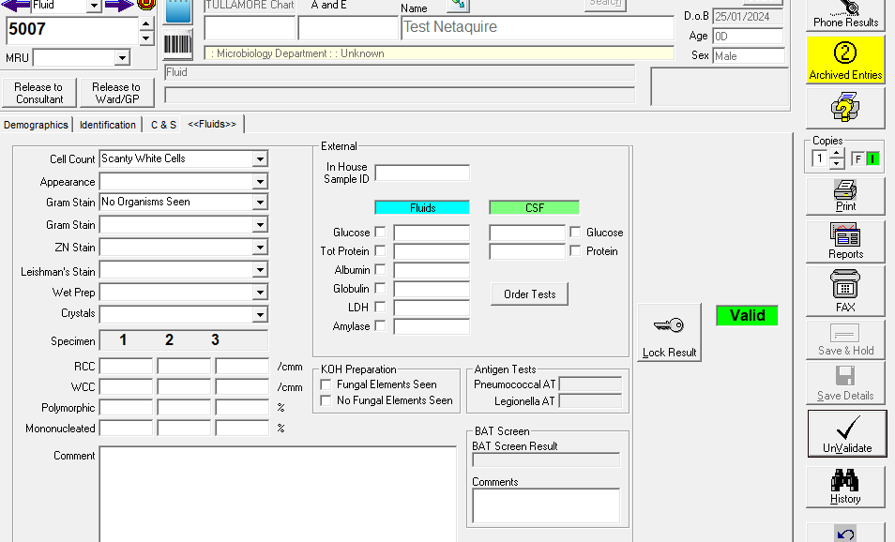

**Selected I to release Interim Report and Selected Release to Ward/GP**

**Release to Ward/GP button goes green and Interim report released which is OK**

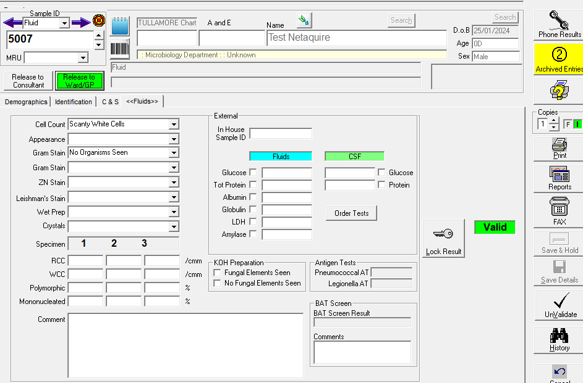

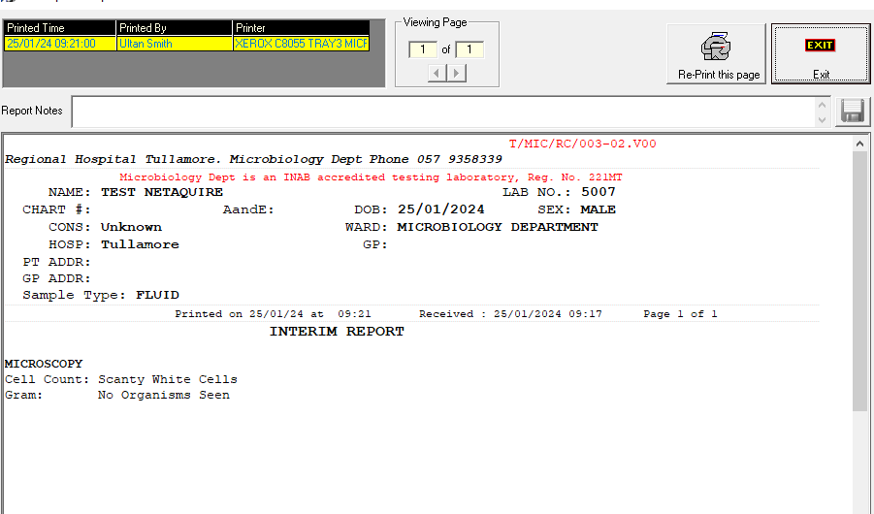

**Up to this point all OK.**

**Now add further results ie. No growth in C/S Tab**

**Screenshot before Select Validate on C/S Tab**

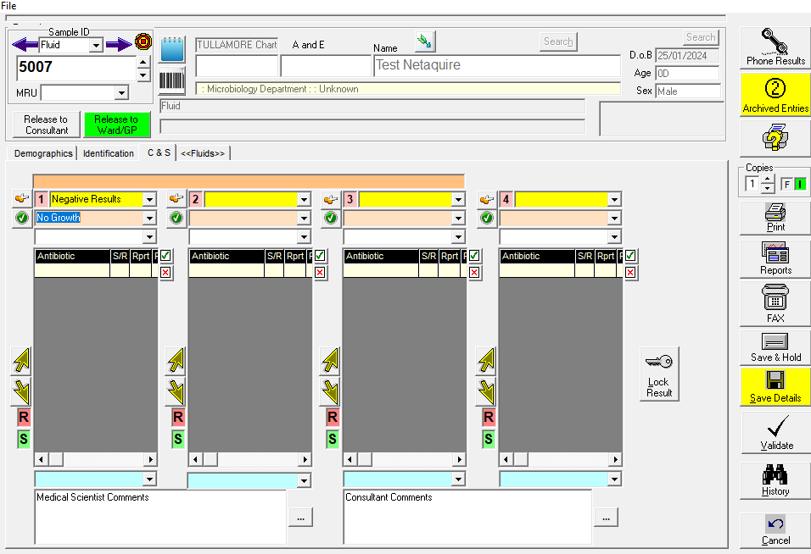

When Select Validate a popup appears saying “ Do you want to re-release report to Ward’. This should not pop up. Did not previously.

I select No:

Green Release to Ward goes back to Grey and also a report is released even though I said No as per screenshot below. This report will overwrite the initial interim report on Ward Enquiry.

**This is the main issue as per screenshot.**

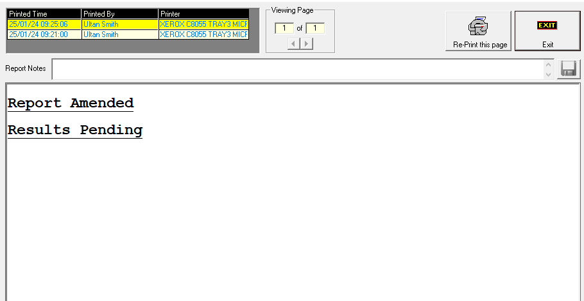

Went back and Selected Interim and Select Release to Ward and correct report released as per below.

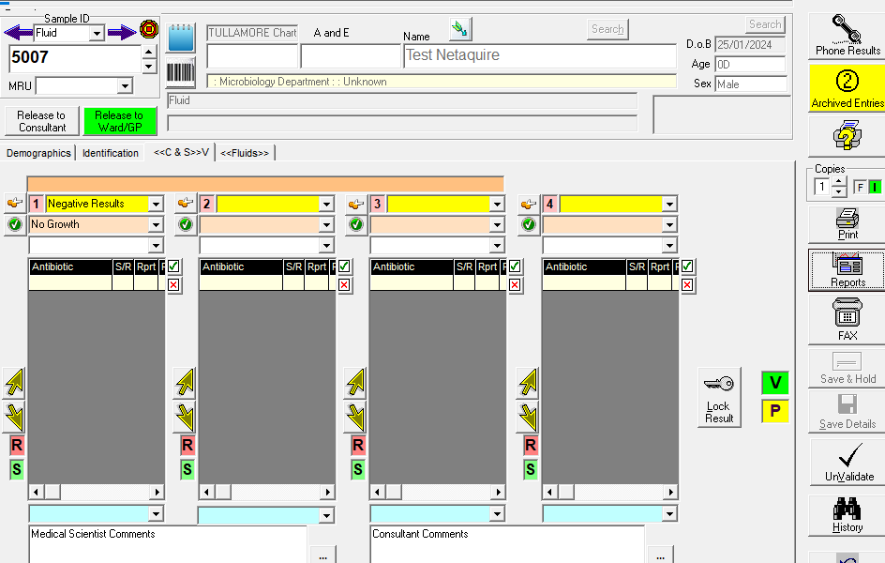

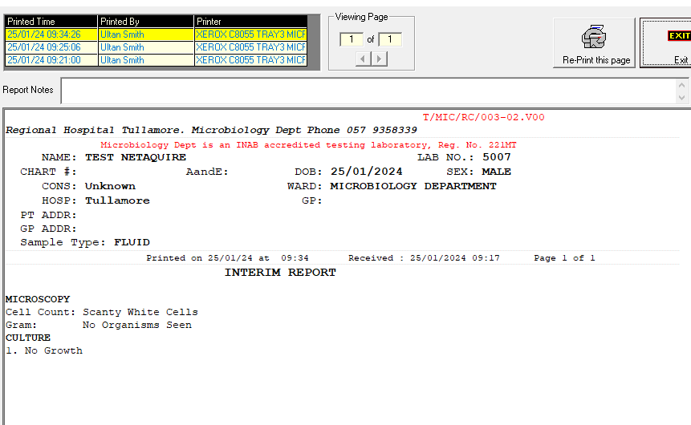

Unvalidated C and S and added further results before trying to re lease another interim report.

When select Validate above, the pop up box comes up and if I select Yes a ‘Final Report’ is released. This should not be a final report.

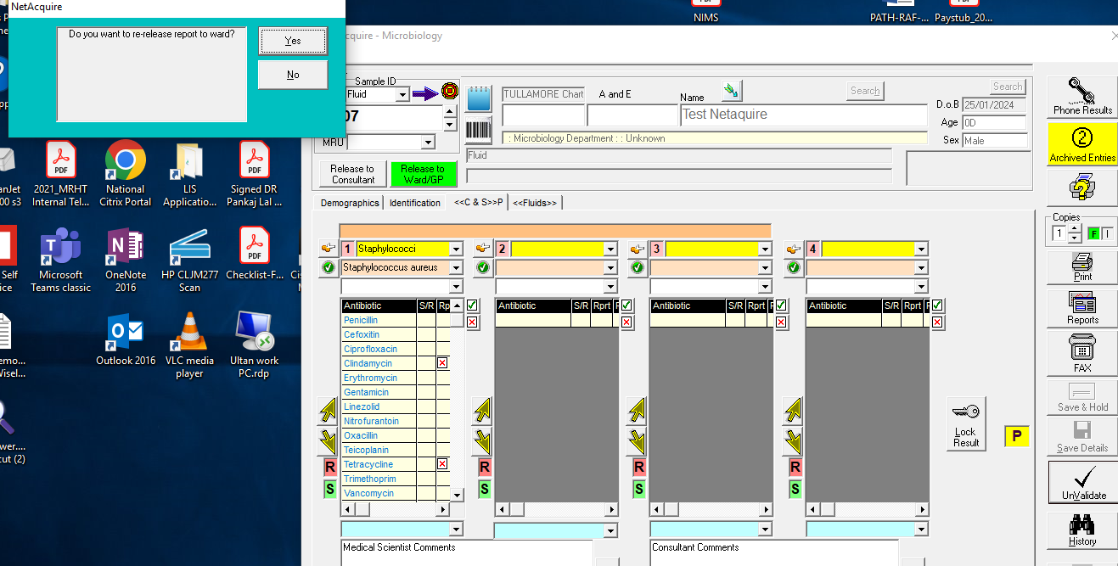

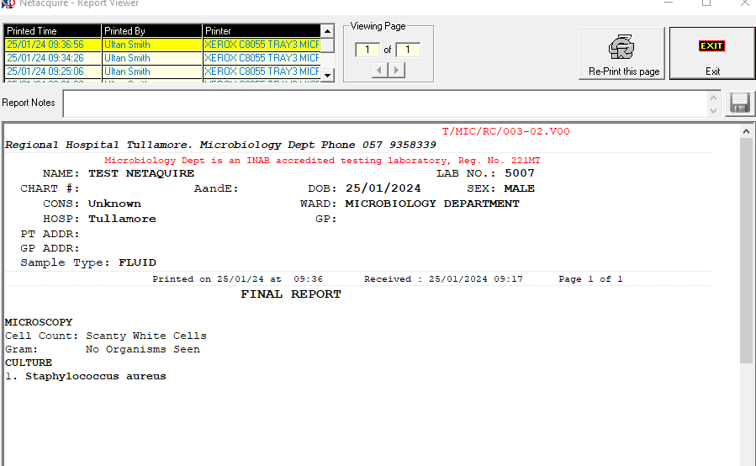

**Also see Example 10428248.**