On the old one when you were in under Haematology tab and selected history the plot was for the last 6months as below:

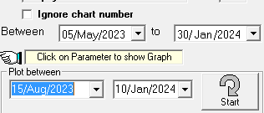

With the new version it is only allowing us to plot the last 7 days which is very frustrating for blood film reviews. Is there a simple way to change that setting?

**We need this to default to 3 months please.**

**Apply default for plots in all departments to 3 months**