Demographics entered with DOB 05-06-1978

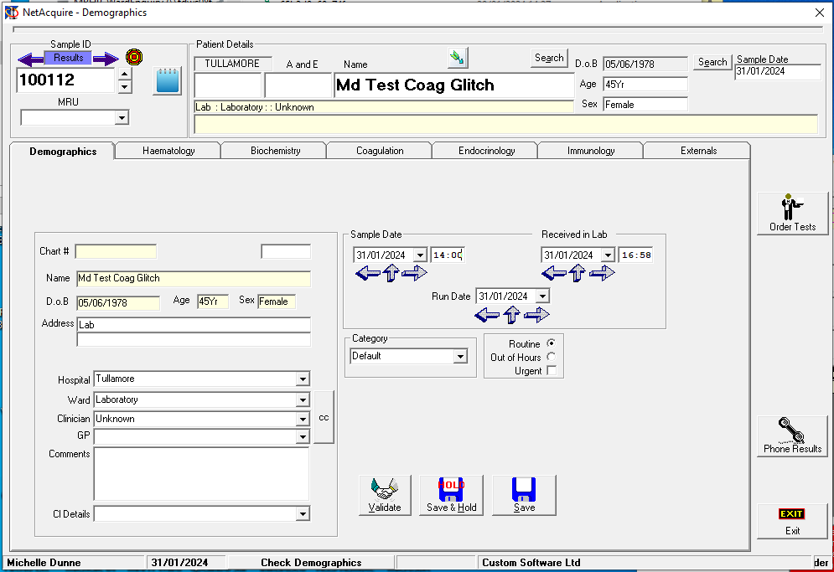

Clicked Validate – clicked through tabs and demographoics disappeared and caog is empty

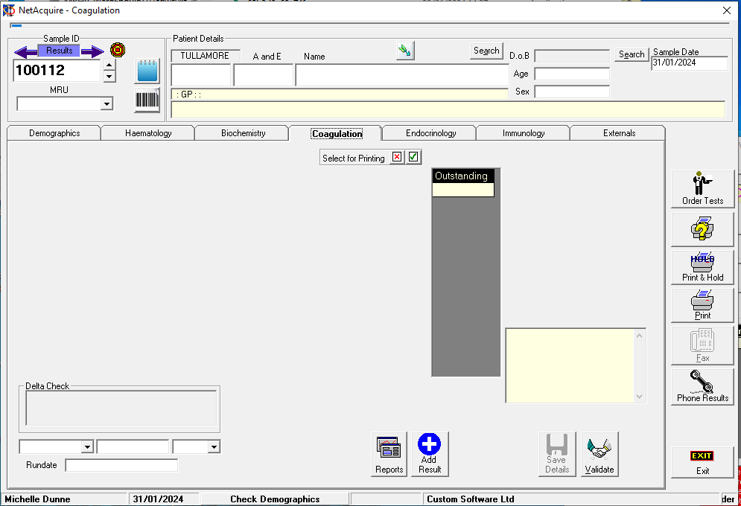

Externals empty also

