Header is: MRH @ Tullamore

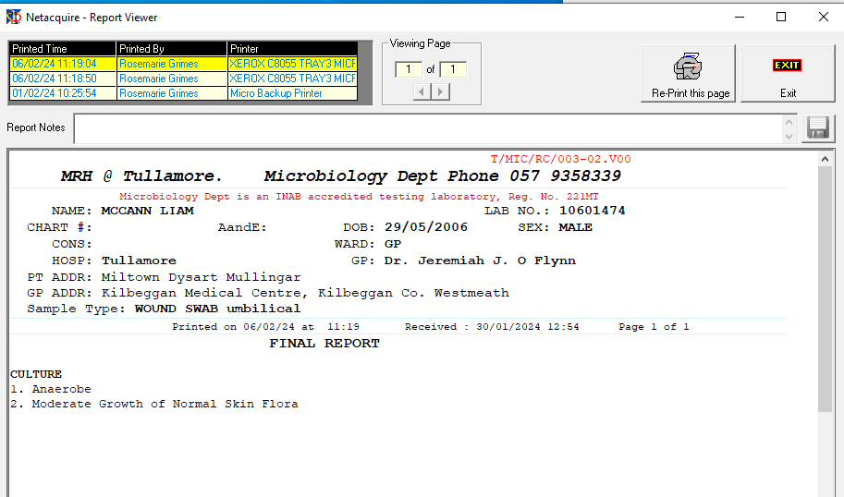

New PrintHandler exe - Regional Hospital Tullamore

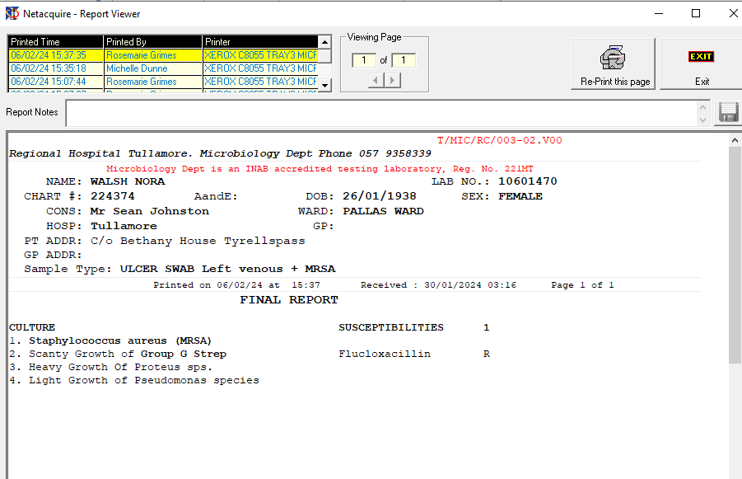

INTERIM REPORT ISSUED 02-02-24 SUSCEPTABILITIES PRESENT

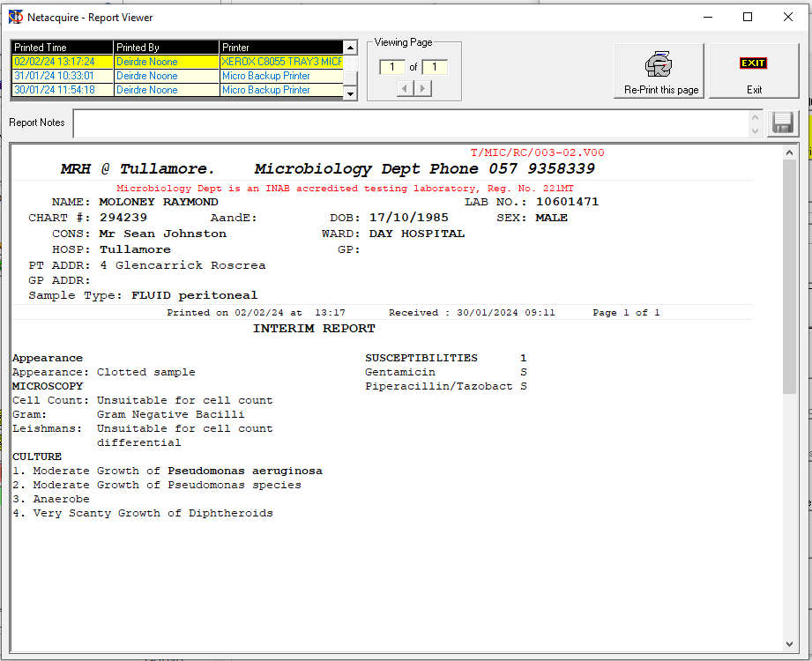

ADDED ANOTHER SUSCEPTABILITY

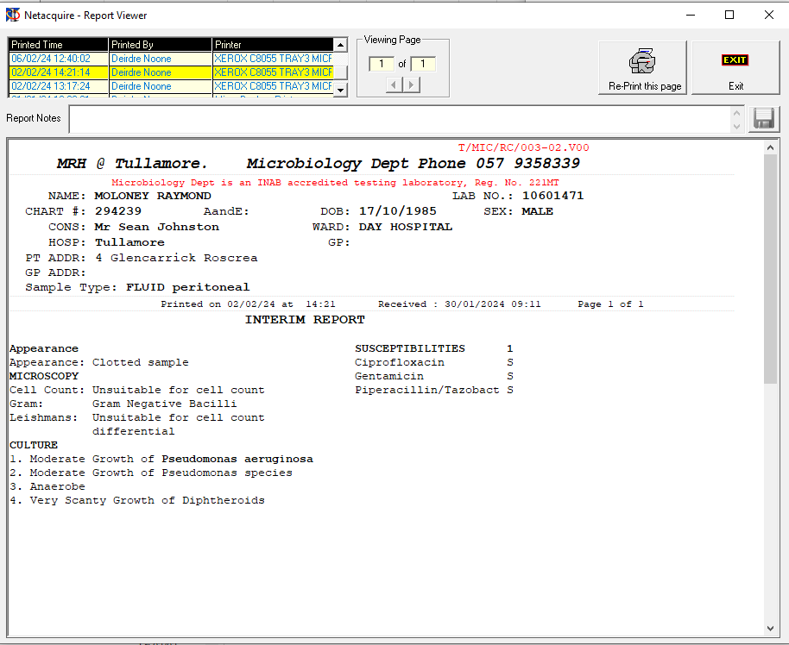

ISSUED FINAL REPORT – SUSCEPTABILITIES DISAPPEARED (NetAcquire , old Print Handler)

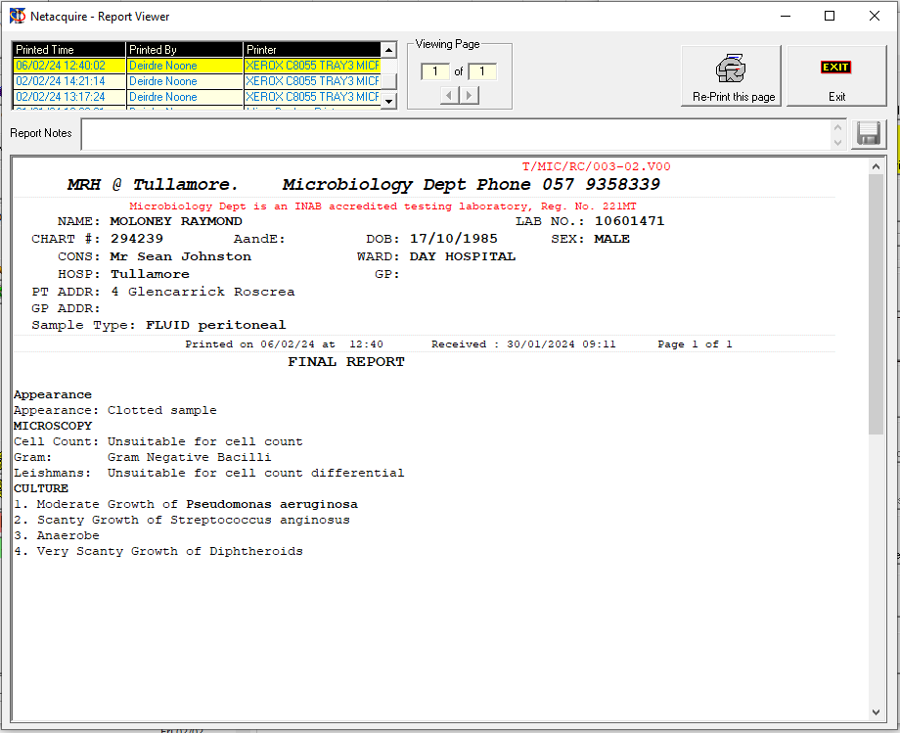

UPDATED NETACQUIRE EXE PLUS UPDATED PRINT HANDLER EXE – STILL NO SUSCEPTABIOLITIES

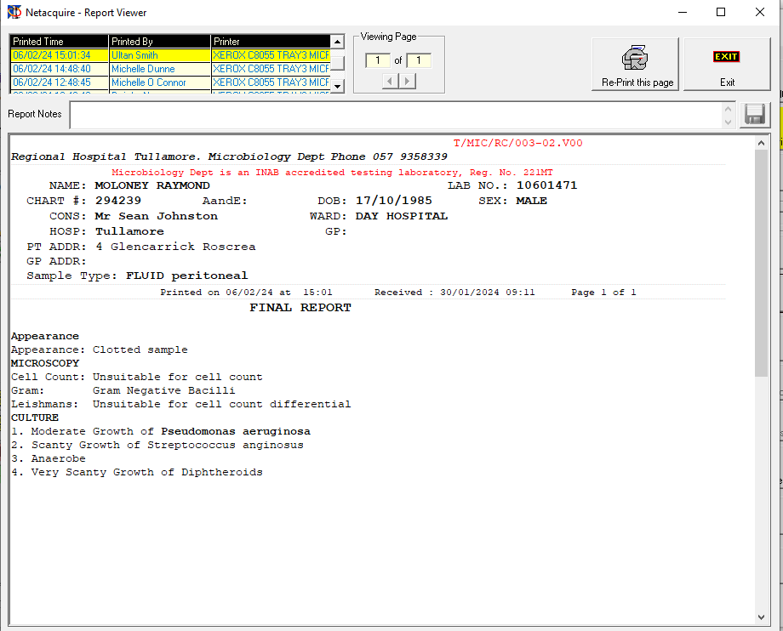

RE PRINT WITH NEW NETACQUIRE EXE AND OLD PRINT HANDLER – NO SUSCEPTABILITIES

