Histology exe from 08.01.24

Unable to add numbers or text to Case number

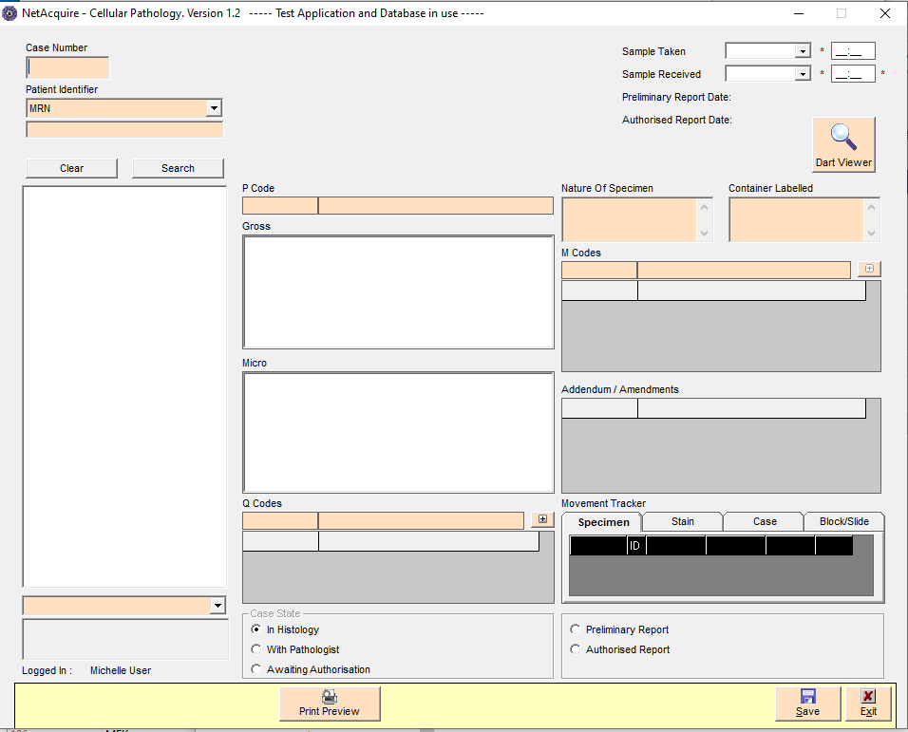

Unable to type into any fields that are blank on this screenshot

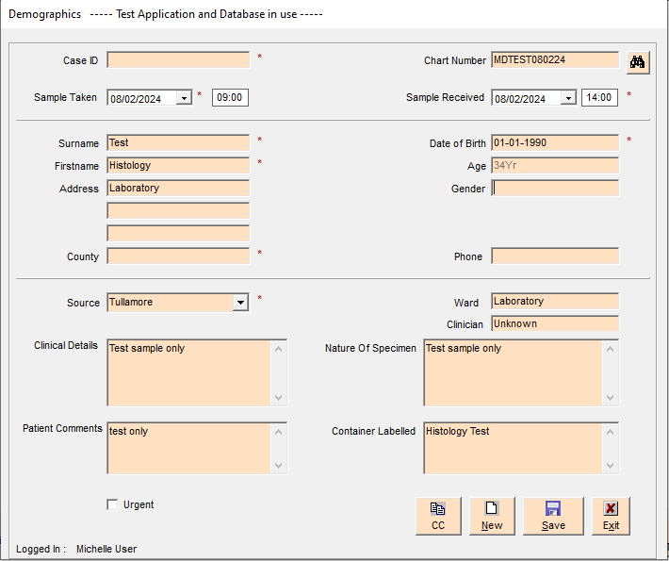

Can type into County but only 2 characters and once I tab or click into another field, the entry in county disappears.

Click Save

