Cannot enter gender

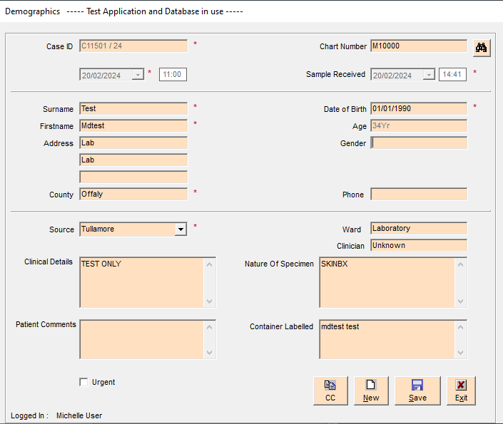

Try search without clicking a Search for option – blank box comes up

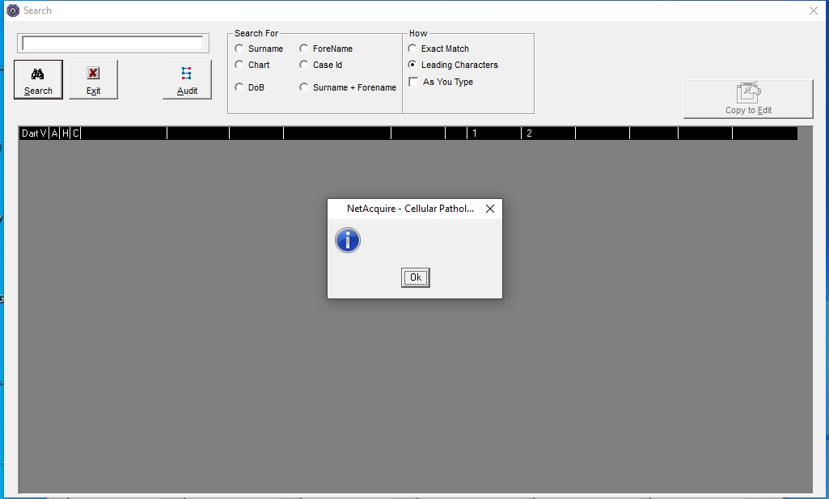

Click Surname and enter test as surname and search…this seems ok:

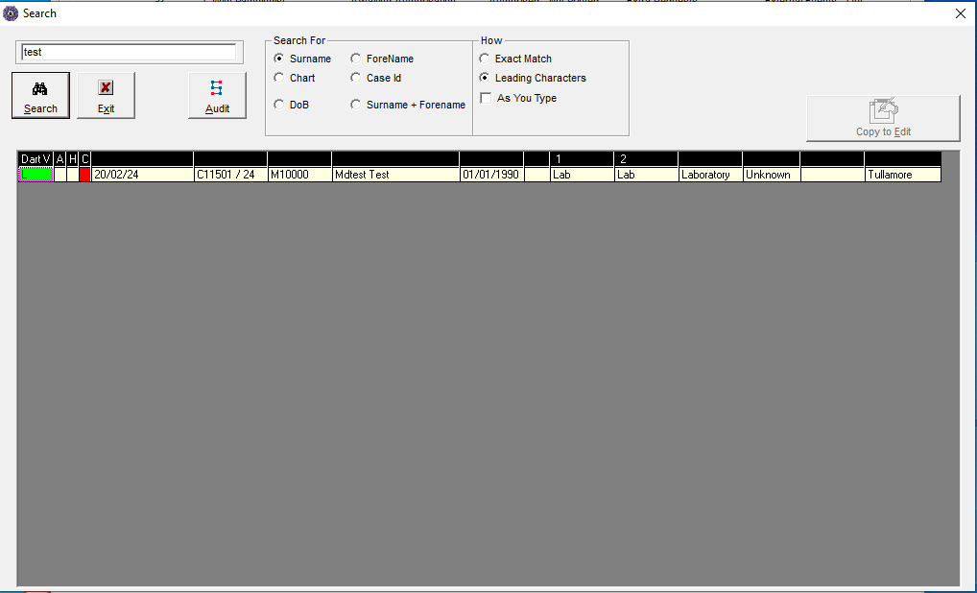

Click on Green DartV button (what does L mean?) and this Phase screen comes up – what is this? tHis did not bring me to DartViewer

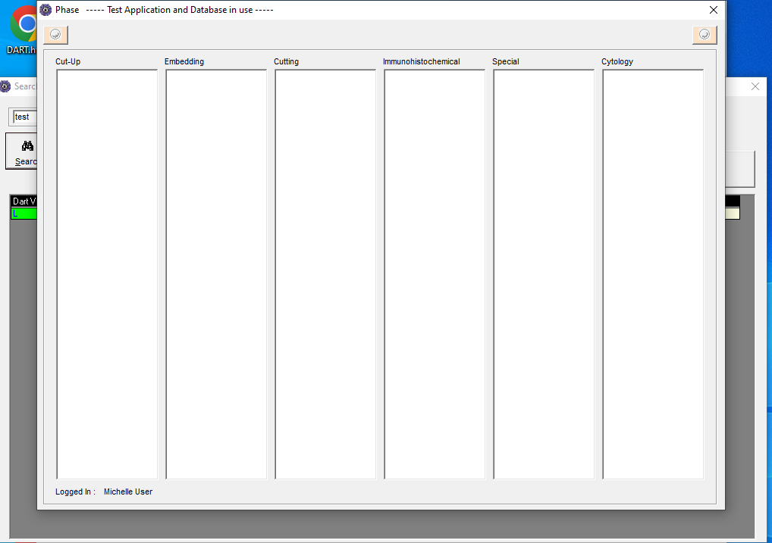

Searched under chart number and clicked into DartV for sample ID TA00154/19 and this did go to DartViewer?!

