Enter port no 50000 – doesn’t connect – message appears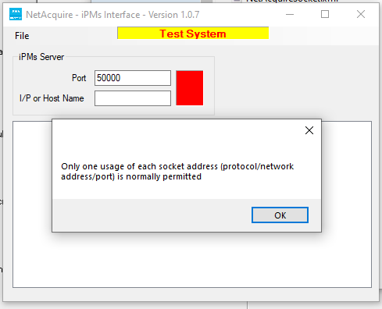

Ok to message and add IP to see if that’s makes connection – it doesn’t and I get this message

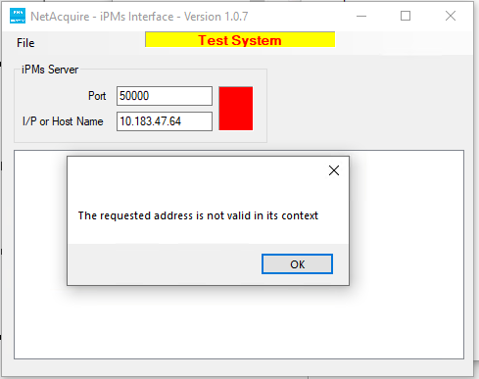

**NOTE DIFFERENCE IN VERSIONS BETWEEN TEST AND LIVE?...........**

Current LIVE

