Testing carried out on the NetAcquire test database. Most tests coming across. A few tests are not.

See below for detail on what needs to be fixed:

**Combined FLU/RSV/Assay Anomaly:**

•         SCV-2 Virus **Result status** not coming across to test netacquire

I have codes entered on the Gx server database as below. These match what is entered into current live Gx interface for Cl2 laboratory which is functioning properly. This needs to be replicated for this interface for all assays.

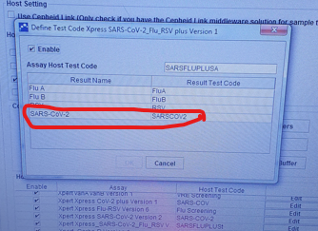

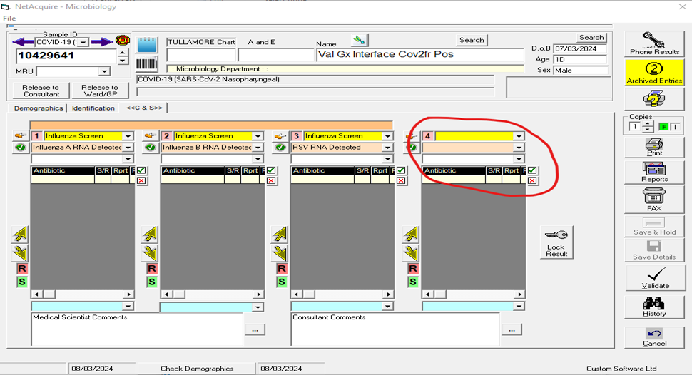

**Clostridium difficile Assay Anomaly**

The result below circled should be C.diff Tox Pos(027 Strain) **NOT**C.diff Tox Pos(non-027 Strain). The sample I used was positive for the 027 gene and should come across as 027 strain. All codes below are entered correctly into Gx database. Again the Live Gx Interface in the cl2 works perfectly. If all coding could be replicated from working interface to this test interface that would fix things I would say.

