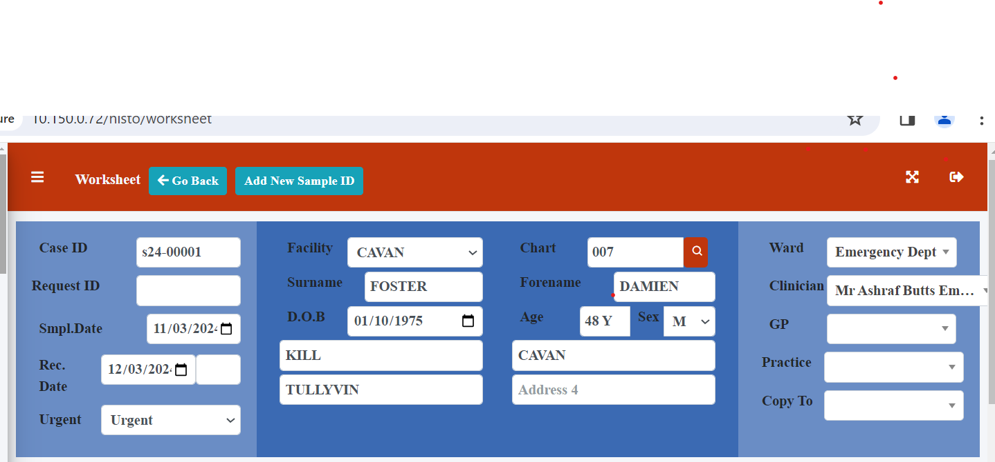

The Cavan (S24-) is now saving. I can still change the Facility from Cavan to Tullamore while in the patient record. Should this be allowed?

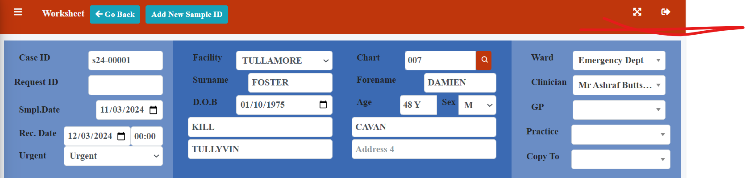

Also the work list still contains the (/) in the case ID number but this looks fine in te worksheet view.

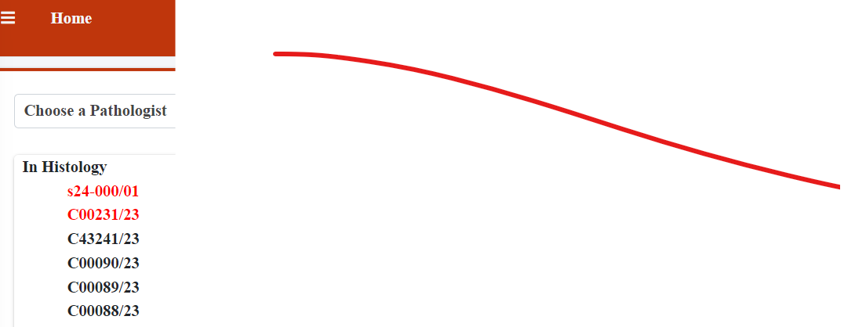

The list does not include Hala or Megan? Also we still have a box for checked By? Delete this?

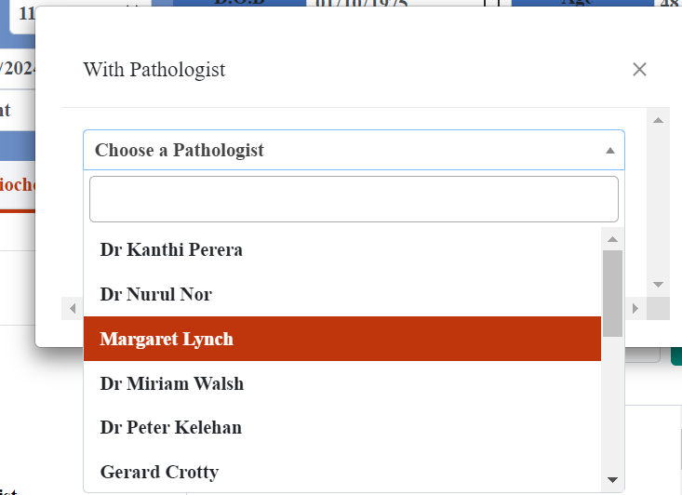

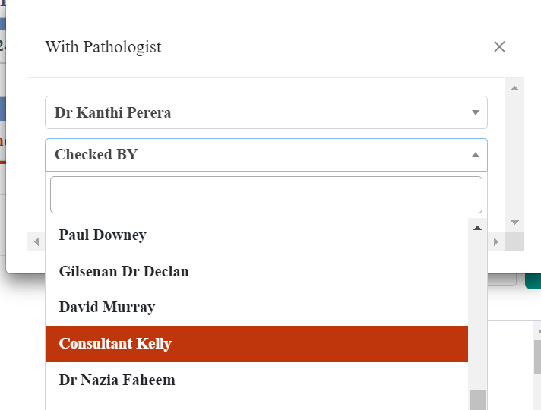

There is no need for this drop down (above)

The print preview does not appear to be working? (below)

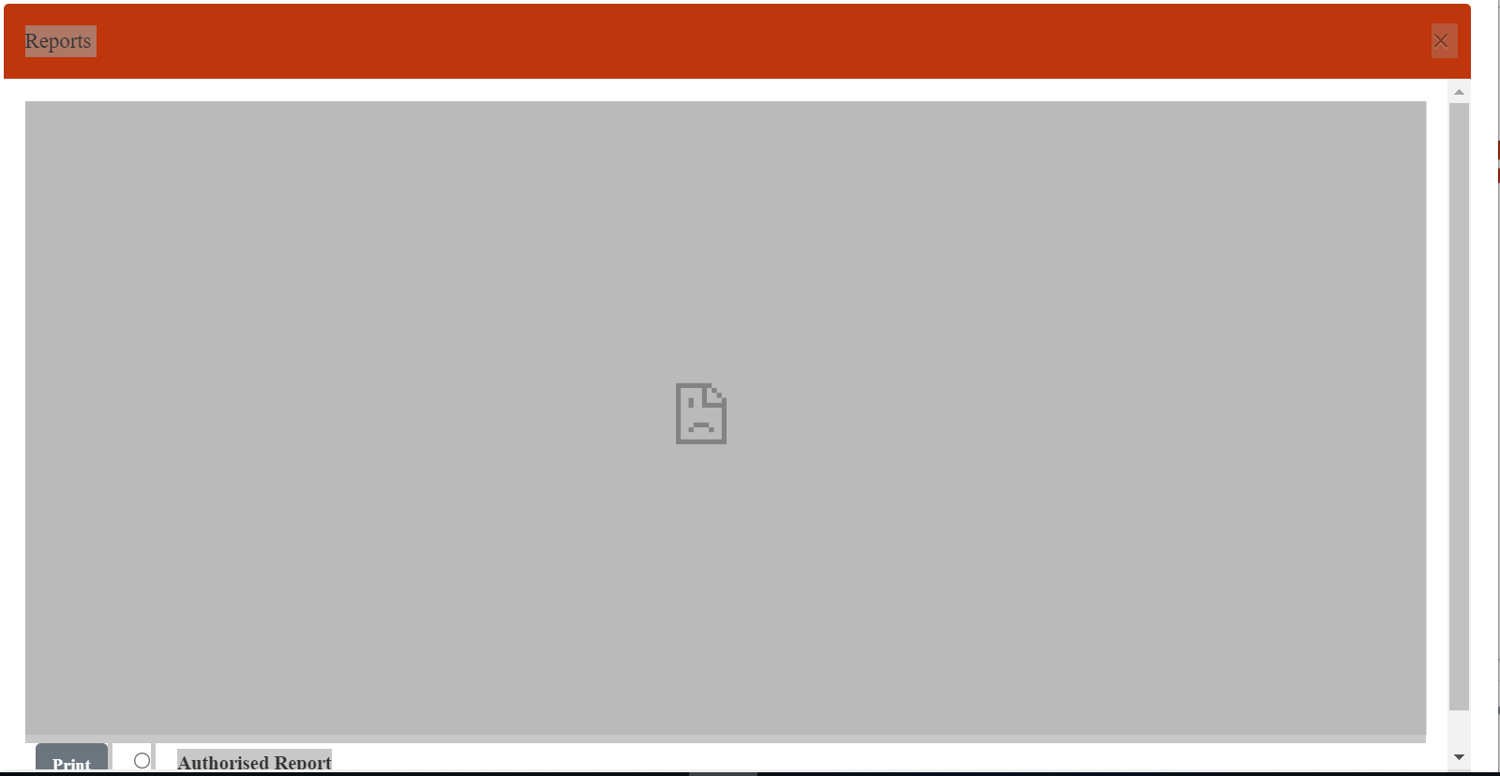

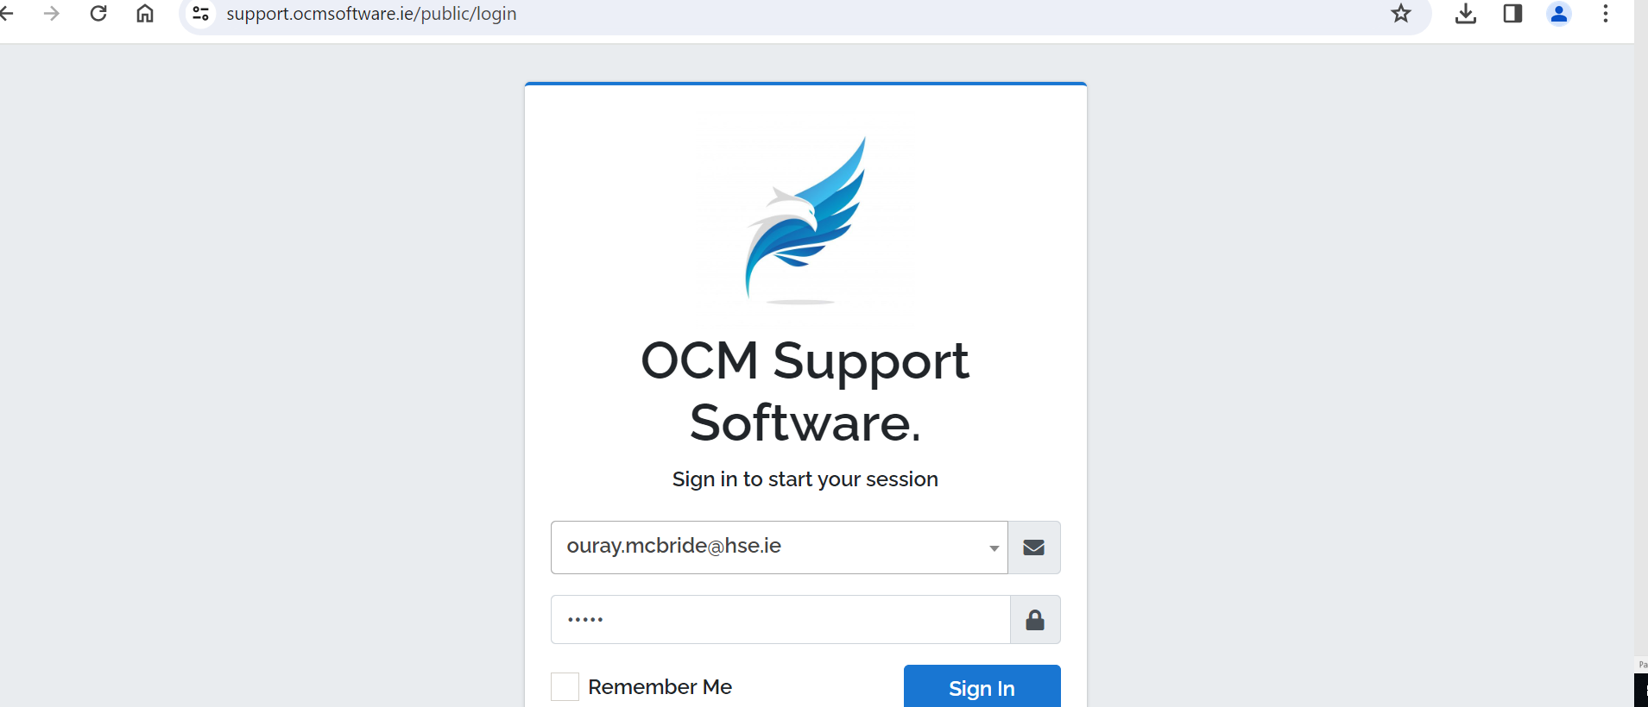

Can not accesss the ticketing system? Warning email or password is incorrect yellow box pops up in top left?