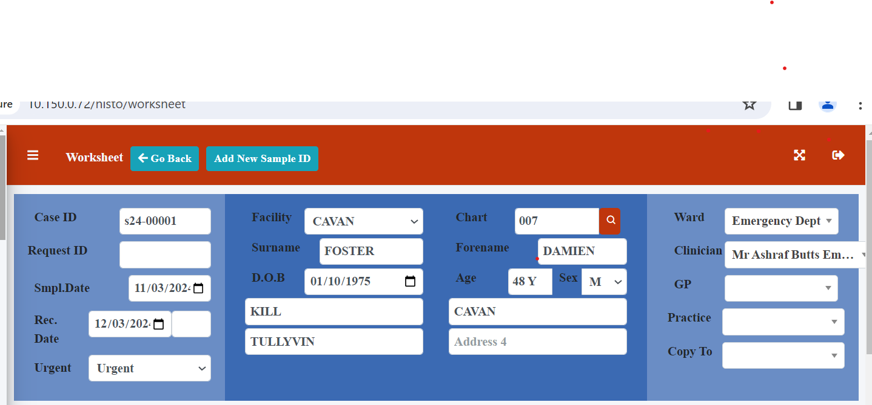

The Cavan (S24-) is now saving. I can still change the Facility from Cavan to Tullamore while in the patient record. Should this be allowed?

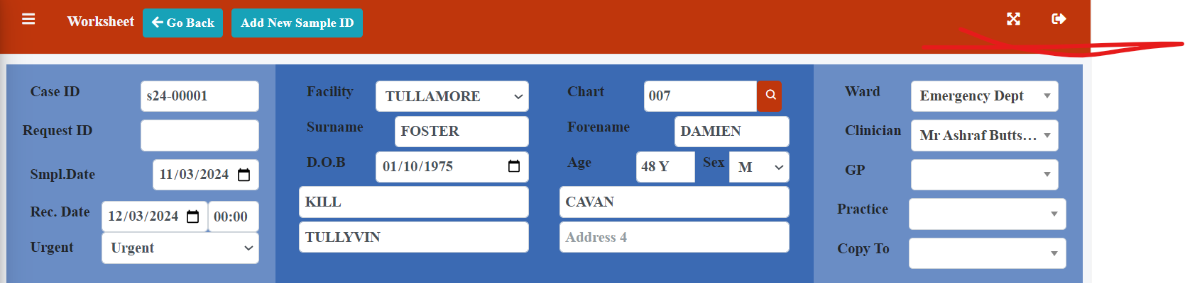

Also the work list still contains the (/) in the case ID number but this looks fine in the worksheet view.

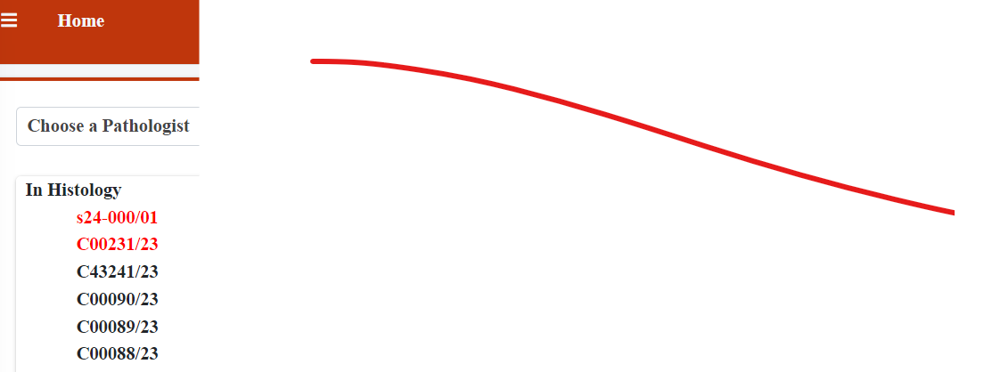

The list does not include Hala or Megan? Also we still have a box for checked By? Delete this?

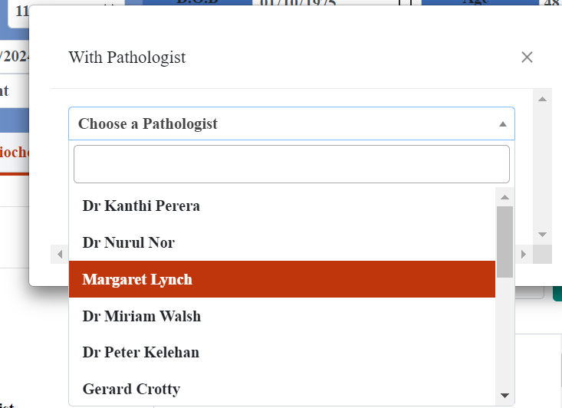

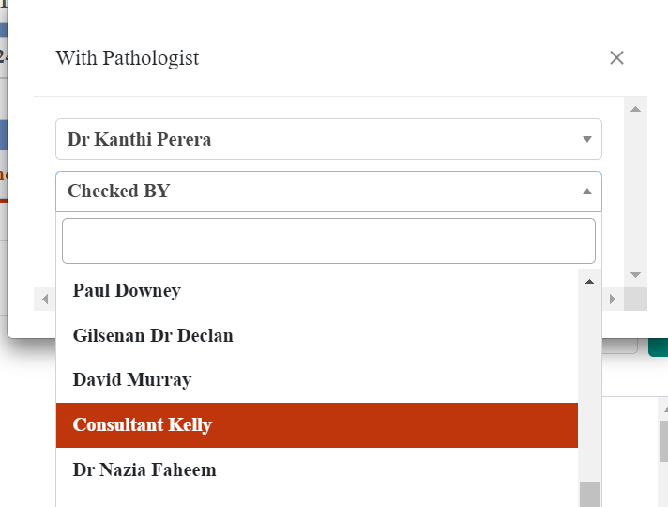

There is no need for this drop down (above)

The print preview does not appear to be working? (below)

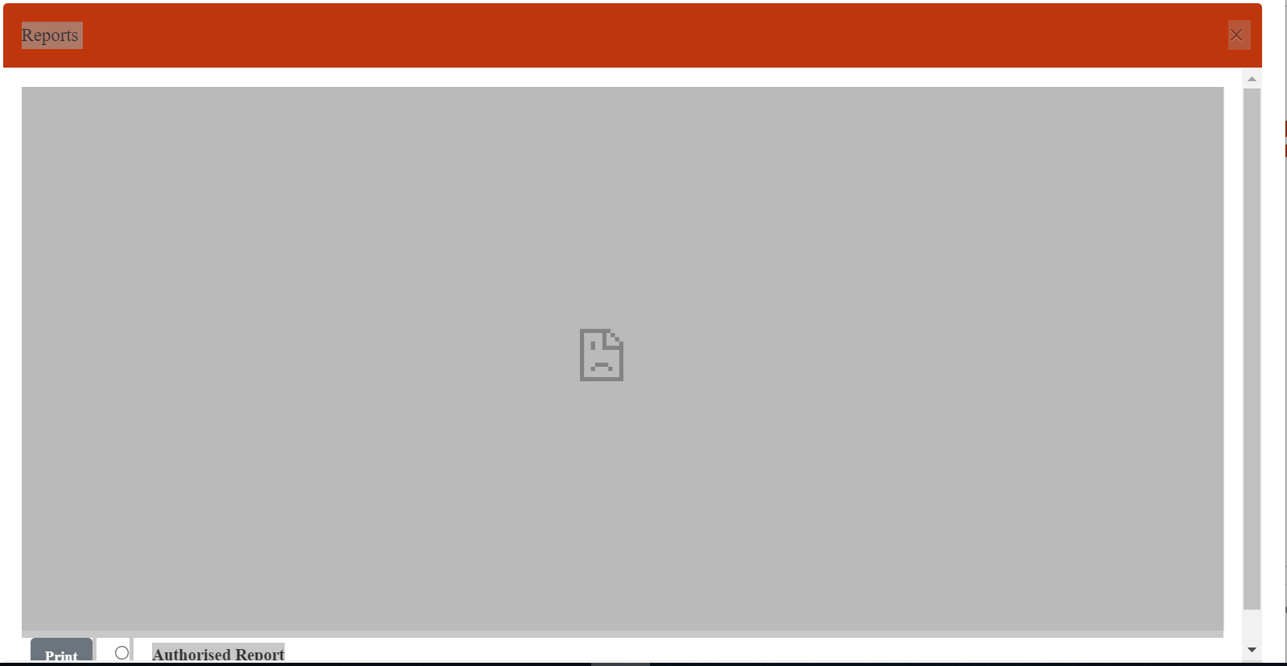

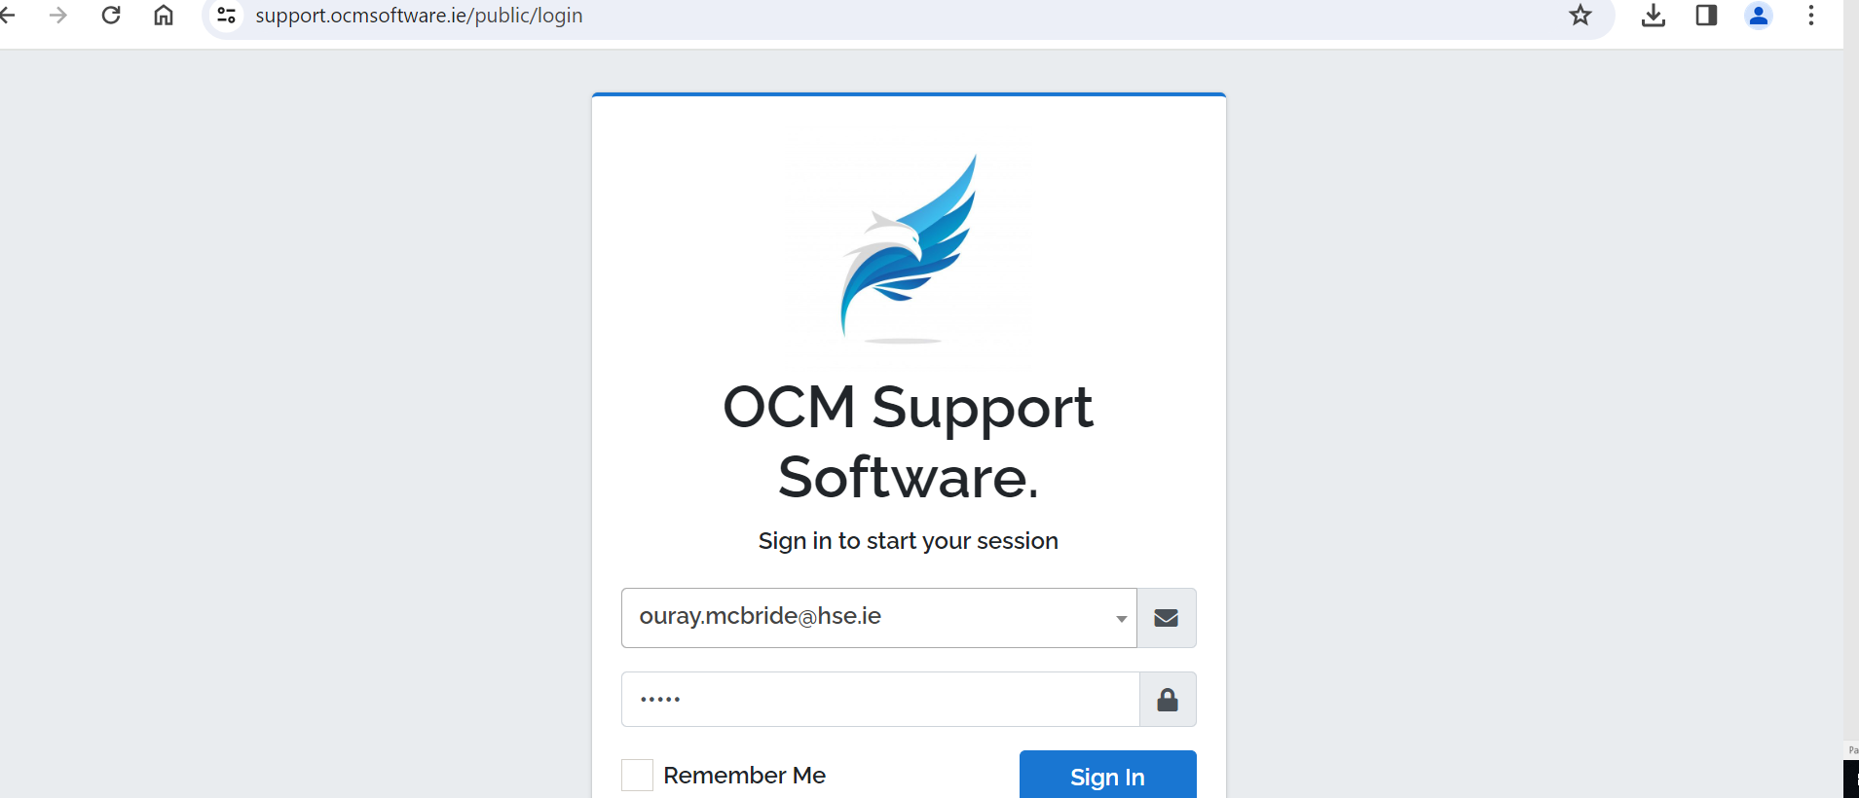

Can not accesss the ticketing system? Warning email or password is incorrect yellow box pops up in top left?

FACILITY SHOULD NOT BE INTERCHANGABLE?

The forward stroke (/) in case ID still present on the work list view S24-000/01

When you select With Pathologist to move case out of Histology Hala or Megan are not on the drop down list

We do not need the Checked By drop down when we select the pathologist

Print Preview was inaccessibe for both Naomi and cavan so we could not check if other features were functioning properly

Both Naomi and Cavan spent a lot of time trying to access the ticketing system to become familiar with it but could not gain access