**Microbiology LIMS Development-Report errors**

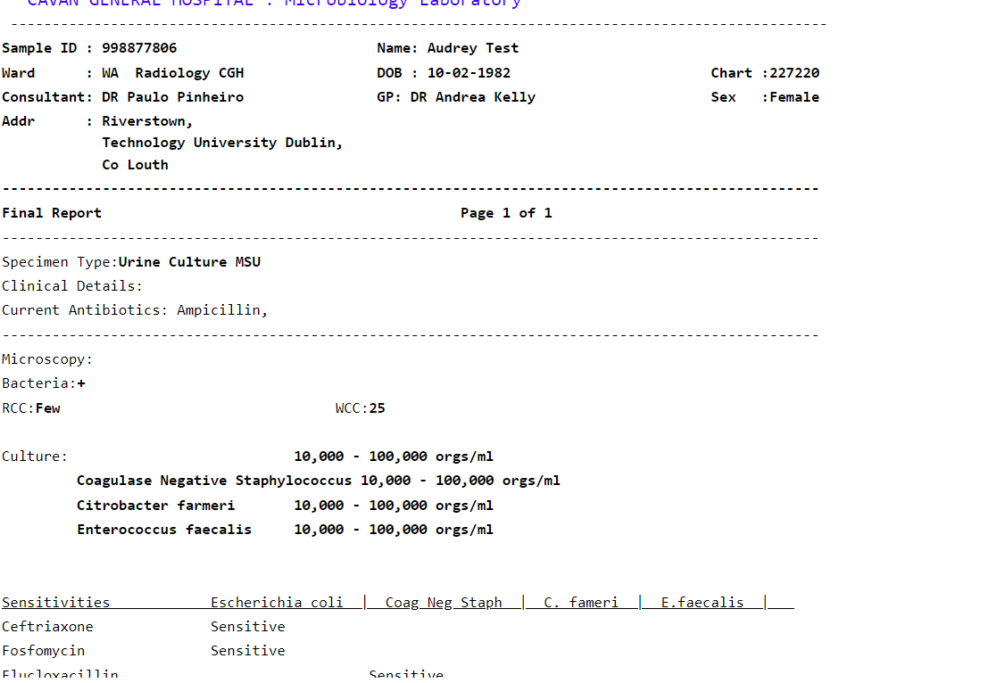

It is stating Final Report on interim reports

Sensitivities out of line for multiple isolates. d

Isolate 1 disappeared off report when additional isolates were entered

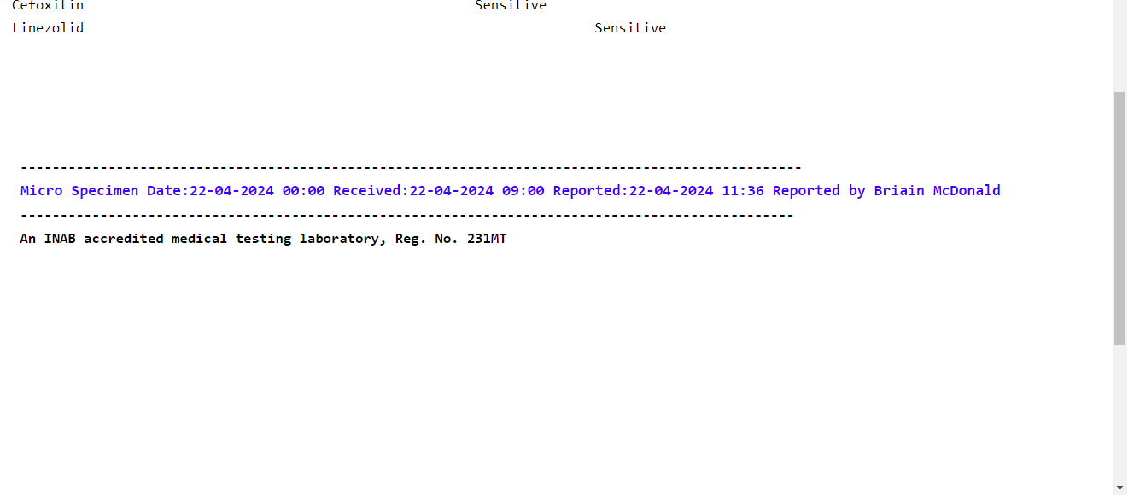

Medical scientist Comments and Consultant comments are missing from the report

Can we change the wording from ‘Specimen Type’ to