Entered case ID, then Chart number – these boxes appeared

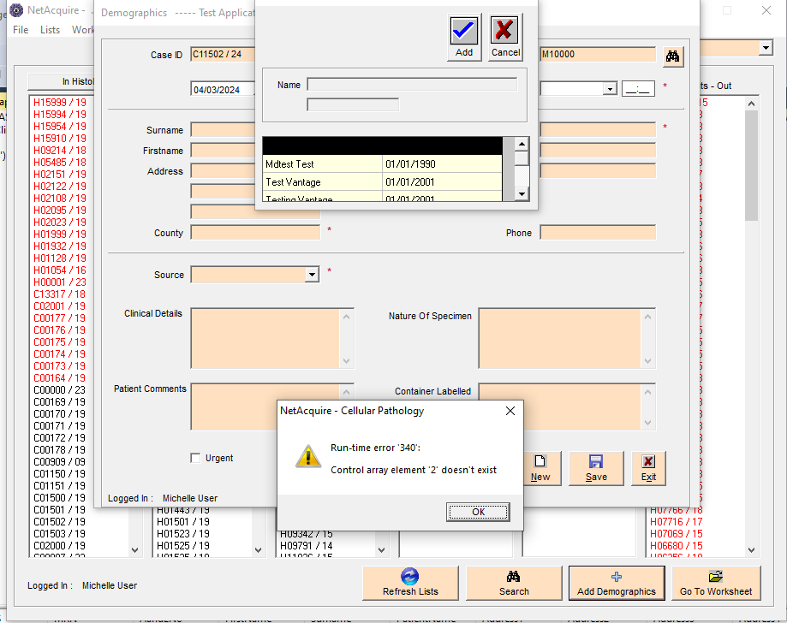

Click ok and the application closes

Tried again with different case ID and chart number

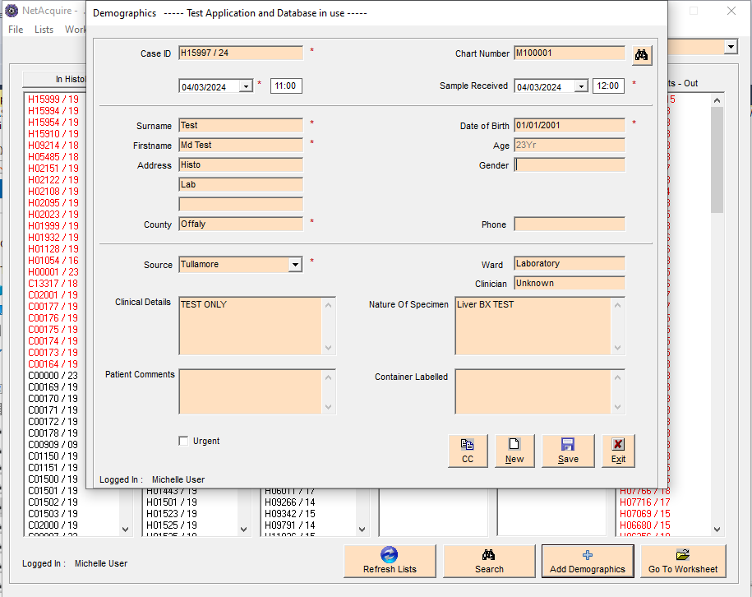

Allowed input details, gender field still does not allow entry – no option to choose from, not allowed to free text either

Allowed save without gender

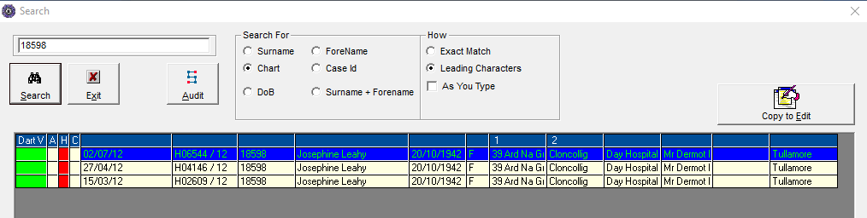

Added new number H17000/24, not showing recent more recent 2018 specimens only 2012.

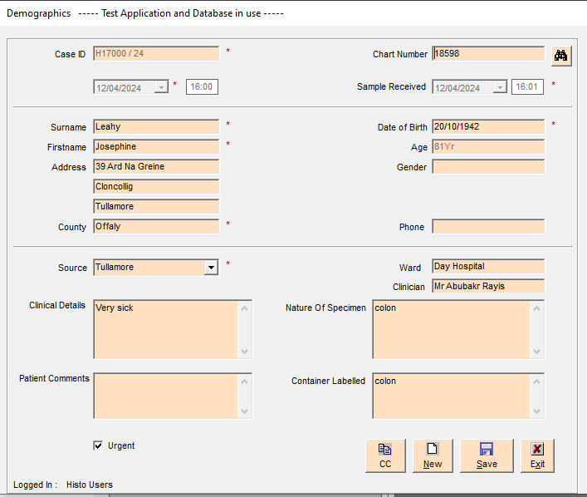

DEMOGRAPHICS OK.

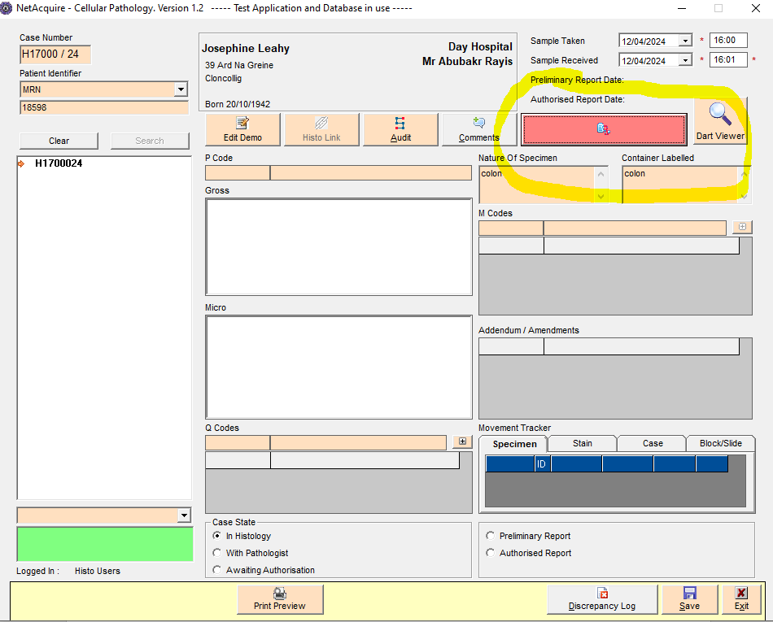

Highlighted box should be labelled clinical details

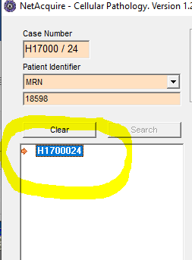

I should be able to right click on highlighted number and ass tissue type but nothing happens when I right click. I can’t proceed any further in booking in the case if I can’t add tissue type.