|  |  |  |  |
| --- | --- | --- | --- |
| 64f9d4699f904 | 23. When entering platelets into stock, alert appears requesting Kell status | Fail | Asking for Kell status for platelet products |

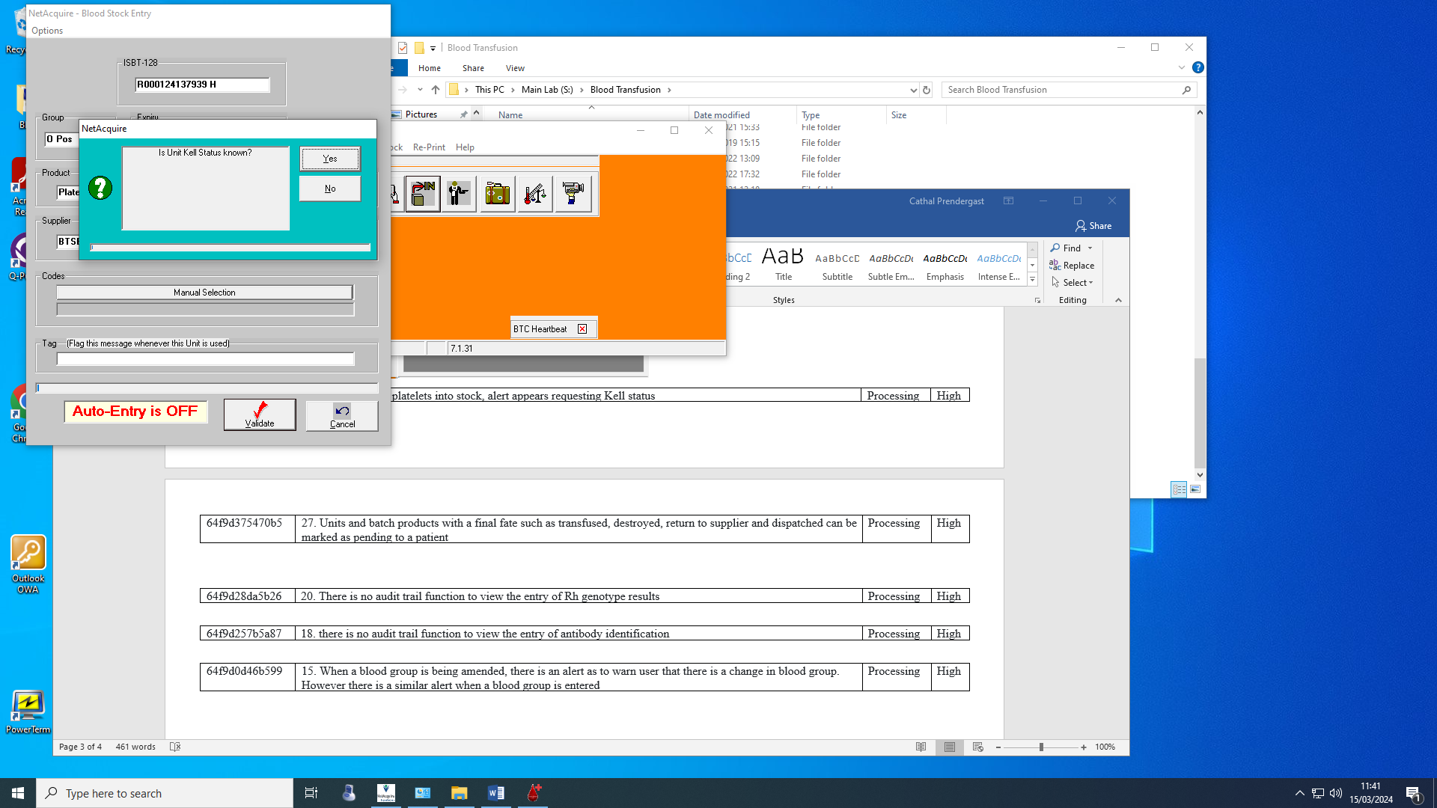

To apply to all products below

|  |  |  |
| --- | --- | --- |
| **Wording** | **BarCode** | **Generic** |
| Platelets Pooled Leucocyte Depleted | 12769 | Platelets |
| Platelets Pooled in Plasma/PAS LD | 54232 | Platelets |
| Platelets Apheresis | 12035 | Platelets |
| Platelet Pooled Leucodepleted Washed | 12679 | Platelets |
| Platelet Pool LD S3 | 12803 | Platelets |
| Platelet Pool LD S2 | 12802 | Platelets |
| Platelet Pool LD S1 | 12801 | Platelets |
| Platelet Pool in Plas/PAS LD Ext Life | 54477 | Platelets |
| Platelet APH Leucocyte Depleted | 12030 | Platelets |
| Platelet APH LD Washed S3 | 12942 | Platelets |
| Platelet APH LD Washed S2 | 12941 | Platelets |
| Platelet APH LD Washed S1 | 12940 | Platelets |
| Platelet APH LD Washed | 12033 | Platelets |
| Platelet APH LD S3 | 58342 | Platelets |
| Platelet APH LD S2 | 58341 | Platelets |
| Platelet APH LD S1 | 58340 | Platelets |
| Platelet APH LD EXT Life S3 | 54291 | Platelets |
| Platelet APH LD EXT Life S2 | 54290 | Platelets |
| Platelet APH LD Ext Life S1 | 54289 | Platelets |
| Platelet APH LD Ext Life | 54288 | Platelets |
| Platelet APH in Plasma/PAS LD | 54231 | Platelets |
| Pooled Platelets (leucocyte depleted) | 0127693 | Platelets |
| Platelet Concentrate Extended Life | 128 | Platelets |
| Pooled Platelets. Filtered/Washed | 12759 | Platelets |
| Platelet Concentrate. Store at 22C | 12050 | Platelets |
| Platelet Apheresis Leuco Depleted | A0583423B | Platelets |
| Pooled Platelets | 12669 | Platelets |
| Platelet Rich Plasma | 171 | Platelets |
| Platelet APH LD NNU S2 | 58236 | Platelets |
| PLATELET APH LD EXT LIFE FOR NNU | 54388 | Platelets |
| PLATELET APH LD EXT LIFE FOR NNU S1 | 54389 | Platelets |
| PLATELET APH LD EXT LIFE FOR NNU S2 | 54390 | Platelets |
| PLATELET APH LD EXT LIFE FOR NNU S3 | 54391 | Platelets |
| PLATELET APH LD NNU S1 | 58235 | Platelets |
| PLATELET APH LD NNU S3 | 58237 | Platelets |
| PLATELET APH LD NNU | 58238 | Platelets |
| PLATELET APH LD PLASMA REDUCED NNU | 50870 | Platelets |
| PLATELET APH LD PLASMA REDUCED NNU S1 | 50871 | Platelets |
| PLATELET APH LD PLASMA REDUCED NNU S2 | 50872 | Platelets |
| Platelets, Adult Dose, Irradiated | E3929V00 | Platelets |
| Platelets, Adult Dose, Irradiated, Split 1 | E3929VA0 | Platelets |
| Platelets, Adult Dose, Irradiated, Split 2 | E3929VB0 | Platelets |
| Platelets, Adult Dose, Irradiated, Split 3 | E3929VC0 | Platelets |
| Platelets, Adult Dose, Irradiated | E7716V00 | Platelets |
| Platelets, Adult Dose, Irradiated, Split 1 | E7716VA0 | Platelets |
| Platelets, Adult Dose, Irradiated, Split 2 | E7716VB0 | Platelets |
| Platelets, Adult Dose, Irradiated, Split 3 | E7716VC0 | Platelets |
| Platelets, Adult Dose, Washed, Irradiated | E6667V00 | Platelets |
| Platelets, Adult Dose, Washed, Irradiated, Split 1 | E6667VA0 | Platelets |
| Platelets, Adult Dose, Washed, Irradiated, Split 2 | E6667VB0 | Platelets |
| Platelets, Adult Dose, Washed, Irradiated, Split 3 | E6667VC0 | Platelets |
| Platelets, Adult Dose, Suitable for Neonatal Use, Irradiated | C3929V00 | Platelets |
| Platelets, Adult Dose, Suitable for Neonatal Use, Irradiated, Split 1 | C3929VA0 | Platelets |
| Platelets, Adult Dose, Suitable for Neonatal Use, Irradiated, Split 2 | C3929VB0 | Platelets |
| Platelets, Adult Dose, Suitable for Neonatal Use, Irradiated, Split 3 | C3929VC0 | Platelets |
| Platelets, Adult Dose, Suitable for Neonatal Use, Irradiated | C7716V00 | Platelets |
| Platelets, Adult Dose, Suitable for Neonatal Use, Irradiated, Split 1 | C7716VA0 | Platelets |
| Platelets, Adult Dose, Suitable for Neonatal Use, Irradiated, Split 2 | C7716VB0 | Platelets |
| Platelets, Adult Dose, Suitable for Neonatal Use, Irradiated. Split 3 | C7716VC0 | Platelets |
| Platelets, Adult Dose, Suitable for Neonatal Use, Washed, Irradiated | C6667V00 | Platelets |
| Platelets, Adult Dose, Suitable for Neonatal Use, Washed, Irradiated, Split 1 | C6667VA0 | Platelets |
| Platelets, Adult Dose, Suitable for Neonatal Use, Washed, Irradiated, Split 2 | C6667VB0 | Platelets |
| Platelets, Adult Dose, Suitable for Neonatal Use, Washed, Irradiated, Split 3 | C6667VC0 | Platelets |
| Platelets, Hyperconcentrated, Suitable for Neonatal Use, Irradiated | C9310V00 | Platelets |
| Platelets, Hyperconcentrated, Suitable for Neonatal Use, Irradiated, Split 1 | C9310VA0 | Platelets |
| Platelets, Hyperconcentrated, Suitable for Neonatal Use, Irradiated, Split 2 | C9310VB0 | Platelets |
| Platelets, Hyperconcentrated, Suitable for Neonatal Use, Irradiated, Split 3 | C9310VC0 | Platelets |
| Platelets, Paediatric Dose, Suitable for Neonatal Use, Irradiated, Split 1 | C3929VAa | Platelets |
| Platelets, Paediatric Dose, Irradiated, Split 1 | E3929VAa | Platelets |
| Platelets, Paediatric Dose, Irradiated, Split 1 | E3929VBa | Platelets |
| Platelets, Paediatric Dose, Irradiated, Split 1 | E3929VCa | Platelets |
| Platelets, Paediatric Dose, Suitable for Neonatal Use, Irradiated, Split 1 | C3929VAa | Platelets |
| Platelets, Paediatric Dose, Suitable for Neonatal Use, Irradiated, Split 1 | C3929VBa | Platelets |
| Platelets, Paediatric Dose, Suitable for Neonatal Use, Irradiated, Split 1 | C3929VCa | Platelets |
| Platelets, Adult Dose with Plasma/PAS, Irradiated | E6953V00 | Platelets |
| Platelets, Adult Dose with Plasma/PAS, Irradiated | E6645V00 | Platelets |
| Platelets, Adult Dose with Plasma/PAS, Washed, Irradiated | E7546V00 | Platelets |