Proposed new look of CSF Microscopy Report

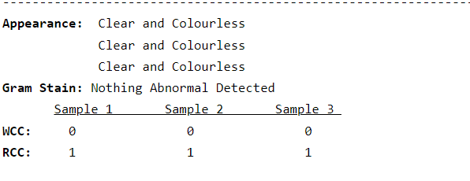

**APPEARANCE: Clear & Colourless Clear & Colourless Clear & Colourless**