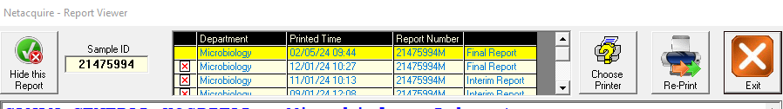

If we unclick any of the red x’s and click on the report we can see the previous report and we have the ability re-hide subsequently