It is under Lists, Locations, Gps

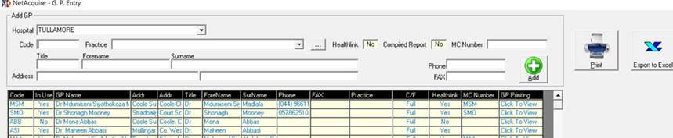

Clink on Click to View under GP Printing to supress printing per discipline

