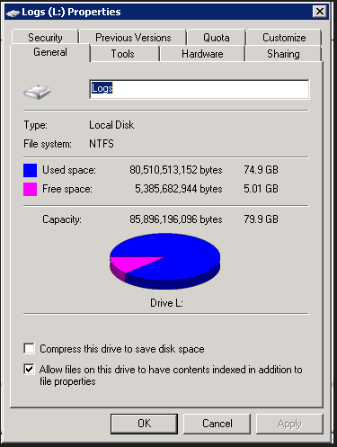

Increased by 20GB 13 May 24

Drive following downtime on 20 May 24

