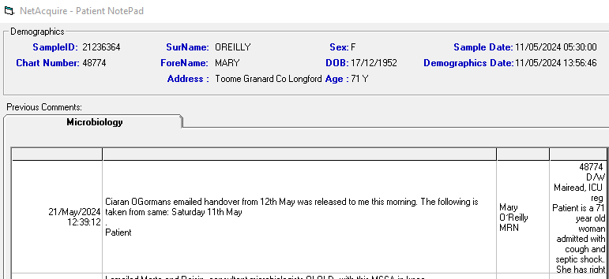

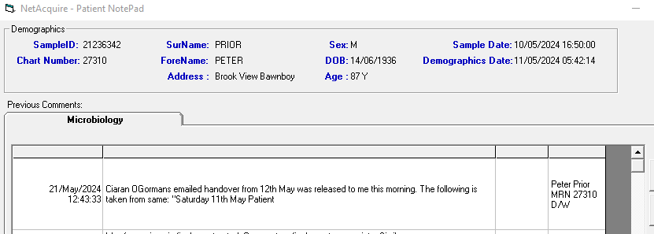

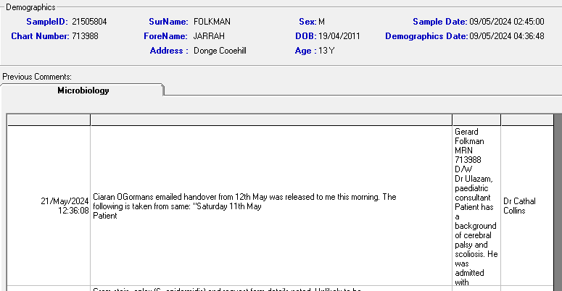

**From:** Cathal Collins   
**Sent:** 21 May 2024 12:34  
**To:** Ken Gregg <[Ken.Gregg@hse.ie](mailto:Ken.Gregg@hse.ie)>; CarmelT Maguire <[CarmelT.Maguire@hse.ie](mailto:CarmelT.Maguire@hse.ie)>  
**Cc:** Elizabeth Trautt <[Elizabeth.Trautt@hse.ie](mailto:Elizabeth.Trautt@hse.ie)>  
**Subject:** RE: Patient notepad issue  
**Sensitivity:** Confidential

Hi Ken,

It looks like the previous fix hasn’t sorted the issue detailed in this email trail- please see screenshot of a notepad entry from today.

Would it be possible to review as soon as possible please?

Kind Regards,

Cathal

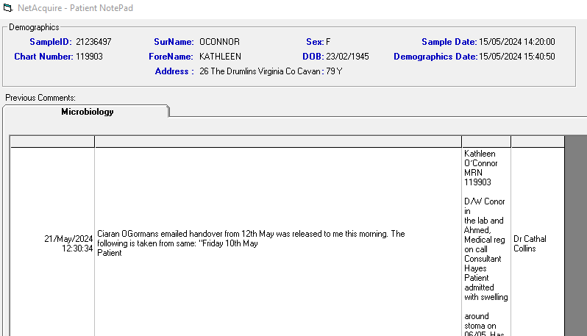

**From:** Cathal Collins   
**Sent:** 09 April 2024 14:40  
**To:** Ken Gregg <[Ken.Gregg@hse.ie](mailto:Ken.Gregg@hse.ie)>; CarmelT Maguire <[CarmelT.Maguire@hse.ie](mailto:CarmelT.Maguire@hse.ie)>  
**Cc:** Elizabeth Trautt <[Elizabeth.Trautt@hse.ie](mailto:Elizabeth.Trautt@hse.ie)>  
**Subject:** RE: Patient notepad issue  
**Sensitivity:** Confidential

Thanks Ken, that’s great.

Kind Regards,

Cathal

**From:** Ken Gregg <[Ken.Gregg@hse.ie](mailto:Ken.Gregg@hse.ie)>   
**Sent:** 05 April 2024 09:49  
**To:** Cathal Collins <[Cathal.Collins@hse.ie](mailto:Cathal.Collins@hse.ie)>; CarmelT Maguire <[CarmelT.Maguire@hse.ie](mailto:CarmelT.Maguire@hse.ie)>  
**Cc:** Elizabeth Trautt <[Elizabeth.Trautt@hse.ie](mailto:Elizabeth.Trautt@hse.ie)>  
**Subject:** RE: Patient notepad issue  
**Sensitivity:** Confidential

Hi Cathal

This is now fixed

K

Ken Gregg FIBMS FACSLM DMLM

Laboratory IT Manager

Cavan General Hospital

Cavan

Co Cavan

Office 049 437 6416

Mobile 0044 7802 566338

**From:** Cathal Collins <[Cathal.Collins@hse.ie](mailto:Cathal.Collins@hse.ie)>   
**Sent:** Wednesday 20 March 2024 10:25  
**To:** Ken Gregg <[Ken.Gregg@hse.ie](mailto:Ken.Gregg@hse.ie)>; CarmelT Maguire <[CarmelT.Maguire@hse.ie](mailto:CarmelT.Maguire@hse.ie)>  
**Cc:** Elizabeth Trautt <[Elizabeth.Trautt@hse.ie](mailto:Elizabeth.Trautt@hse.ie)>  
**Subject:** RE: Patient notepad issue  
**Sensitivity:** Confidential

Thanks Ken, that’s great. Please let me know when it has been done.

Kind Regards,

Cathal

**From:** Ken Gregg <[Ken.Gregg@hse.ie](mailto:Ken.Gregg@hse.ie)>   
**Sent:** 20 March 2024 10:24  
**To:** Cathal Collins <[Cathal.Collins@hse.ie](mailto:Cathal.Collins@hse.ie)>; CarmelT Maguire <[CarmelT.Maguire@hse.ie](mailto:CarmelT.Maguire@hse.ie)>  
**Cc:** Elizabeth Trautt <[Elizabeth.Trautt@hse.ie](mailto:Elizabeth.Trautt@hse.ie)>  
**Subject:** RE: Patient notepad issue  
**Sensitivity:** Confidential

Hi Cathal

Yes there has been progress, just waiting on an upgrade to the Netacquire exe to be shared with me so it can be installed.

Kind regards

Ken

Ken Gregg FIBMS FACSLM DMLM

Laboratory IT Manager

Cavan General Hospital

Cavan

Co Cavan

Office 049 437 6416

Mobile 0044 7802 566338

**From:** Cathal Collins <[Cathal.Collins@hse.ie](mailto:Cathal.Collins@hse.ie)>   
**Sent:** Wednesday 20 March 2024 10:23  
**To:** Ken Gregg <[Ken.Gregg@hse.ie](mailto:Ken.Gregg@hse.ie)>; CarmelT Maguire <[CarmelT.Maguire@hse.ie](mailto:CarmelT.Maguire@hse.ie)>  
**Cc:** Elizabeth Trautt <[Elizabeth.Trautt@hse.ie](mailto:Elizabeth.Trautt@hse.ie)>  
**Subject:** RE: Patient notepad issue  
**Sensitivity:** Confidential

Hi Ken,

Has there been any update on this issue? It’s happened again- please see screenshot below.

Kind Regards,

Cathal

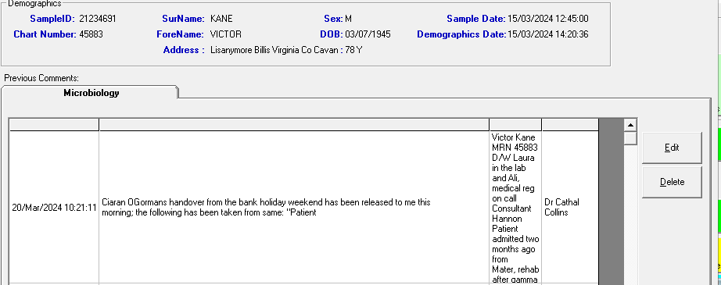

**From:** Cathal Collins   
**Sent:** 15 March 2024 10:07  
**To:** Ken Gregg <[Ken.Gregg@hse.ie](mailto:Ken.Gregg@hse.ie)>; CarmelT Maguire <[CarmelT.Maguire@hse.ie](mailto:CarmelT.Maguire@hse.ie)>  
**Cc:** Elizabeth Trautt <[Elizabeth.Trautt@hse.ie](mailto:Elizabeth.Trautt@hse.ie)>  
**Subject:** RE: Patient notepad issue  
**Sensitivity:** Confidential

Thanks for that Ken, much appreciated.

Kind Regards,

Cathal

**From:** Ken Gregg <[Ken.Gregg@hse.ie](mailto:Ken.Gregg@hse.ie)>   
**Sent:** 15 March 2024 10:03  
**To:** Cathal Collins <[Cathal.Collins@hse.ie](mailto:Cathal.Collins@hse.ie)>; CarmelT Maguire <[CarmelT.Maguire@hse.ie](mailto:CarmelT.Maguire@hse.ie)>  
**Cc:** Elizabeth Trautt <[Elizabeth.Trautt@hse.ie](mailto:Elizabeth.Trautt@hse.ie)>  
**Subject:** RE: Patient notepad issue  
**Sensitivity:** Confidential

Good Morning Cathal

I have looked at this and everything is stored correctly in the database so I believe that there must be a control character that I cannot see affecting that particular entry and pushing the information into the next field. I have referred this to the Netacquire team for their comments.  Should you find another example of this please let me know as it will help with the investigation.

Kind regards

Ken

Ken Gregg FIBMS FACSLM DMLM

Laboratory IT Manager

Cavan General Hospital

Cavan

Co Cavan

Office 049 437 6416

Mobile 0044 7802 566338

**From:** Cathal Collins <[Cathal.Collins@hse.ie](mailto:Cathal.Collins@hse.ie)>   
**Sent:** Thursday 14 March 2024 23:50  
**To:** Ken Gregg <[Ken.Gregg@hse.ie](mailto:Ken.Gregg@hse.ie)>; CarmelT Maguire <[CarmelT.Maguire@hse.ie](mailto:CarmelT.Maguire@hse.ie)>  
**Cc:** Elizabeth Trautt <[Elizabeth.Trautt@hse.ie](mailto:Elizabeth.Trautt@hse.ie)>  
**Subject:** Patient notepad issue  
**Sensitivity:** Confidential

Hi Ken, Carmel,

Please see the screenshots below.

In the first one, part of the commentary text is populating the 2nd column from the right (it normally only contains my name when I enter the note) and my name has moved to the last column on the right (it normally contains the accession number which the note has been applied to). I clicked on the ‘edit’ tab to see what the commentary text looked like but most of the text seems to have been lost (the second screenshot).

It’s very strange. Could you look into it please?

Kind Regards,

Cathal

