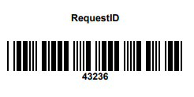

Department of Clinical & Laboratory Sciences

Cavan General Hospital,

Lisdaran, Cavan H12 Y7W1

+353 (49) 4376293

Hospital/HSE logo

**Pathology Request Form**

**Patient Name:** Harkin Pauline **MRN:** 23610

**DOB:** 07-02-1964

**Gender**: Female

**Address:** Line 1,

Line 2,

Line 3

Dear Phlebotomist,

Please arrange for the following tests for this patient who is attending DR Saeed Khilji.

**Notes. If the user puts in a message, place it here**

Kind regards

Person name that placed blood request

|  |  |
| --- | --- |
| Tick if sample collected □ | Tick if sample collected □ |
| Tick if sample collected □ | Tick if sample collected □ |
| Tick if sample collected □ | Tick if sample collected □ |

LF-OCM-xxxxx Ed 1

**NB** Sample must be labelled with Full name, DOB MRN & date

Date Sample Collected:________________

Time Sample collected:________________

Patient fasting yes □No□

Collected by:_____________________