FBC processed and results transmitted to LIS correctly

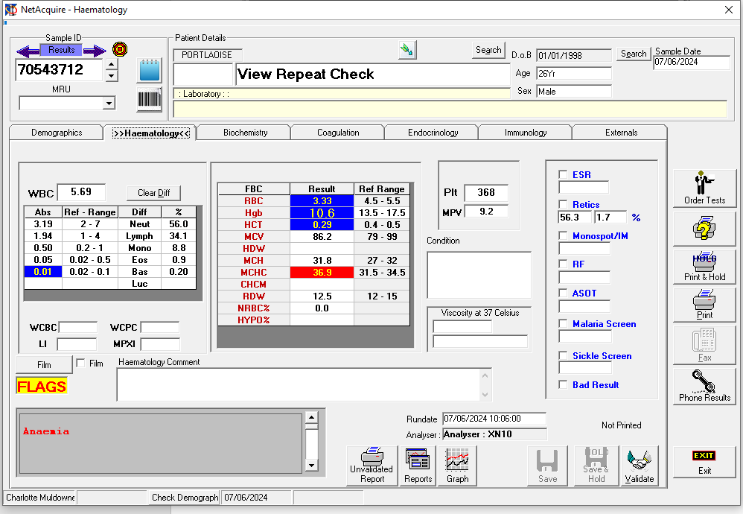

An ESR was then processed and the result correctly transmitted to LIS.

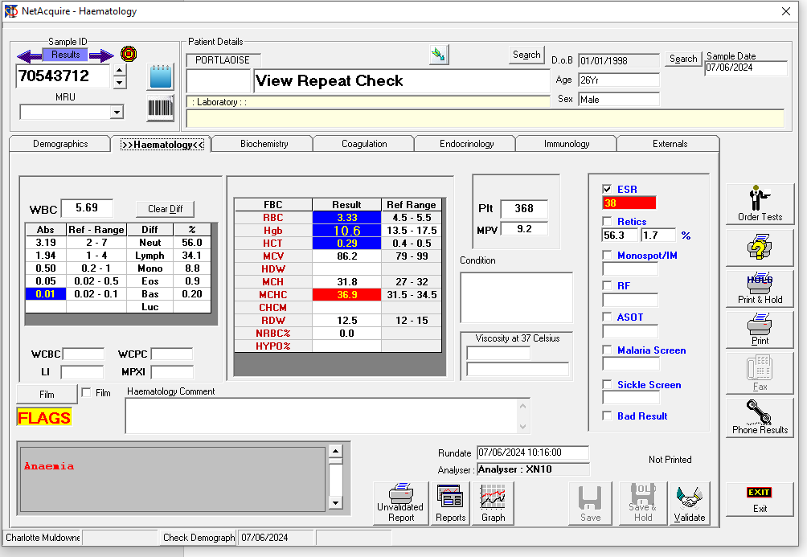

The ESR was then rerun and the ‘View Repeat’ icon is active indicating that there is a repeat result available.

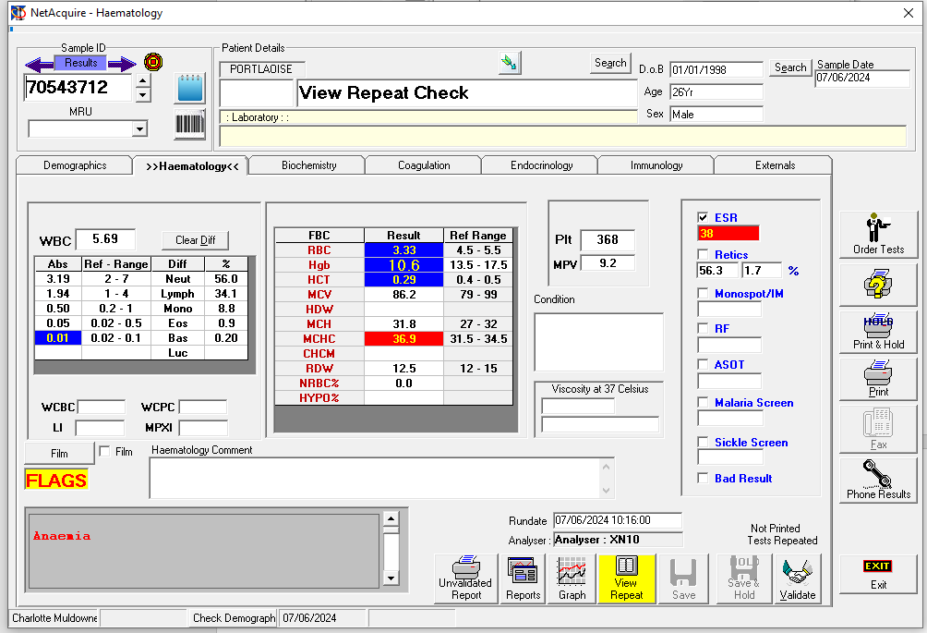

Selected ‘View Repeat’ Icon. Can see the initial and rerun ESR results correctly.

Note: I have raised a ticket 07/06/2024 to get the FBC and ESR results on separate lines as the ESR is not processed on the same analyser as the FBC.

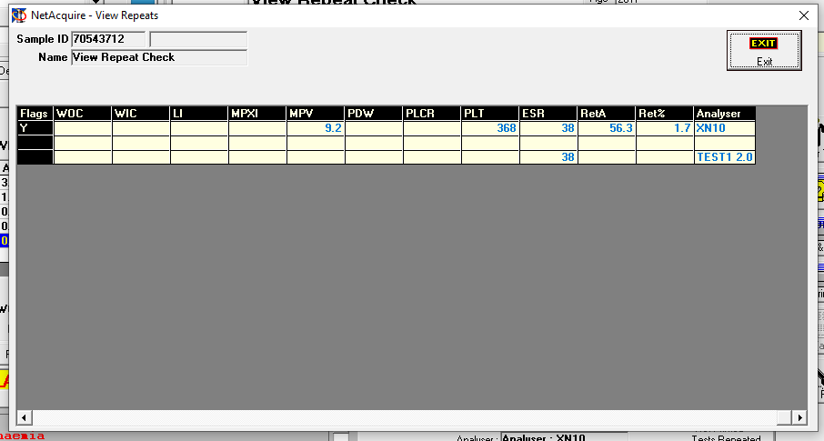

Highlighted the rerun ESR result

Selected ‘ESR’ and ‘Swap Haematology Results’

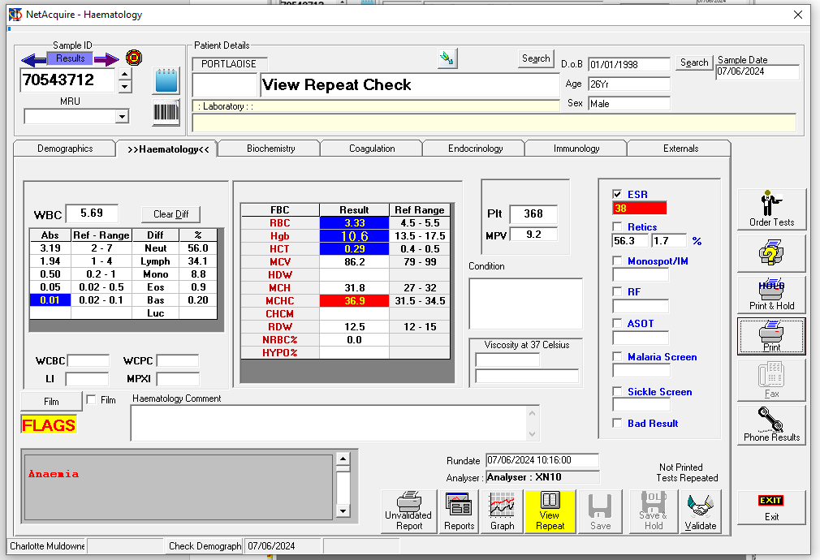

Note**: Problem** Result did not swap in as it should have.

Tried again by selecting the ‘view repeat’ icon

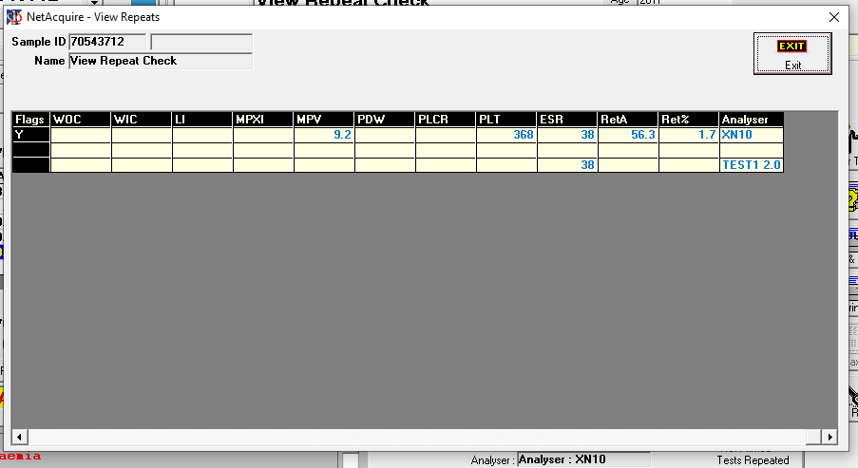

Highlighted the rerun ESR result again.

Selected ‘ESR’ and ‘FBC’ and ‘Swap Haematology Results’

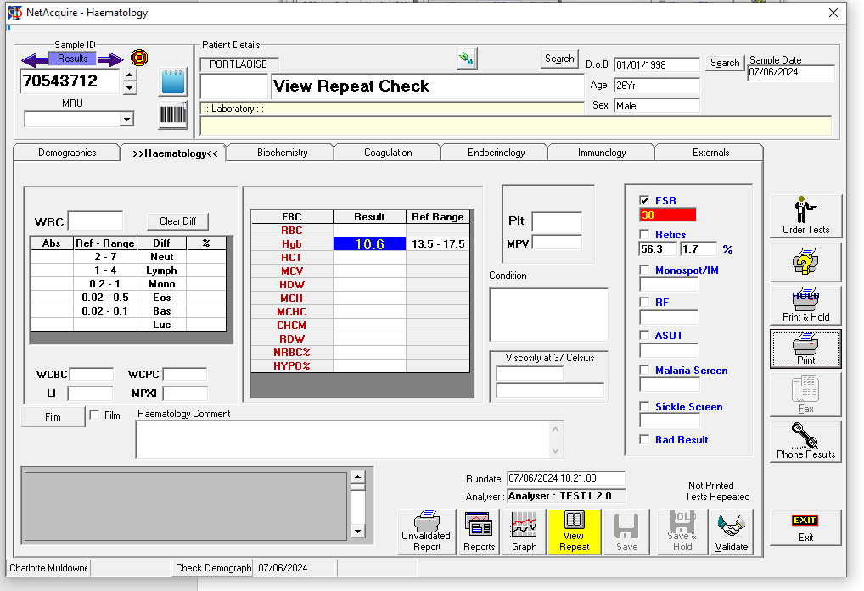

Note: **Problem** HB, Retics and ESR swapped in even though there was no FBC to swap

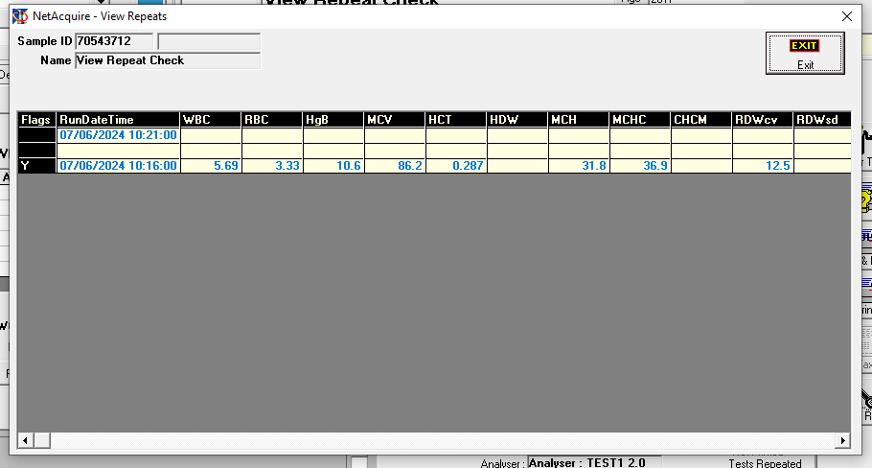

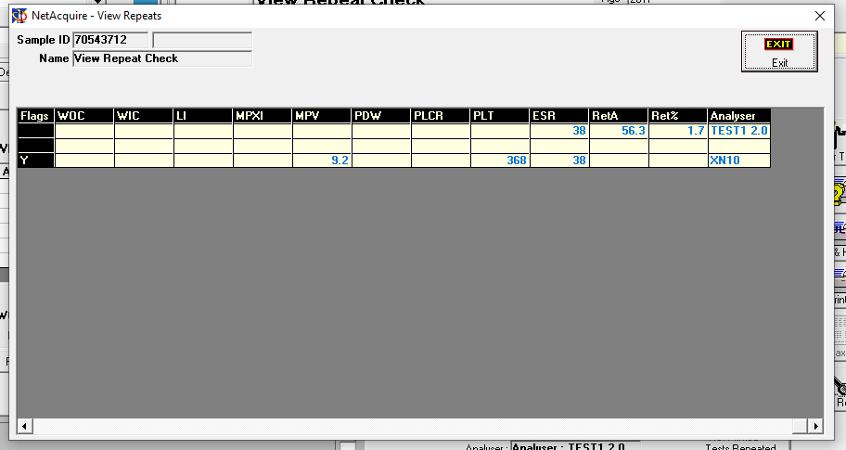

Reran ESR

‘Exit’ NA screen and reentered

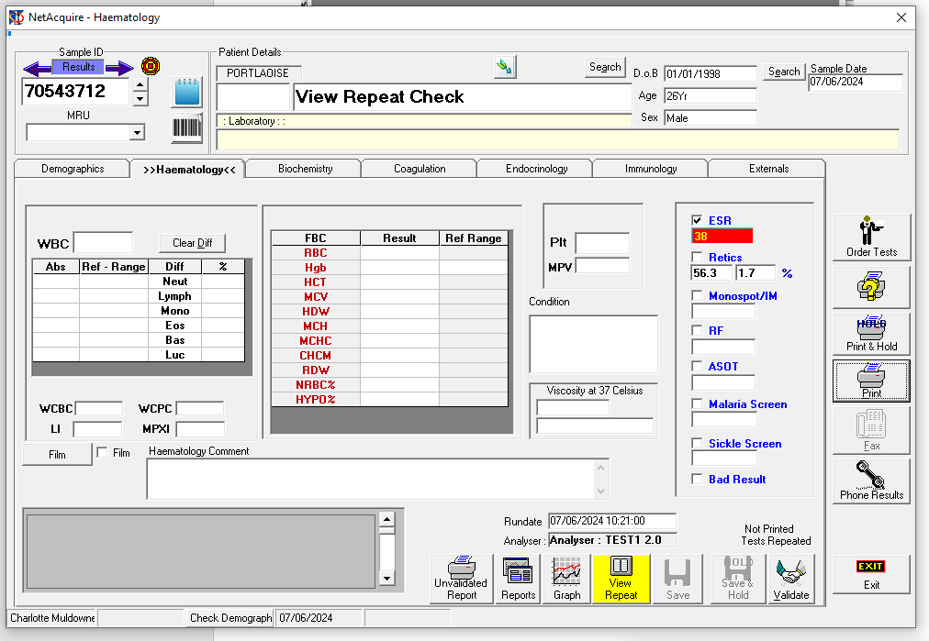

Note: The HB is now not visible.

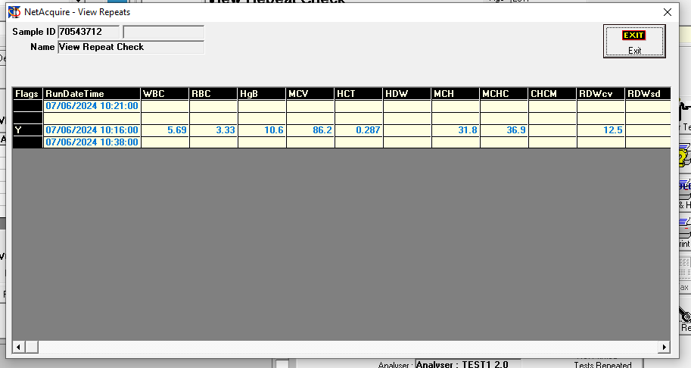

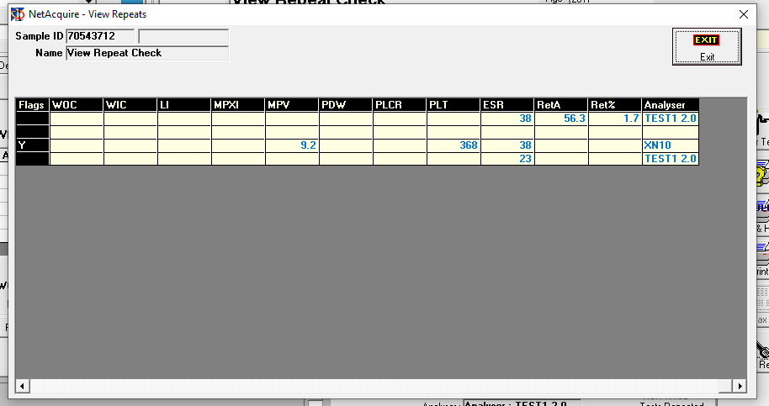

Selected ‘ESR’ and ‘Swap Haematology Results’

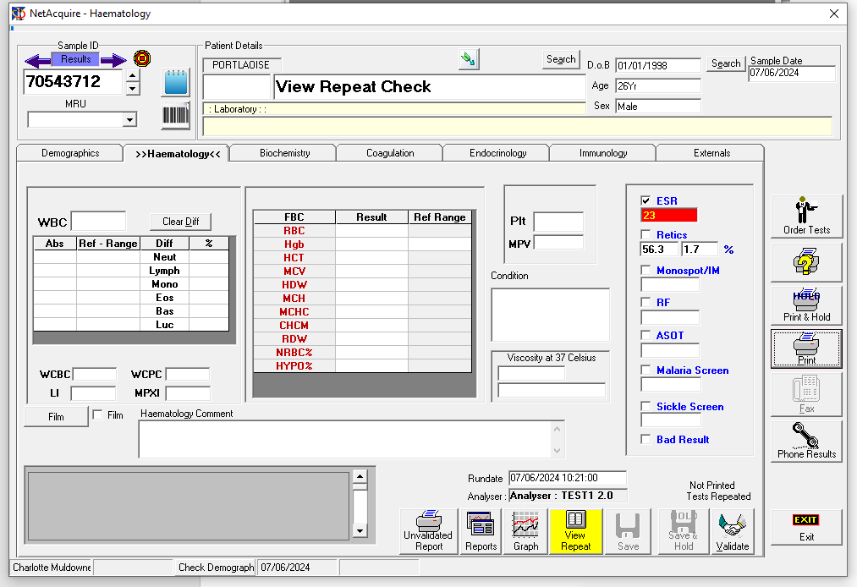

Note ESR swapped but Retic results remained.