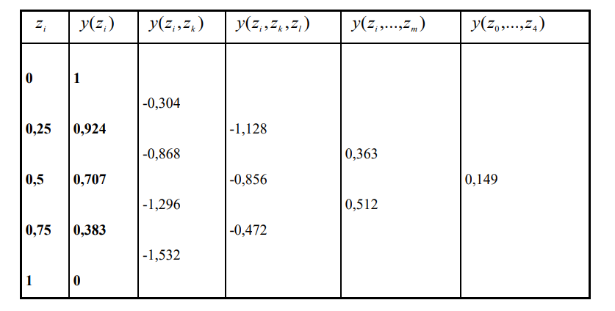

|  |  |  |  |  |  |
| --- | --- | --- | --- | --- | --- |
| 0 | 1 | -0.304 | -1.128 | 0,363 | 0,149 |
| 0,25 | 0.924 | -0.868 | -0,856 | 0,512 |  |
| 0,5 | 0.707 | -1.296 | -0,472 |  |  |
| 0,75 | 0.383 | -1.532 |  |  |  |
| 1 | 0 |  |  |  |  |