- ECE569- Setting Up HPC Accounts
We will start with setting up your HPC accounts and basic file transfer information. Main source for hpc access information:
https://hpcdocs.hpc.arizona.edu/

Please go over the following pages to learn about the HPC system, logging in, data transfers, running jobs and compute resources available to you.

https://hpcdocs.hpc.arizona.edu/quick_start/overview/

https://hpcdocs.hpc.arizona.edu/quick_start/what_is_hpc/

https://hpcdocs.hpc.arizona.edu/quick_start/common_misconceptions/

https://hpcdocs.hpc.arizona.edu/quick_start/logging_in/

https://hpcdocs.hpc.arizona.edu/quick_start/storage_and_transfers/

https://hpcdocs.hpc.arizona.edu/quick_start/accessing_compute/#interactive-jobs

https://hpcdocs.hpc.arizona.edu/resources/compute_resources/

Account creation:
Use the following link and follow the two step process
https://hpcdocs.hpc.arizona.edu/registration_and_access/account_creation/

After setting up your account
Accessing the system and transferring files:
https://uarizona.atlassian.net/wiki/spaces/UAHPC/pages/75990560/System+Access

Please read the instructions carefully. HPC systems require 2-factor authentication.
Go over the following three topics carefully: Accessing Software, Transferring Files, Running Jobs

- Transferring files:
https://hpcdocs.hpc.arizona.edu/storage_and_transfers/transfers/overview/
Install the ones that work for you. I use WinSCP.

In WinSCP:
Use host name: sftp.hpc.arizona.edu and login with your netid.
You can drag and drop files and folders in WinSCP.
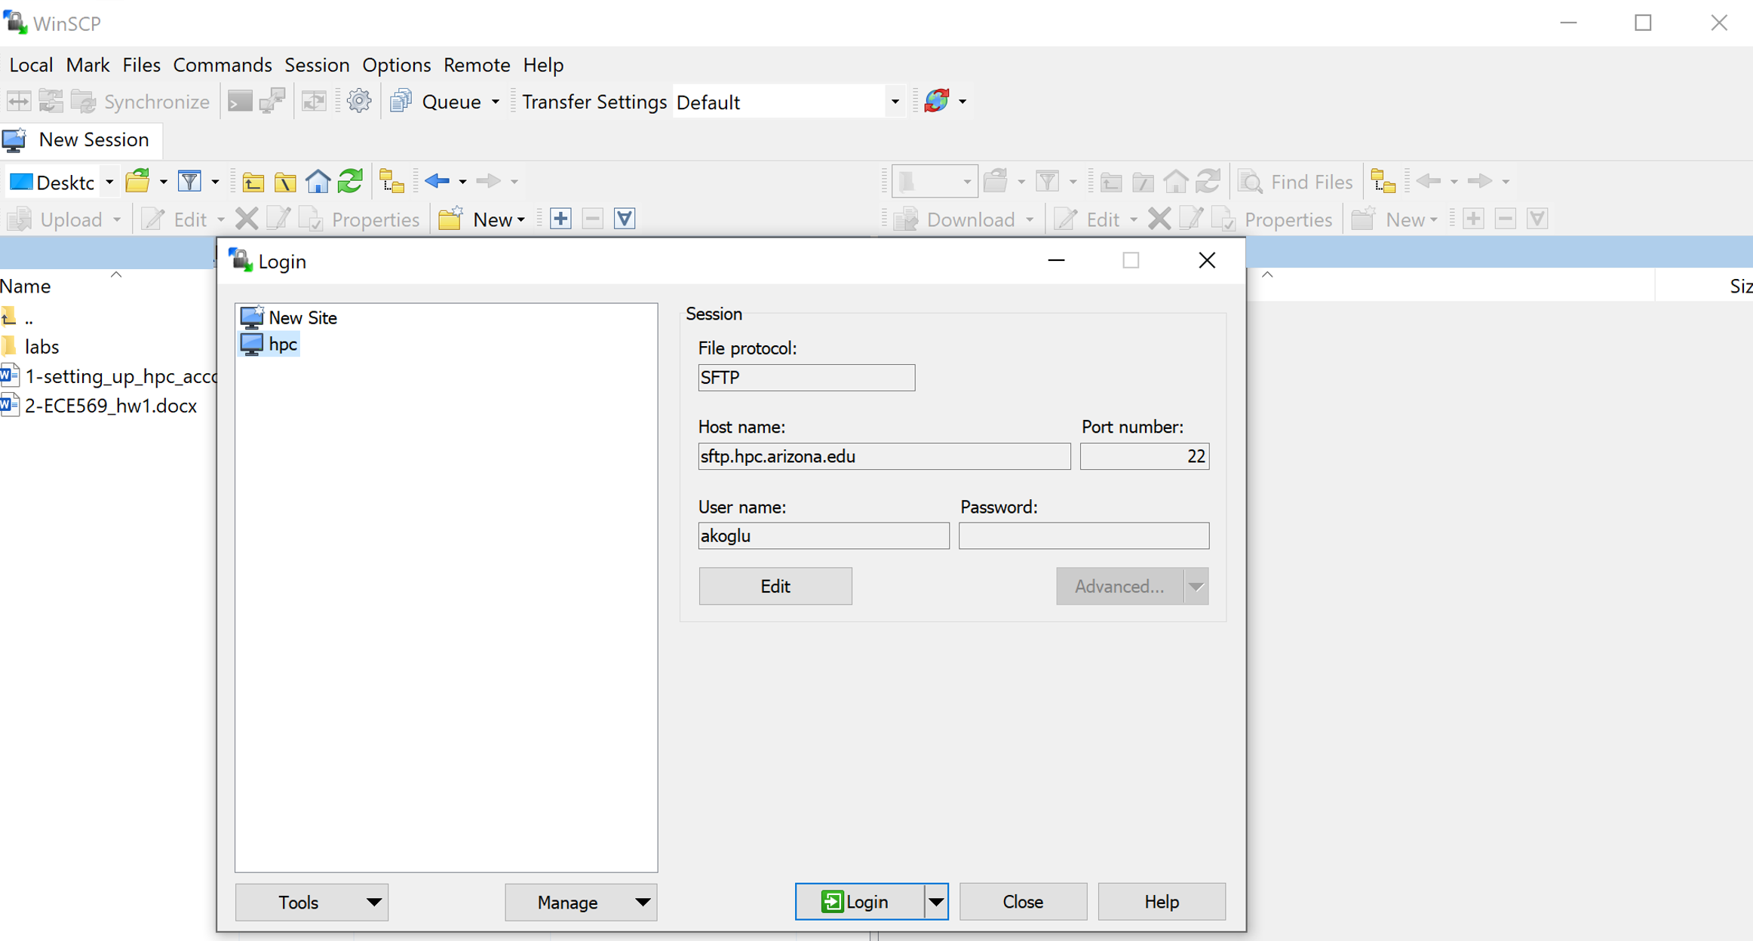
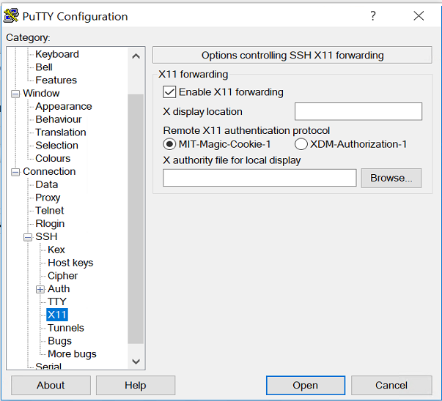
if you are using putty, first login to hpc.arizona.edu
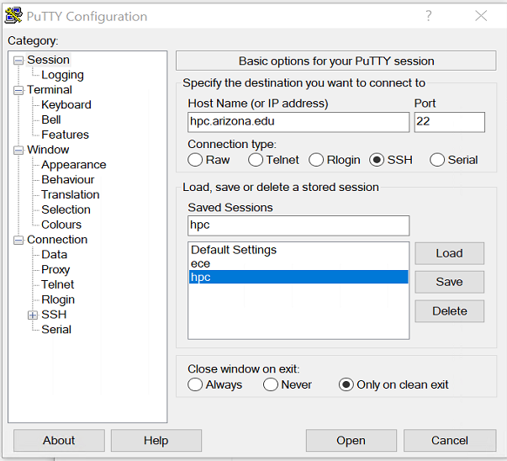
Make sure to enable X11 if you are going to use Xserver
- Accessing Ocelote
First read the info at:
https://hpcdocs.hpc.arizona.edu/registration_and_access/system_access/#command-line-access

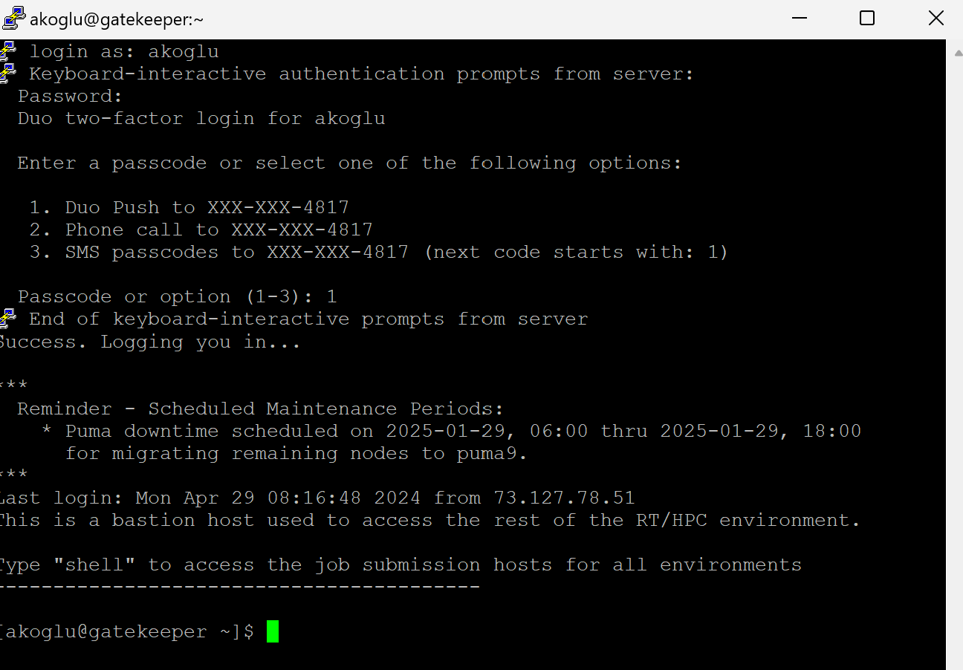
When you login to hpc.arizona.edu you will be at the frontend (“netid@gatekeeper”).
Type "shell" to access the job submission hosts for all environments
$shell
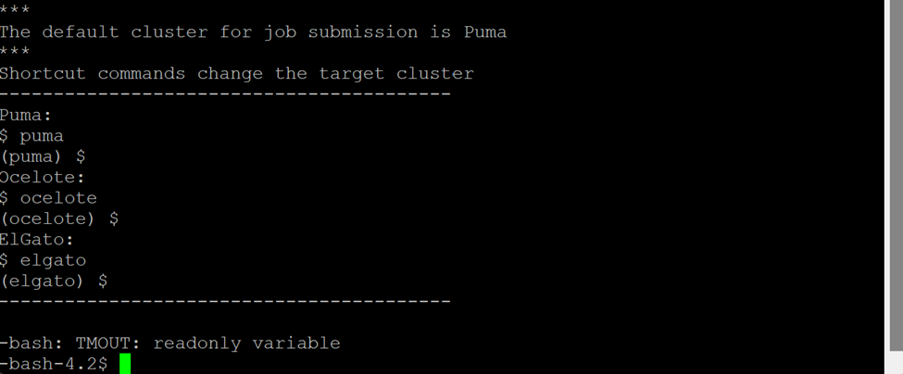
You will then connect to Puma as the default.
Use the –X option for X11 forwarding above when connecting.
$puma -X
Optionally after connecting to Puma, you can change your cluster then to Ocelote or Elgato.
$ocelote -X
Then start the interactive session
$interactive -a ece569
Refer to
https://hpcdocs.hpc.arizona.edu/running_jobs/overview/
Very helpful page for running interactive jobs:
https://hpcdocs.hpc.arizona.edu/running_jobs/interactive_jobs/
for further information about command line options for the “interactive” command.
A full command would be
$ salloc --job-name=interactive --mem-per-cpu=4GB --nodes=1 --ntasks=1 --time=00:10:00 --account=ece569 --partition=standard --gres=gpu:1

- Running your first program
The command line setup through putty may become a convenient way of submitting large scale jobs later in the semester. Now we can move onto compiling and executing the device query program that will allow you to collect GPU configuration information. We will use the virtual desktop setup for getting access to the GPU system. Note that in this setup you have direct access to a GPU as part of the desktop configuration.
The web interface, Open OnDemand, provides access to HPC's three clusters. Please go over the following page: https://hpcdocs.hpc.arizona.edu/running_jobs/open_on_demand/
This service is available from https://ood.hpc.arizona.edu/

You can request a virtual desktop with a GPU configuration using the “Interactive Desktop”
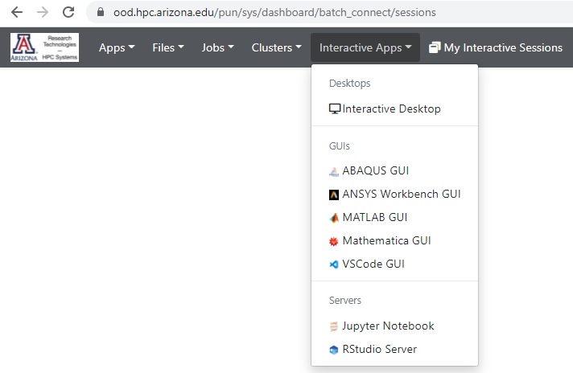

Then configure with a single GPU and make sure to use “ece569” as the PI group.
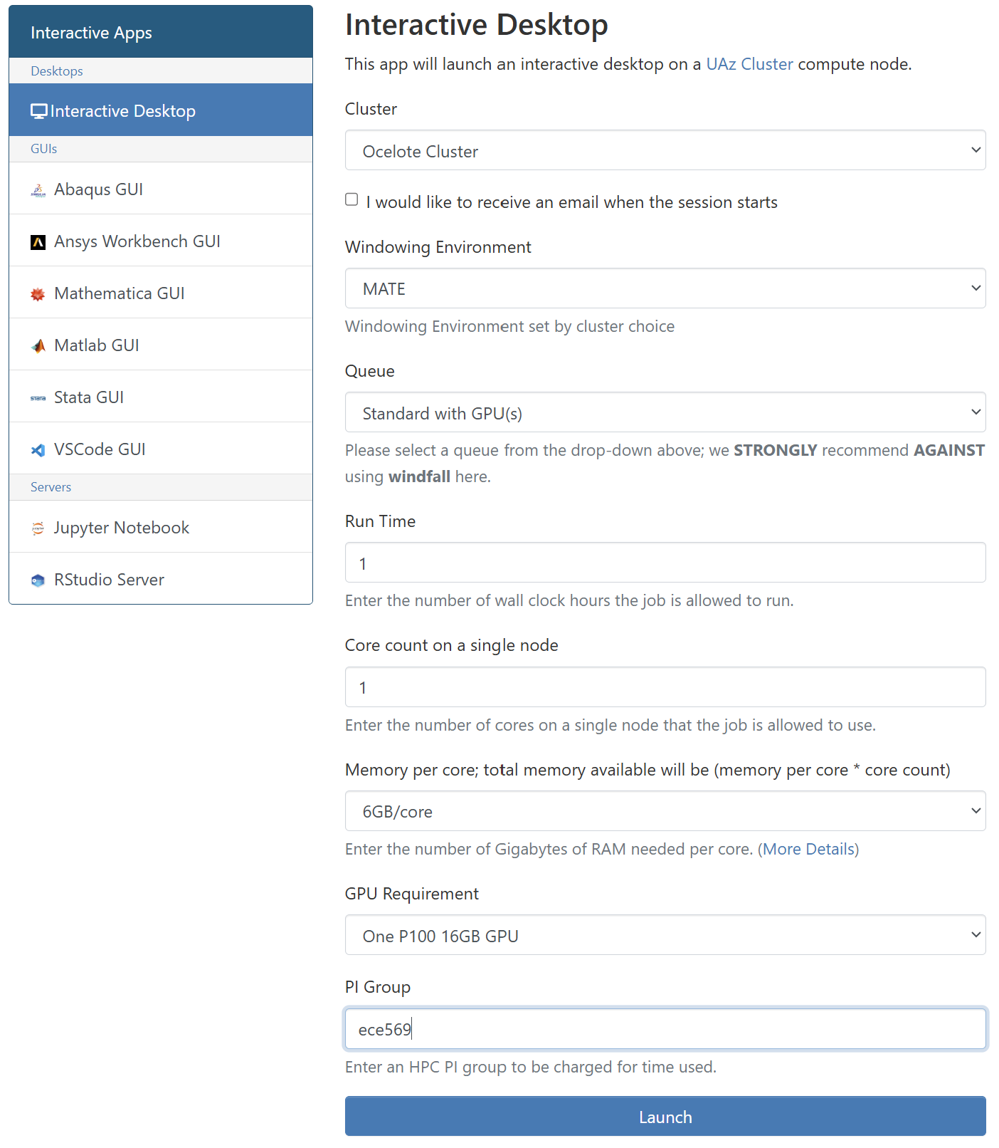
You can read more about HPC access using the following link: https://uarizona.atlassian.net/wiki/spaces/UAHPC/pages/75990560/System+Access
Scroll to the “Web Access” portion

When the resource becomes available you will see the following page. “Launch Interactive Desktop” to get started.
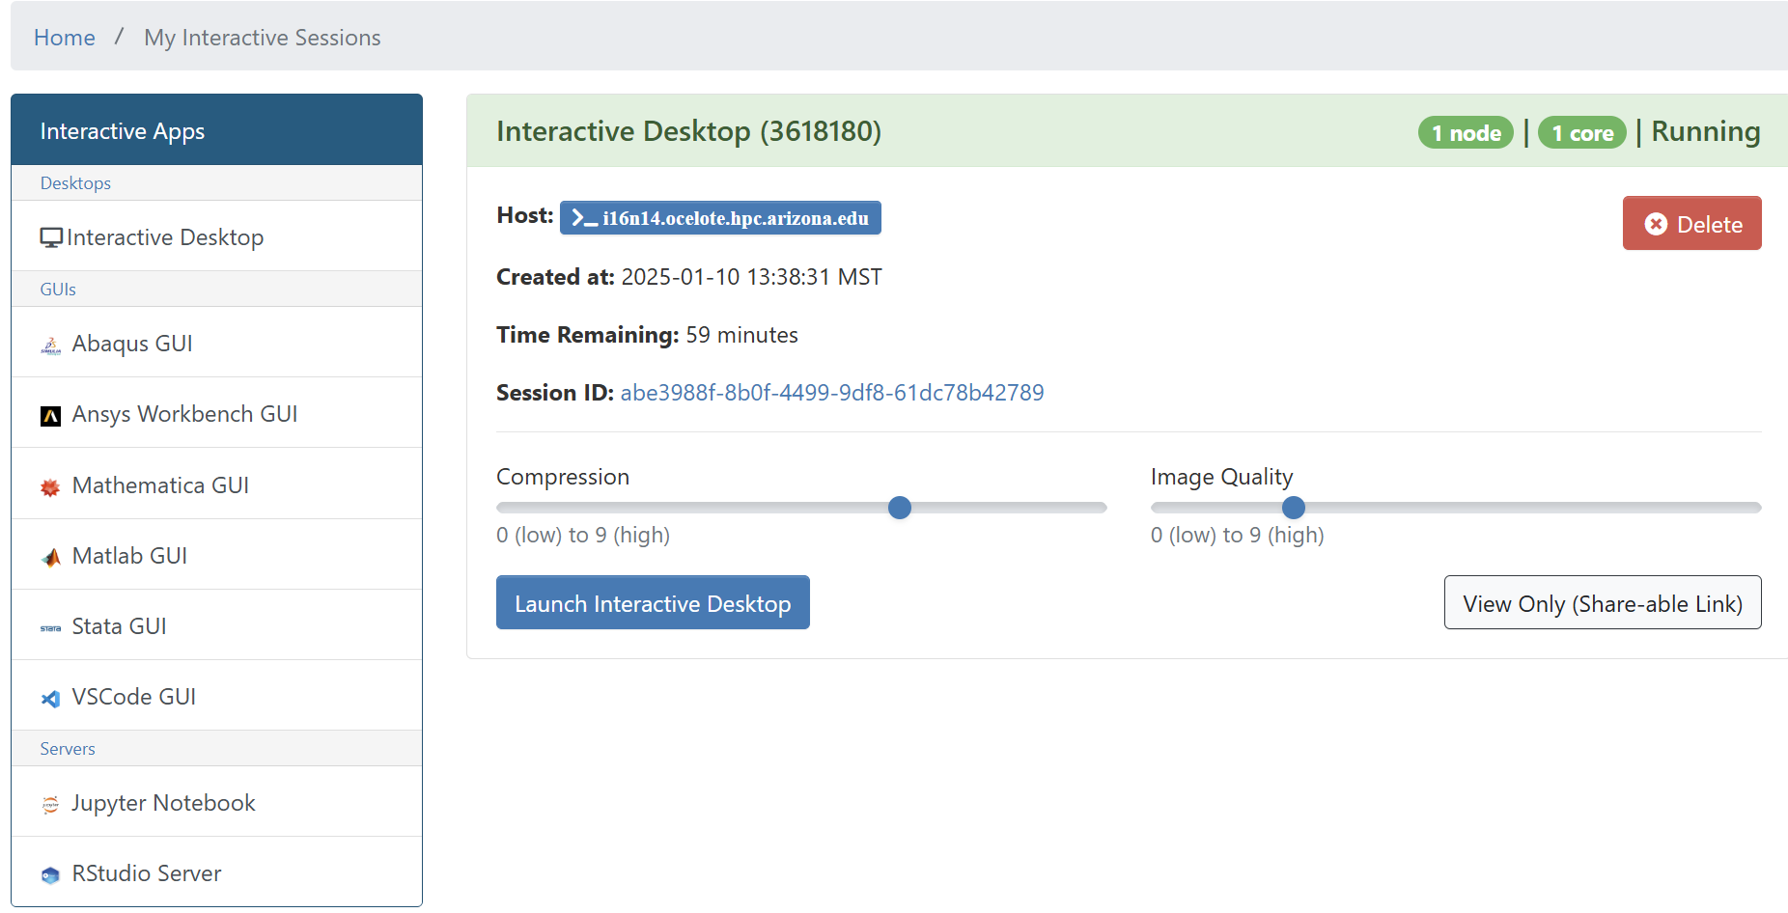

After your session starts, on your virtual desktop explore the tools you have access to. Use the terminal icon to start the command line.
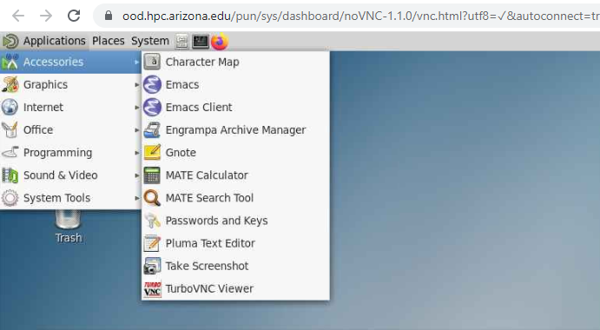
On the command line terminal, now let’s start setting up your directory and transferring hw1 related files and folders to the HPC.
Ok, let’s build our directories for the assignments. In your putty shell on Ocelote:
$ mkdir ece569
$ mkdir ece569/build_dir

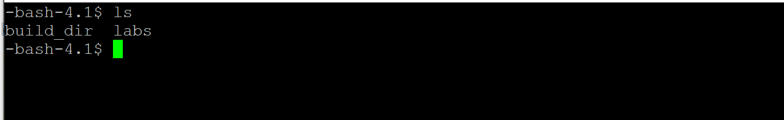
Copy the "labs" folder posted on d2l in hw1 into the ece569/ folder. You may want to use WinSCP for copying the entire folder conveniently. After copying the folder, you should have build_dir and labs directories in your 569 folder.

Change your home directory to ece569/build_dir
$ cd ece569/build_dir

Then run the following two commands:
$CC=gcc cmake ../labs

You should see the following screen flow.
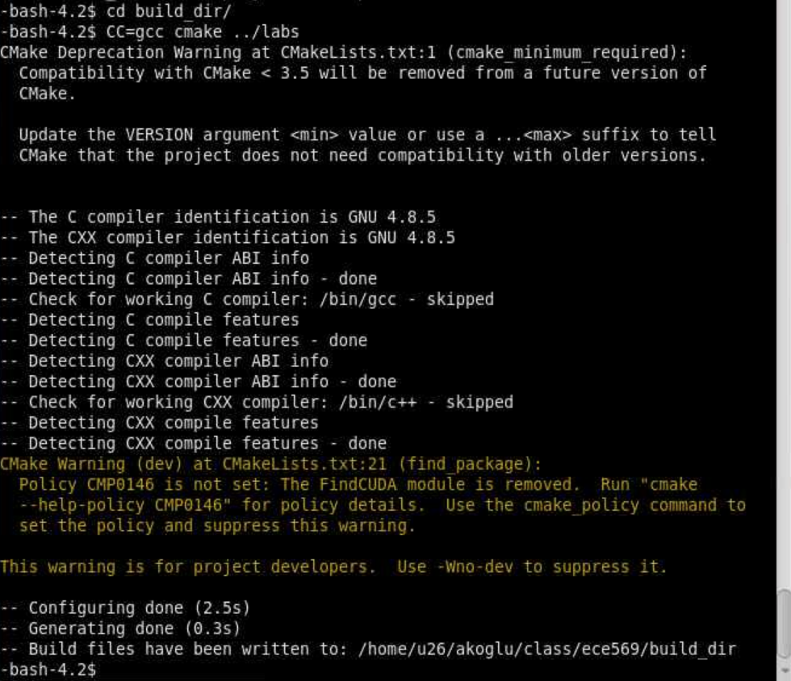

If you observe error stating “Specify CUDA TOLLKIT ROOT DIR”
CMake Error at /opt/ohpc/pub/apps/cmake/3.28.3/share/cmake3.28/Modules/FindCUDA.cmake:883 (message):
Specify CUDA_TOOLKIT_ROOT_DIR
Call Stack (most recent call first):
CMakeLists.txt:21 (find_package) -- Configuring incomplete, errors occurred!
Please try this path:
$ export CC=gcc
$ cmake -D CUDA_TOOLKIT_ROOT_DIR=/opt/ohpc/pub/apps/cuda/11.8 ../labs

Then run the following command:
$make
You should see the following screen flow.
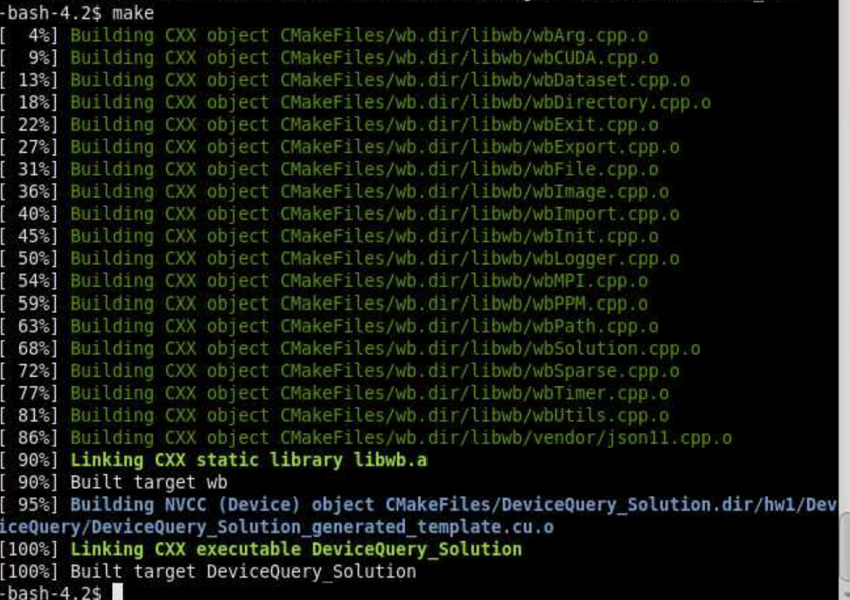

The makefile compiles and generates the executable “DeviceQuery_Solution” in the build-dir directory.
$ls
With this command, you should see the following files in your build_dir directory:
CMakeCache.txt CMakeFiles cmake_install.cmake DeviceQuery_Solution libwb.a Makefile

You can directly run the device query solution on the GPU using the following command
./DeviceQuery_Solution > output.txt
And observe the contents of the output file. After completion, “output.txt” will include P100 GPU information if you used the Ocelote system.

Later you will need to run multiple jobs. For this you will need to use a script to submit jobs.
A template file for running the jobs on ocelote is given in the “labs” folder named “run_hw1.slurm”
Assuming you are in the build_dir directory copy the “run_hw1_slurm” file from the labs folder into your current build_dir directory. This script is needed to launch your jobs on the HPC system.

$cp ../labs/run_hw1.slurm ./

Go over the document to see the types of commands issued.

Before executing the script, open the run_hw1.slurm, locate the line #35 that shows as:
cd ~akoglu/class/ece569/build_dir and set the correct path for your “build_dir”

Your group should show as “ece569”. (line 10)

Then execute the following command
$srun run_hw1.slurm
This command submits your job and assigns a unique process id for your job.
In case you receive “permission denied”, change the permission settings:
$chmod 777 run_hw1.slurm
$srun run_hw1.slurm
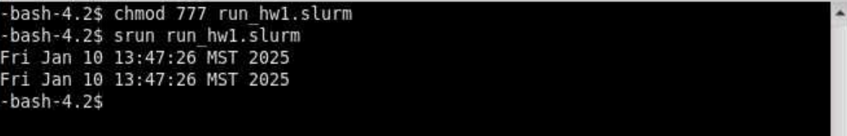
Now observe the output generated by this script.
Note that the source code “template.cu” is located in the labs/hw1/DeviceQuery
The code provided queries the GPU hardware on the system. Do not concentrate on the API calls, but on functions starting with `wb`. The `wbLog` function logs hardware features.

In the same folder you will find the file “questions.txt”. Insert your solutions and submit the questions.txt file on D2L to the designated folder.

slurm commands to monitor your jobs.
Key commands to be familiar with are:
srun <options> Submit a job for realtime execution. Can also be used to submit an interactive session
squeue --job <jobid> Check status of a specific job
squeue -u <netid> Check status of jobs specific to user
scancel <jobid> Delete a specific job
scancel -u <netid> Delete all user jobs

Using the ondemand service you can also initiate a shell access

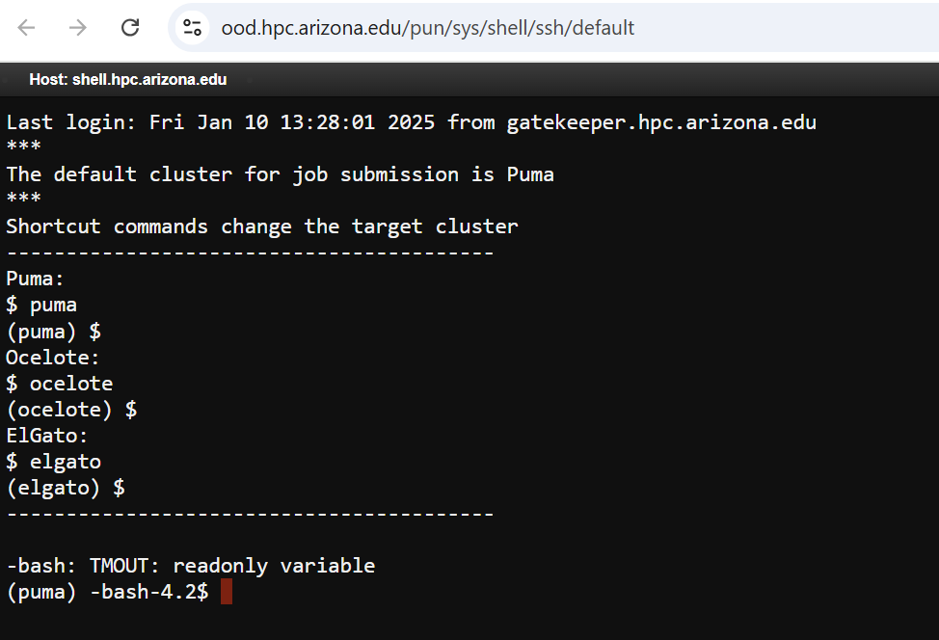

After you are done with your session, make sure to “Delete” the on demand desktop so that GPU source you allocated becomes available for others to use.
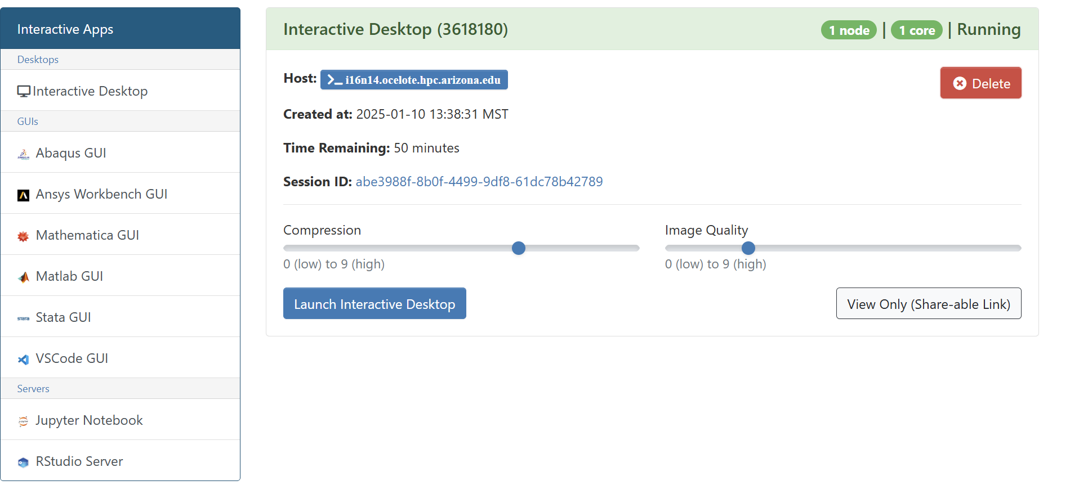
Key part of our assignments will involve submitting jobs to the HPC system with GPU resources allocated. For this you need to learn about running jobs with SLURM.
You need to go through the “Running Jobs with SLURM” carefully to find out the best setup for yourself.
The following page is under development but it may have more information as we go through the semester.
https://ua-researchcomputing-hpc.github.io/

