1. Copy and paste the code changes made to change the color of the first triangles. What *values* have you changed?



I changed the size of the points from 1.0 to 10.0, and the color of the points from black (0.0, 0.0, 0.0) to green (0.0, 1.0, 0.0).

1. Triangle rotation
   1. Copy and paste the code you made to rotate the triangle



* 1. Can you think of any other way to rotate the triangle? Describe one possibility.

We could multiply the verticies matrix by a rotation matrix.

1. What does it mean to *perturb the bisector*, as performed in Section 3?

I think it means to add variance to the points.

1. Paste your screenshots here on perturbing things.

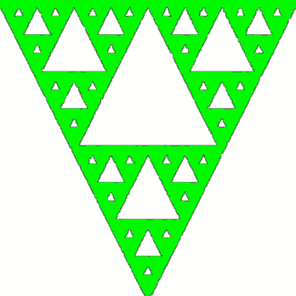

1. In the JavaScript file, there are two uses of the scale function. For the second (scale(0.5, p);) modify the value sent in. What do you think is happening here (i.e., what is the purpose of scaling)?

I think that the scale function is scaling the floating point variables up to a scale that makes sense for the window.

1. We have the following three lines of code in all our gasket files, and they will show up in one form or another in pretty much everything we do. What is the purpose of each line of this code block specifically?



Line 1: Tells WebGL to get the attribute in our program called vPosition (located

in our shader) and to save it in the variable vPosition.

Line 2: Package the data in vPosition up.

Line 3: Enable the data.

1. Create your portfolio website