***# Secondary school of electrotechnical engineering Jecna 30***

***# 2022-2023***

***# Matěj Šturma***

***# C4c***

## **Introduction**

This is an analysis document for the database. I’ve properly analyzed an invoice of an order from a furniture store. The invoice can be found in **/src/invoice.jpg**.

### **Deciding on the provider**

I decided to use MySQL for this project, because it’s the most convenient option for me and it works on almost every system. It’s also the best option if the database was hosted on a linux server.

## **Table determination**

Firstly, I determined what tables would be needed for this database to be fully compatible with the given invoice and also to comply with an adequate normalization form.

I’ve chosen the following:

* **a customer table**
* This one is pretty self explanatory in my opinion. You can see information about a customer in the top-left corner of the invoice. It’s a very good idea to store them.
* **tables for countries and cities**
* I decided to separate addresses into different tables to remove redundancy and duplicates.
* **a products table**
* It’s definitely a good idea to store products and information about them in a database used by a shop, and that’s exactly what I’m trying to achieve with this table.
* **tables for categories and subcategories**
* Every product has its own category, which is usually a subcategory of a bigger category. I decided to store both categories and subcategories.
* 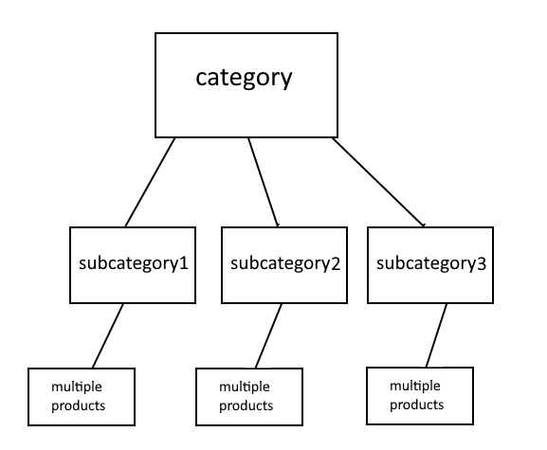
* **a colors table**
* I also decided to store colors in a separate table to remove duplicates. There won’t be many colors used in a furniture store, so having them as attributes wouldn’t be very effective.
* **a stores table**
* This table is made to store information about shops or branches of the company as written in the top-right of the invoice.
* **a “product availability” table**
* I decided that it’s a good idea to store information whether a product is available in a given shop/branch. This would be an effective way to tell a user if they can order a product from their desired country for example.
* **an orders table**
* Finally, a table that can store information about placed orders.

## **Attribute determination**

After determining what tables would be useful, I needed to decide on the attributes and relations for each table.

Firstly, I made a logical model to decide on relations between each table. I started with the most obvious ones:

* **countries : cities relation**
* **categories : subcategories relation**
* **products : product_availability : stores**

After making relations between these tables, I proceeded to continue with other tables as well.

The full conceptual model can be found in **/img/diagram.png**.