**CSE474/574 Introduction to Machine Learning Programming**

**Assignment 2**

**Classification and Regression**

**Members of GROUP 43 Instructor:Prof.Varun Chandola**

1. Arundhati Ravikumar Rao
2. Cuurie Athiyaman
3. Prithvi Ganesan

**Problem 1: Experiment with Gaussian discriminators**

Linear discriminant analysis (LDA) and Quadratic discriminant analysis (QDA) are linear and quadratic decision surface classifiers, discriminating boundaries between multiple classes.

We have trained the sample_train dataset by both LDA and QDA and then tested them with the given sample_test.

The accuracies observed were:

LDA - 97%

QDA-94%

From the figure for LDA below, we can see that almost all the data points are linearly separable for the given test dataset. In LDA, we assume the same covariance matrix for Gaussian distributors with multiple classes. LDA uses straight lines to separate the various classes and hence a higher accuracy is expected for linear separable dataset, which is observed in the problem.

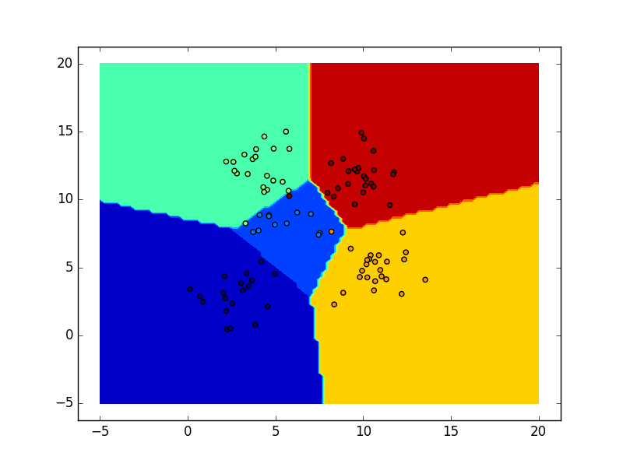

As opposed to as in LDA, for QDA we do not assume that the Gaussian distributions for all classes share the same covariance. And since each class has its own covariance matrix, the classifier is observed to be quadratic. QDA makes use of curved lines for separating or discriminating data points in a quadratic fashion. 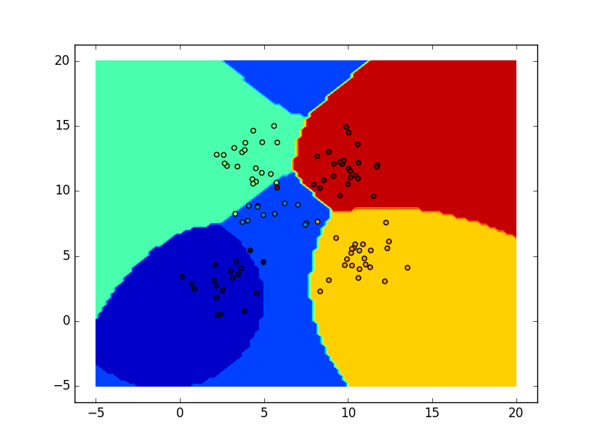

*Figure 2*

The Figure above shows QDA’s discriminating boundaries for the same dataset as for LDA. The boundary’s shape is determined in a quadratic fashion, resulting in curved lines. This is more suitable for real world situations where the data points do not fit into rigid linearly separable boundaries.

As seen from our observations, QDA offers lesser accuracy when compared to LDA.