МИНИСТЕРСТВО ОБРАЗОВАНИЯ РЕСПУБЛИКИ БЕЛАРУСЬ

УЧРЕЖДЕНИЕ ОБРАЗОВАНИЯ
«ГОМЕЛЬСКИЙ ГОСУДАРСТВЕННЫЙ ТЕХНИЧЕСКИЙ УНИВЕРСИТЕТ ИМЕНИ П. О. СУХОГО»

Факультет автоматизированных и информационных систем

Кафедра «Информационные технологии»

дисциплина «Разработка приложений баз данных для информационных систем»
ОТЧЕТ ПО ЛАБОРАТОРНОЙ РАБОТЕ №6
«Создание Web-сервиса с использованием WEB API.NET MVC (ASP.NET Core MVC) для работы с информацией из базы данных»

Вариант №13
Кинотеатр

Выполнил:
студент группы ИТИ-31, Ивашко В. Н.
Принял:
доцент Асенчик О.Д.

Гомель 2024
Цель работы: ознакомиться с возможностями .NET Core по получению, отображению и изменение данных при помощи технологии WEB API.

Ход работы и результаты.

На рисунке 1 представлен созданный GitHub репозиторий. https://github.com/Vadyao00/Cinema (также репозиторий с frontend частью: https://github.com/Vadyao00/CinemaFrontend).

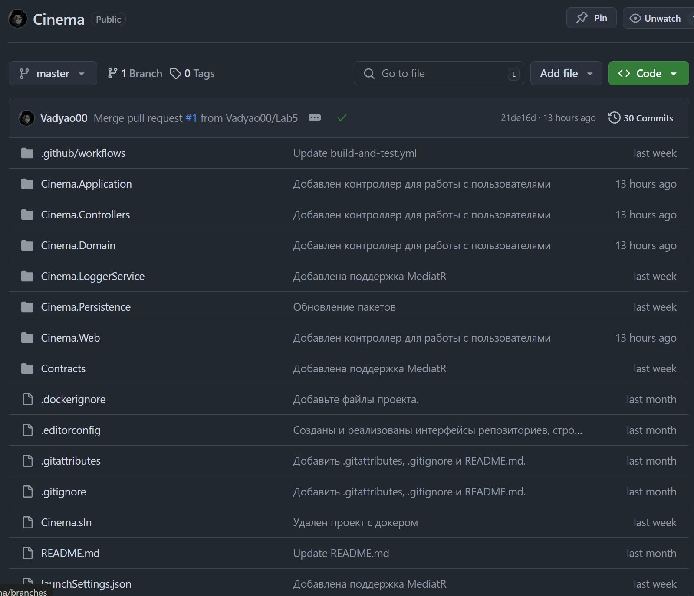

Рисунок 1 – GitHub Репозиторий

На рисунке 2 представлен просмотр данных таблицы «Фильмы», где предусмотрено разбиение данных на страницы, фильтрация по одному или нескольким полям.

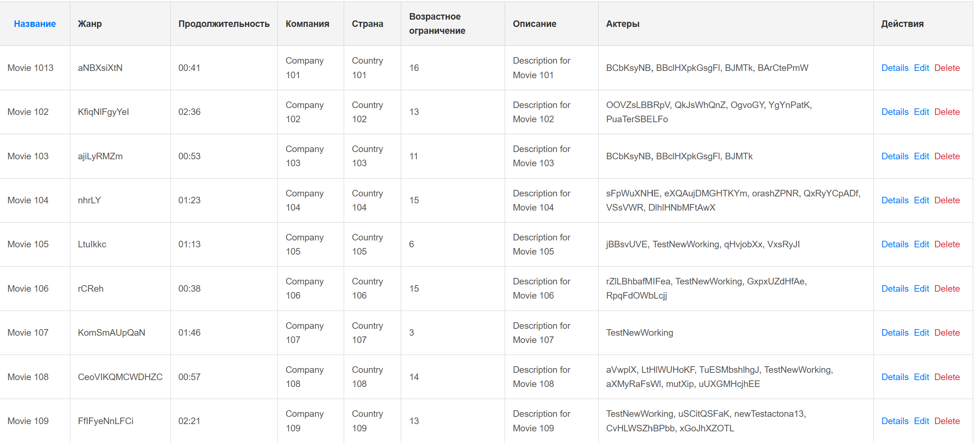

Рисунок 2 – Просмотр данных таблицы «Фильмы»

На рисунке 3 представлено добавление данных в таблицу «Фильмы».

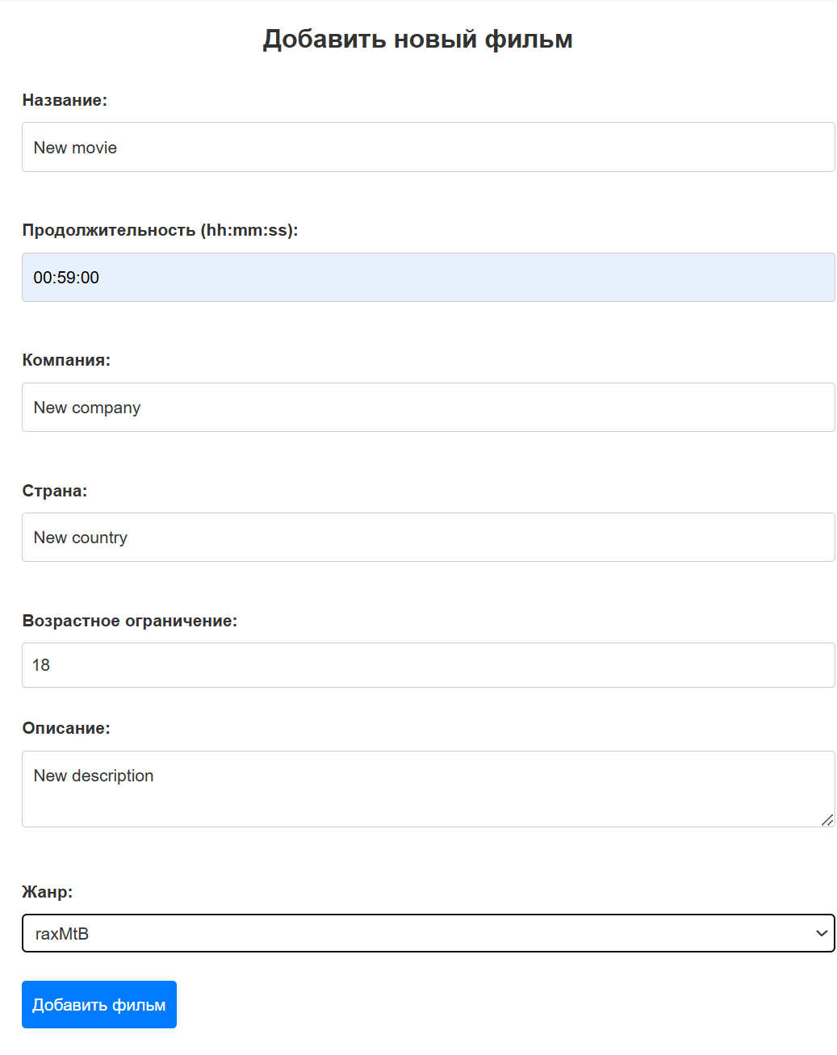

Рисунок 3 – Добавление данных в таблицу «Фильмы»

На рисунке 4 представлено редактирование данных таблицы «Фильмы».

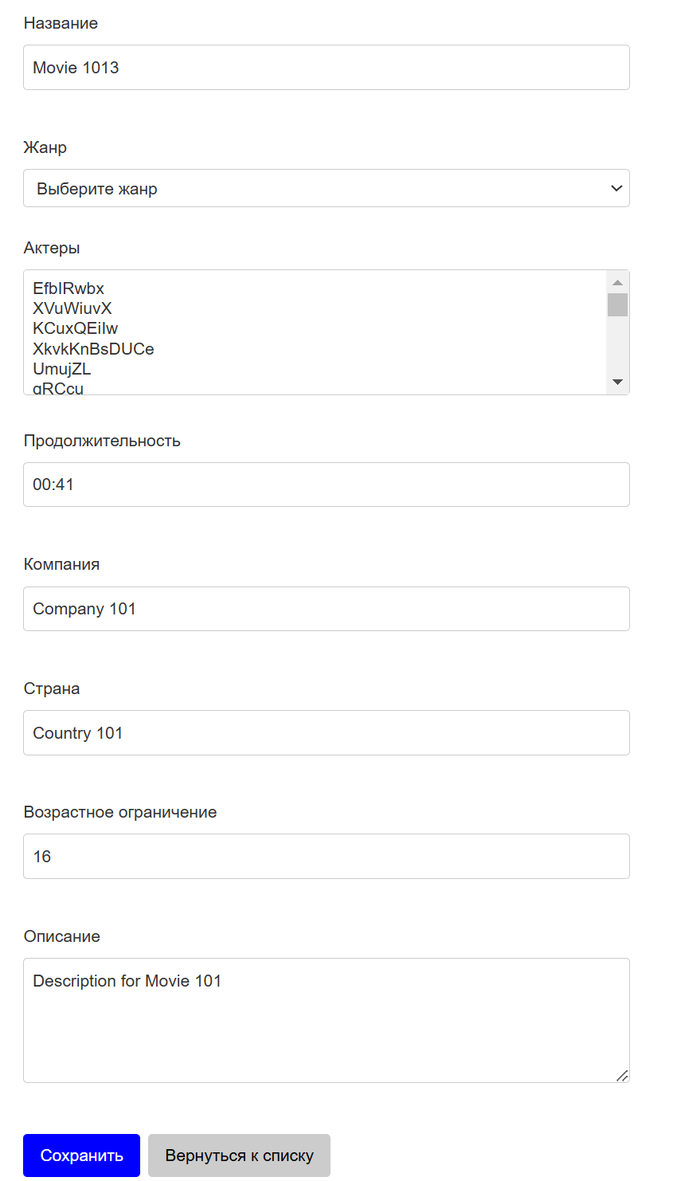

Рисунок 4 – Редактирование данных таблицы «Фильмы»

На рисунке 5 представлено удаление данных таблицы «Фильмы».

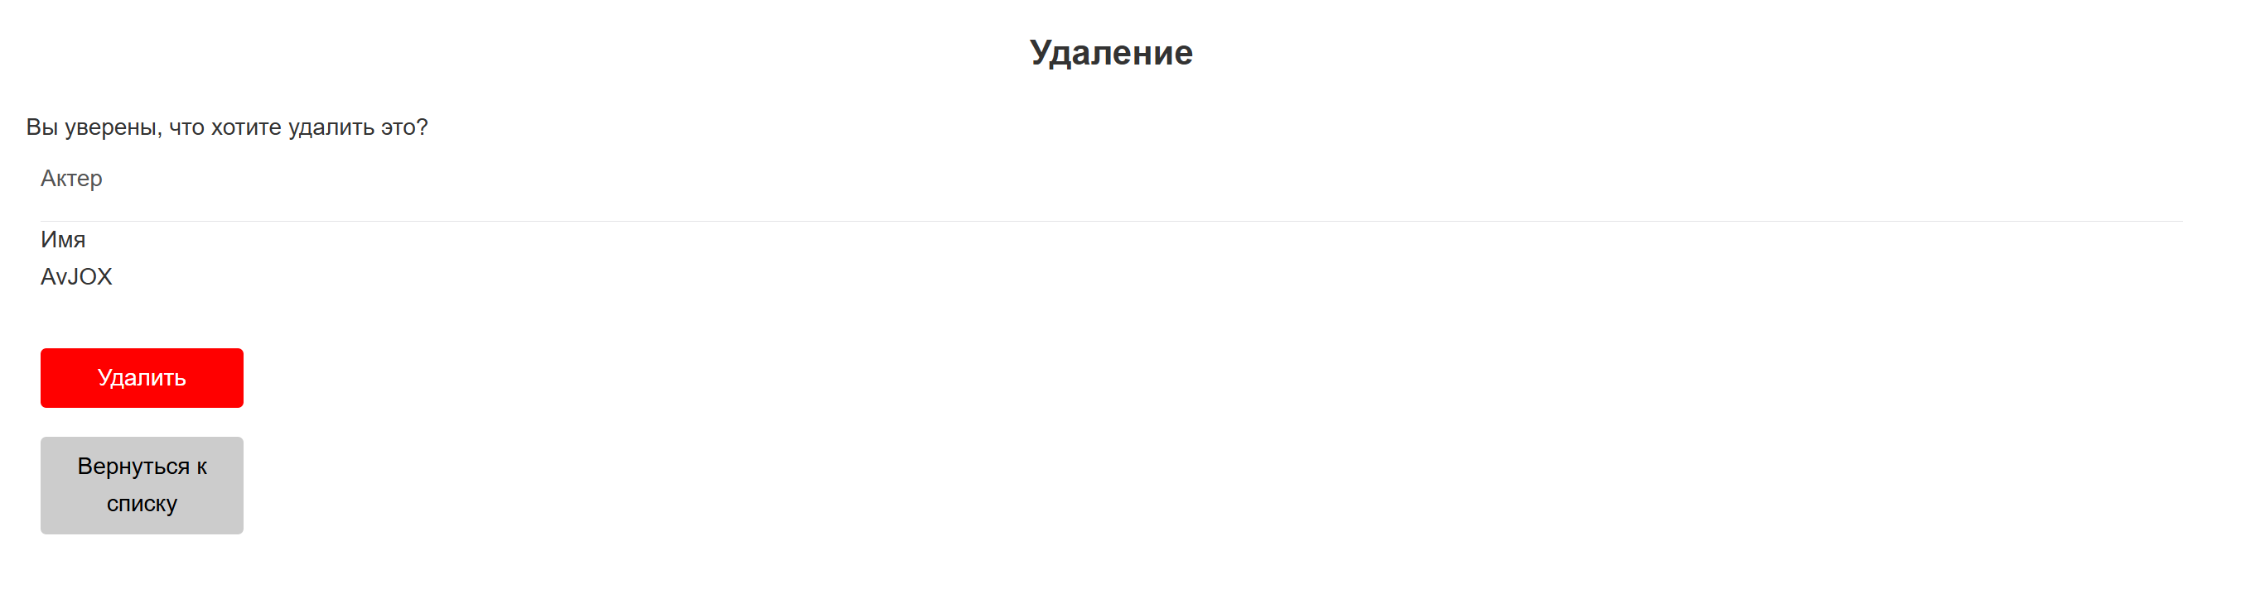

Рисунок 5 – Удаление данных таблицы «Фильмы»

На рисунке 6 представлено успешно пройденное модульное тестирвоание.

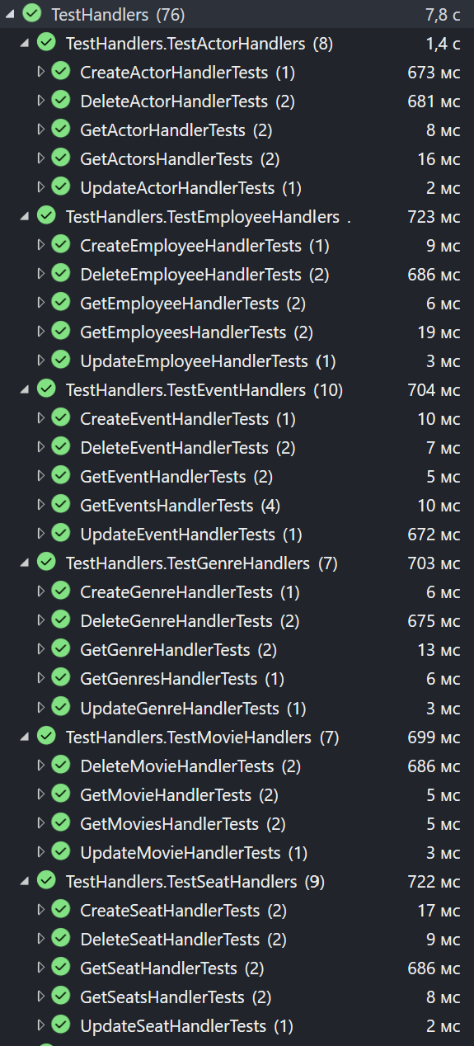

Рисунок 6 – Модульное тестирование

На рисунке 7 представлен отредактированный README.md файл опубликованного проекта, вставив в него код для создания эмблемы состояния рабочего процесса (status badge), показывающей, чем в данный момент завершился рабочий процесс.

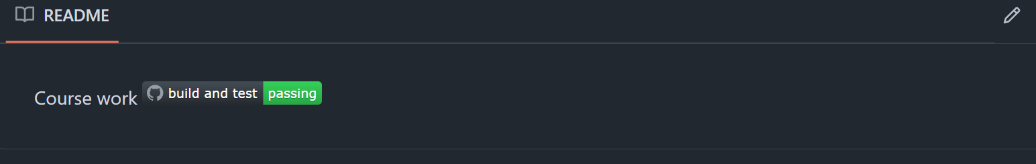

Рисунок 7 – Эмблема состояния

В данной лабораторной работе контроллеры возвращают ObjectResult, который обрабатывается на клиенте и отображается для пользователя.

Выводы: ознакомились с возможностями .NET Core по получению, отображению и изменению данных при помощи технологии WEB API.
ПРИЛОЖЕНИЕ А
(обязательное)

Текст программы

Program.cs:
using Cinema.API.Extensions;
using Cinema.Controllers;
using Microsoft.AspNetCore.Mvc;
using Microsoft.Extensions.Options;
using Microsoft.AspNetCore.Mvc.Formatters;
using Cinema.Controllers.Filters;
using NLog;
using Cinema.LoggerService;

namespace Cinema.API
{
public class Program
{
static NewtonsoftJsonPatchInputFormatter GetJsonPatchInputFormatter() =>
new ServiceCollection().AddLogging().AddMvc().AddNewtonsoftJson()
.Services.BuildServiceProvider()
.GetRequiredService<IOptions<MvcOptions>>().Value.InputFormatters
.OfType<NewtonsoftJsonPatchInputFormatter>().First();

public static void Main(string[] args)
{
var builder = WebApplication.CreateBuilder(args);

LogManager.Setup().LoadConfigurationFromFile(string.Concat(Directory.GetCurrentDirectory(), "/nlog.config"));

ConfigureServices(builder.Services,builder.Configuration);

var app = builder.Build();

var logger = app.Services.GetRequiredService<ILoggerManager>();
app.ConfigureExceptionHandler(logger);

if (app.Environment.IsProduction())
{
app.UseHsts();
}

ConfigureApp(app);

app.MapControllerRoute(
name: "default",
pattern: "{controller=Home}/{action=Index}/{id?}");

app.MapRazorPages();

//app.MapControllers();

app.Run();
}

public static void ConfigureServices(IServiceCollection services, IConfiguration configuration)
{
services.Configure<ApiBehaviorOptions>(options =>
{
options.SuppressModelStateInvalidFilter = true;
});

services.ConfigureSwagger();

services.ConfigureCors();

services.AddScoped<ValidationFilterAttribute>();

services.ConfigureLoggerService();

services.ConfigureRepositoryManager();

services.ConfigureServiceManager();

services.ConfigureSqlContext(configuration);

services.AddControllers(config =>
{
config.RespectBrowserAcceptHeader = true;
config.ReturnHttpNotAcceptable = true;
config.InputFormatters.Insert(0, GetJsonPatchInputFormatter());
config.CacheProfiles.Add("120SecondsDuration", new CacheProfile { Duration = 120 });
}).AddXmlDataContractSerializerFormatters()
.AddApplicationPart(typeof(AssemblyReference).Assembly);

services.AddMediatR(cfg =>
cfg.RegisterServicesFromAssembly(typeof(Application.AssemblyReference).Assembly));
services.AddAutoMapper(typeof(Program));

services.AddAuthentication();
services.ConfigureIdentity();
services.ConfigureJWT(configuration);
services.AddJwtConfiguration(configuration);
services.AddAuthorization();
services.AddRazorPages();
}

public static void ConfigureApp(IApplicationBuilder app)
{
app.UseSwagger();
app.UseSwaggerUI(s =>
{
s.SwaggerEndpoint("/swagger/v1/swagger.json", "Cinema API v1");
});

app.UseHttpsRedirection();

app.UseForwardedHeaders(new ForwardedHeadersOptions
{
ForwardedHeaders = Microsoft.AspNetCore.HttpOverrides.ForwardedHeaders.All
});
app.UseHttpsRedirection();
app.UseCors("CorsPolicy");

app.UseStaticFiles();

app.UseRouting();

app.UseAuthentication();
app.UseAuthorization();

}
}
}

ActorsController.cs
using Cinema.Application.Commands.ActorsCommands;
using Cinema.Application.Queries.ActorsQueries;
using Cinema.Controllers.Extensions;
using Cinema.Controllers.Filters;
using Cinema.Domain.DataTransferObjects;
using Cinema.Domain.RequestFeatures;
using MediatR;
using Microsoft.AspNetCore.Authorization;
using Microsoft.AspNetCore.Mvc;
using System.Text.Json;

namespace Cinema.Controllers.Controllers
{
[ApiController]
[Route("api/actors")]
[Authorize]
[ApiExplorerSettings(GroupName = "v1")]
public class ActorsController : ApiControllerBase
{
private readonly ISender _sender;

public ActorsController(ISender sender) => _sender = sender;

[HttpGet]
public async Task<IActionResult> GetActors([FromQuery]ActorParameters actorParameters)
{
var baseResult = await _sender.Send(new GetActorsQuery(actorParameters, TrackChanges: false));
if (!baseResult.Suссess)
return ProccessError(baseResult);

var (actors, metaData) = baseResult.GetResult<(IEnumerable<ActorDto>, MetaData)>();

Response.Headers.Add("X-Pagination", JsonSerializer.Serialize(metaData));

ViewBag.ActorParameters = actorParameters;
ViewBag.MetaData = metaData;

return Ok(actors);
}

[HttpGet("{id:guid}", Name = "ActorById")]
public async Task<IActionResult> GetActor(Guid id)
{
var baseResult = await _sender.Send(new GetActorQuery(id, TrackChanges: false));
if(!baseResult.Suссess)
return ProccessError(baseResult);

var actor = baseResult.GetResult<ActorDto>();

return Ok(actor);
}

[HttpPost(Name = "CreateActor")]
[ServiceFilter(typeof(ValidationFilterAttribute))]
[Authorize(Roles = "Administrator")]
public async Task<IActionResult> CreateActor([FromBody] ActorForCreationDto actor)
{
var createdActor = await _sender.Send(new CreateActorCommand(actor));

return CreatedAtRoute("ActorById", new { id = createdActor.ActorId }, createdActor);
}

[HttpDelete("{id:guid}")]
[Authorize(Roles = "Administrator")]
public async Task<IActionResult> DeleteActor(Guid id)
{
var baseResult = await _sender.Send(new DeleteActorCommand(id, TrackChanges: false));
if(!baseResult.Suссess)
return ProccessError(baseResult);

return NoContent();
}

[HttpPut("{id:guid}")]
[ServiceFilter(typeof(ValidationFilterAttribute))]
[Authorize(Roles = "Administrator")]
public async Task<IActionResult> UpdateActor(Guid id, [FromBody] ActorForUpdateDto actor)
{
var baseResult = await _sender.Send(new UpdateActorCommand(id,actor, TrackChanges: true));
if (!baseResult.Suссess)
return ProccessError(baseResult);

return NoContent();
}
}
}

GenresController.cs
using Cinema.Application.Commands.GenresCommands;
using Cinema.Application.Queries.GenresQueries;
using Cinema.Controllers.Extensions;
using Cinema.Controllers.Filters;
using Cinema.Domain.DataTransferObjects;
using Cinema.Domain.RequestFeatures;
using MediatR;
using Microsoft.AspNetCore.Authorization;
using Microsoft.AspNetCore.Mvc;
using System.Text.Json;

namespace Cinema.Controllers.Controllers
{
[ApiController]
[Route("api/genres")]
[Authorize]
public class GenresController : ApiControllerBase
{
private readonly ISender _sender;

public GenresController(ISender sender) => _sender = sender;

[HttpGet]
public async Task<IActionResult> GetGenres([FromQuery]GenreParameters genreParameters)
{
var baseResult = await _sender.Send(new GetGenresQuery(genreParameters, TrackChanges: false));
if (!baseResult.Suссess)
return ProccessError(baseResult);

var (genres, metaData) = baseResult.GetResult <(IEnumerable<GenreDto>, MetaData)>();

Response.Headers.Add("X-Pagination", JsonSerializer.Serialize(metaData));

return Ok(genres);
}

[HttpGet("{id:guid}", Name = "GenreById")]
public async Task<IActionResult> GetGenre(Guid id)
{
var baseResult = await _sender.Send(new GetGenreQuery(id, TrackChanges: false));
if (!baseResult.Suссess)
return ProccessError(baseResult);

var genre = baseResult.GetResult<GenreDto>();

return Ok(genre);
}

[HttpPost(Name = "CreateGenre")]
[ServiceFilter(typeof(ValidationFilterAttribute))]
[Authorize(Roles = "Administrator")]
public async Task<IActionResult> CreateGenre([FromBody] GenreForCreationDto genre)
{
var createdGenre = await _sender.Send(new CreateGenreCommand(genre));

return CreatedAtRoute("GenreById", new { id = createdGenre.GenreId }, createdGenre);
}

[HttpDelete("{id:guid}")]
[Authorize(Roles = "Administrator")]
public async Task<IActionResult> DeleteGenre(Guid id)
{
var baseResult = await _sender.Send(new DeleteGenreCommand(id, TrackChanges: false));
if (!baseResult.Suссess)
return ProccessError(baseResult);

return NoContent();
}

[HttpPut("{id:guid}")]
[ServiceFilter(typeof(ValidationFilterAttribute))]
[Authorize(Roles = "Administrator")]
public async Task<IActionResult> UpdateGenre(Guid id, [FromBody] GenreForUpdateDto genre)
{
var baseResult = await _sender.Send(new UpdateGenreCommand(id, genre, TrackChanges: true));
if (!baseResult.Suссess)
return ProccessError(baseResult);

return NoContent();
}
}
}

MoviesController.cs
using Cinema.Application.Commands.MoviesCommands;
using Cinema.Application.Queries.MoviesQueries;
using Cinema.Controllers.Extensions;
using Cinema.Controllers.Filters;
using Cinema.Domain.DataTransferObjects;
using Cinema.Domain.RequestFeatures;
using Contracts.IServices;
using MediatR;
using Microsoft.AspNetCore.Authorization;
using Microsoft.AspNetCore.Mvc;
using System.Text.Json;

namespace Cinema.Controllers.Controllers
{
[ApiController]
[Route("api/movies")]
[Authorize]
public class MoviesController : ApiControllerBase
{
private readonly ISender _sender;

public MoviesController(ISender sender) => _sender = sender;

[HttpGet]
public async Task<IActionResult> GetMovies([FromQuery]MovieParameters movieParameters)
{
var baseResult = await _sender.Send(new GetMoviesQuery(movieParameters, TrackChanges: false));
if(!baseResult.Suссess)
return ProccessError(baseResult);

var (movies, metaData) = baseResult.GetResult<(IEnumerable<MovieDto>, MetaData)>();

Response.Headers.Add("X-Pagination", JsonSerializer.Serialize(metaData));

return Ok(movies);
}

[HttpGet("{id:guid}", Name = "GetMovieById")]
public async Task<IActionResult> GetMovie(Guid id)
{
var baseResult = await _sender.Send(new GetMovieQuery(id, TrackChanges: false));
if (!baseResult.Suссess)
return ProccessError(baseResult);

var movie = baseResult.GetResult<MovieDto>();

return Ok(movie);
}

[HttpPost("{genreId:guid}")]
[ServiceFilter(typeof(ValidationFilterAttribute))]
[Authorize(Roles = "Administrator")]
public async Task<IActionResult> CreateMovieForGenre(Guid genreId, [FromBody] MovieForCreationDto movie)
{
var baseResult = await _sender.Send(new CreateMovieCommand(genreId, movie, TrackChanges: false));
if (!baseResult.Suссess)
return ProccessError(baseResult);

var createdMovie = baseResult.GetResult<MovieDto>();

return CreatedAtRoute("GetMovieById", new {id = createdMovie.MovieId }, createdMovie);
}

[HttpDelete("{id:guid}")]
[Authorize(Roles = "Administrator")]
public async Task<IActionResult> DeleteMovie(Guid id)
{
var baseResult = await _sender.Send(new DeleteMovieCommand(id , TrackChanges: false));
if (!baseResult.Suссess)
return ProccessError(baseResult);

return NoContent();
}

[HttpPut("{id:guid}")]
[ServiceFilter(typeof(ValidationFilterAttribute))]
[Authorize(Roles = "Administrator")]
public async Task<IActionResult> UpdateMovie(Guid id, [FromBody] MovieForUpdateDto movie)
{
var baseResult = await _sender.Send(new UpdateMovieCommand(id, movie, GenrTrackChanges:false, MovTrackChanges: true));
if (!baseResult.Suссess)
return ProccessError(baseResult);

return NoContent();
}
}
}

UserController.cs
using Cinema.Controllers.Extensions;
using Cinema.Controllers.Filters;
using Cinema.Domain.DataTransferObjects;
using Cinema.Domain.Entities;
using Contracts.IServices;
using Microsoft.AspNetCore.Authorization;
using Microsoft.AspNetCore.Identity;
using Microsoft.AspNetCore.Mvc;
using Microsoft.AspNetCore.Mvc.Rendering;
using System.ComponentModel.DataAnnotations;

namespace Cinema.Controllers.Controllers
{
public class UserController : ApiControllerBase
{
private readonly IServiceManager _service;
private readonly UserManager<User> _userManager;
readonly RoleManager<IdentityRole> _roleManager;

public UserController(RoleManager<IdentityRole> roleManager, UserManager<User> userManager, IServiceManager serviceManager)
{
_roleManager = roleManager;
_userManager = userManager;
_service = serviceManager;
}

[HttpGet]
public async Task<IActionResult> Users()
{
var users = _userManager.Users.OrderBy(user => user.Id);

List<UserDto> userDtos = [];

string urole = "";
foreach (var user in users)
{
var userRoles = await _userManager.GetRolesAsync(user);
if (userRoles.Count > 0)
{
urole = userRoles[0] ?? "";
}

userDtos.Add(
new UserDto
{
Id = user.Id,
UserName = user.UserName,
Name = user.FirstName + user.LastName,
Email = user.Email,
UserRole = urole
});
}

return Ok(userDtos);
}

[HttpPut]
public async Task<IActionResult> Edit([FromBody] UserForUpdateDto model)
{
if (ModelState.IsValid)
{
User user = await _userManager.FindByNameAsync(model.OldUserName);
if (user != null)
{
var oldRoles = await _userManager.GetRolesAsync(user);

if (oldRoles.Count > 0)
{
await _userManager.RemoveFromRolesAsync(user, oldRoles);

}
var newRole = model.UserRole;
if (newRole.Length > 0)
{
await _userManager.AddToRoleAsync(user, newRole);
}
user.Email = model.Email;
user.UserName = model.UserName;
user.FirstName = model.FirstName;
user.LastName = model.SecondName;

var result = await _userManager.UpdateAsync(user);
if (result.Succeeded)
{
return Ok();
}
else
{
foreach (var error in result.Errors)
{
ModelState.AddModelError(string.Empty, error.Description);
}
}
}
}
return Ok();
}

[HttpDelete("delete/{name}")]
public async Task<ActionResult> Delete(string name)
{
User user = await _userManager.FindByNameAsync(name);
if (user != null)
{
IdentityResult result = await _userManager.DeleteAsync(user);
}
return Ok();
}

[HttpPost("ChangePassword")]
[Authorize]
public async Task<IActionResult> ChangePassword([FromBody] ChangePasswordRequest request)
{
if (!ModelState.IsValid)
{
return BadRequest(ModelState);
}

var userId = User.FindFirst("sub")?.Value;
if (userId == null)
{
return Unauthorized("Не удалось определить пользователя.");
}

var user = await _userManager.FindByIdAsync(userId);
if (user == null)
{
return NotFound("Пользователь не найден.");
}

var result = await _userManager.ChangePasswordAsync(user, request.OldPassword, request.NewPassword);
if (!result.Succeeded)
{
return BadRequest(result.Errors.Select(e => e.Description));
}

return Ok(new { Message = "Пароль успешно изменён." });
}
}

public class ChangePasswordRequest
{
[Required]
public string? OldPassword { get; set; }

[Required]
[MinLength(6)]
public string? NewPassword { get; set; }
}
}

AuthenticationController.cs
using Cinema.Controllers.Extensions;
using Cinema.Controllers.Filters;
using Cinema.Domain.DataTransferObjects;
using Contracts.IServices;
using Microsoft.AspNetCore.Identity;
using Microsoft.AspNetCore.Mvc;

namespace Cinema.Controllers.Controllers
{
[Route("api/authentication")]
[ApiController]
public class AuthenticationController : ApiControllerBase
{
private readonly IServiceManager _service;

public AuthenticationController(IServiceManager service) => _service = service;

[HttpPost]
[ServiceFilter(typeof(ValidationFilterAttribute))]
public async Task<IActionResult> RegisterUser([FromBody] UserForRegistrationDto userForRegistration)
{
var baseResult = await _service.AuthenticationService.RegisterUser(userForRegistration);
if(!baseResult.Suссess)
return ProccessError(baseResult);

var result = baseResult.GetResult<IdentityResult>();

if (!result.Succeeded)
{
foreach (var error in result.Errors)
{
ModelState.TryAddModelError(error.Code, error.Description);
}
return BadRequest(ModelState);
}
return StatusCode(201);
}

[HttpPost("login")]
[ServiceFilter(typeof(ValidationFilterAttribute))]
public async Task<IActionResult> Authenticate([FromBody] UserForAuthenticationDto user)
{
if (!await _service.AuthenticationService.ValidateUser(user))
return Unauthorized();

var tokenDto = await _service.AuthenticationService.CreateToken(populateExp: true);

return Ok(tokenDto);
}
}
}

IAuhtenticationService.cs
using Cinema.Domain.DataTransferObjects;
using Cinema.Domain.Responses;

namespace Contracts.IServices
{
public interface IAuthenticationService
{
Task<ApiBaseResponse> RegisterUser(UserForRegistrationDto userForRegistrationDto);
Task<bool> ValidateUser(UserForAuthenticationDto userForAuth);
Task<TokenDto> CreateToken(bool populateExp);
Task<ApiBaseResponse> RefreshToken(TokenDto tokenDto);
}
}
AuthenticationService.cs
using AutoMapper;
using Cinema.Domain.ConfigurationModels;
using Cinema.Domain.DataTransferObjects;
using Cinema.Domain.Entities;
using Cinema.Domain.Responses;
using Cinema.LoggerService;
using Contracts.IServices;
using Microsoft.AspNetCore.Identity;
using Microsoft.Extensions.Options;
using Microsoft.IdentityModel.Tokens;
using System.IdentityModel.Tokens.Jwt;
using System.Security.Claims;
using System.Security.Cryptography;
using System.Text;

namespace Cinema.Application.Services
{
internal sealed class AuthenticationService : IAuthenticationService
{
private readonly ILoggerManager _logger;
private readonly IMapper _mapper;
private readonly UserManager<User> _userManager;
private readonly IOptions<JwtConfiguration> _configuration;
private readonly JwtConfiguration _jwtConfiguration;

private User? _user;

public AuthenticationService(ILoggerManager logger, IMapper mapper, UserManager<User> userManager, IOptions<JwtConfiguration> configuration)
{
_logger = logger;
_mapper = mapper;
_userManager = userManager;
_configuration = configuration;
_jwtConfiguration = _configuration.Value;
}

public async Task<ApiBaseResponse> RegisterUser(UserForRegistrationDto userForRegistration)
{
var user = _mapper.Map<User>(userForRegistration);

var result = await _userManager.CreateAsync(user, userForRegistration.Password);

if (result.Succeeded)
await _userManager.AddToRoleAsync(user, userForRegistration.UserRole);

return new ApiOkResponse<IdentityResult>(result);
}

public async Task<bool> ValidateUser(UserForAuthenticationDto userForAuth)
{
_user = await _userManager.FindByNameAsync(userForAuth.UserName);

var result = (_user != null && await _userManager.CheckPasswordAsync(_user, userForAuth.Password));
if (!result)
_logger.LogWarn($"{nameof(ValidateUser)}: Authentication failed. Wrong user name or password.");

return result;
}

public async Task<TokenDto> CreateToken(bool populateExp)
{
var signingCredentials = GetSigningCredentials();
var claims = await GetClaims();
var tokenOptions = GenerateTokenOptions(signingCredentials, claims);

var refreshToken = GenerateRefreshToken();

_user.RefreshToken = refreshToken;

if(populateExp)
_user.RefreshTokenExpiryTime = DateTime.Now.AddDays(7);

await _userManager.UpdateAsync(_user);

var accessToken = new JwtSecurityTokenHandler().WriteToken(tokenOptions);

return new TokenDto(accessToken, refreshToken);
}

private SigningCredentials GetSigningCredentials()
{
var key = Encoding.UTF8.GetBytes(Environment.GetEnvironmentVariable("SECRET"));
var secret = new SymmetricSecurityKey(key);

return new SigningCredentials(secret, SecurityAlgorithms.HmacSha256);
}

private async Task<List<Claim>> GetClaims()
{
var claims = new List<Claim>
{
new Claim(ClaimTypes.Name, _user.UserName)
};

var roles = await _userManager.GetRolesAsync(_user);
foreach (var role in roles)
{
claims.Add(new Claim(ClaimTypes.Role, role));
}

return claims;
}

private JwtSecurityToken GenerateTokenOptions(SigningCredentials signingCredentials, List<Claim> claims)
{
var tokenOptions = new JwtSecurityToken
(
issuer: _jwtConfiguration.ValidIssuer,
audience: _jwtConfiguration.ValidAudience,
claims: claims,
expires: DateTime.Now.AddMinutes(Convert.ToDouble(_jwtConfiguration.Expires)),
signingCredentials: signingCredentials
);

return tokenOptions;
}

private string GenerateRefreshToken()
{
var randomNumber = new byte[32];
using (var rng = RandomNumberGenerator.Create())
{
rng.GetBytes(randomNumber);

return Convert.ToBase64String(randomNumber);
}
}

private ClaimsPrincipal GetPrincipalFromExpiredToken(string token)
{
var tokenValidationParameters = new TokenValidationParameters
{
ValidateAudience = true,
ValidateIssuer = true,
ValidateIssuerSigningKey = true,
IssuerSigningKey = new SymmetricSecurityKey(Encoding.UTF8.GetBytes(Environment.GetEnvironmentVariable("SECRET"))),
ValidateLifetime = true,
ValidIssuer = _jwtConfiguration.ValidIssuer,
ValidAudience = _jwtConfiguration.ValidAudience
};

var tokenHandler = new JwtSecurityTokenHandler();
SecurityToken securityToken;
var principal = tokenHandler.ValidateToken(token, tokenValidationParameters, out securityToken);

var jwtSecurityToken = securityToken as JwtSecurityToken;
if (jwtSecurityToken == null ||
!jwtSecurityToken.Header.Alg.Equals(SecurityAlgorithms.HmacSha256, StringComparison.InvariantCultureIgnoreCase))
{
throw new SecurityTokenException("Invalid token");
}

return principal;
}

public async Task<ApiBaseResponse> RefreshToken(TokenDto tokenDto)
{
var principal = GetPrincipalFromExpiredToken(tokenDto.AccessToken);

var user = await _userManager.FindByNameAsync(principal.Identity.Name);
if (user == null || user.RefreshToken != tokenDto.RefreshToken ||
user.RefreshTokenExpiryTime <= DateTime.Now)
return new RefreshTokenBadRequestResponse();

_user = user;

var token = await CreateToken(populateExp: false);

return new ApiOkResponse<TokenDto>(token);
}
}
}

IServiceManager.cs
namespace Contracts.IServices
{
public interface IServiceManager
{
IAuthenticationService AuthenticationService { get; }
}
}

ServiceManager.cs
using Contracts.IRepositories;
using Contracts.IServices;
using Cinema.LoggerService;
using AutoMapper;
using Microsoft.AspNetCore.Identity;
using Cinema.Domain.Entities;
using Microsoft.Extensions.Configuration;
using Microsoft.Extensions.Options;
using Cinema.Domain.ConfigurationModels;

namespace Cinema.Application.Services
{
public class ServiceManager : IServiceManager
{
private readonly Lazy<IAuthenticationService> _authenticationService;

public ServiceManager(IRepositoryManager repositoryManager, ILoggerManager logger, IMapper mapper, UserManager<User> userManager, IOptions<JwtConfiguration> configuration)
{
_authenticationService = new Lazy<IAuthenticationService>(() => new AuthenticationService(logger, mapper, userManager, configuration));
}

public IAuthenticationService AuthenticationService => _authenticationService.Value;
}
}

Actor.cs
namespace Cinema.Domain.Entities
{
public partial class Actor
{
public Guid ActorId { get; set; }

public string Name { get; set; } = null!;

public virtual ICollection<Movie> Movies { get; set; } = new List<Movie>();
}
}

Employee.cs
namespace Cinema.Domain.Entities
{
public partial class Employee
{
public Guid EmployeeId { get; set; }

public string Name { get; set; } = null!;

public string Role { get; set; } = null!;

public virtual ICollection<WorkLog> WorkLogs { get; set; } = new List<WorkLog>();

public virtual ICollection<Event> Events { get; set; } = new List<Event>();

public virtual ICollection<Showtime> Showtimes { get; set; } = new List<Showtime>();
}
}

Event.cs
namespace Cinema.Domain.Entities
{
public partial class Event
{
public Guid EventId { get; set; }

public string Name { get; set; } = null!;

public DateOnly Date { get; set; }

public TimeOnly StartTime { get; set; }

public TimeOnly EndTime { get; set; }

public decimal TicketPrice { get; set; }

public virtual ICollection<Seat> Seats { get; set; } = new List<Seat>();

public virtual ICollection<Employee> Employees { get; set; } = new List<Employee>();
}
}

Genre.cs
namespace Cinema.Domain.Entities
{
public partial class Genre
{
public Guid GenreId { get; set; }

public string Name { get; set; } = null!;

public string? Description { get; set; }

public virtual ICollection<Movie> Movies { get; set; } = new List<Movie>();
}
}

Movie.cs
namespace Cinema.Domain.Entities
{
public partial class Movie
{
public Guid MovieId { get; set; }

public string Title { get; set; } = null!;

public TimeOnly Duration { get; set; }

public string? ProductionCompany { get; set; }

public string? Country { get; set; }

public int? AgeRestriction { get; set; }

public string? Description { get; set; }

public Guid GenreId { get; set; }

public virtual Genre Genre { get; set; } = null!;

public virtual ICollection<Showtime> Showtimes { get; set; } = new List<Showtime>();

public virtual ICollection<Actor> Actors { get; set; } = new List<Actor>();
}
}

Seat.cs
namespace Cinema.Domain.Entities
{
public partial class Seat
{
public Guid SeatId { get; set; }

public Guid? ShowtimeId { get; set; }

public Guid? EventId { get; set; }

public int? SeatNumber { get; set; }

public bool IsOccupied { get; set; }

public virtual Event? Event { get; set; }

public virtual Showtime? Showtime { get; set; }

public virtual ICollection<Ticket> Tickets { get; set; } = new List<Ticket>();
}
}

Showtime.cs
namespace Cinema.Domain.Entities
{
public partial class Showtime
{
public Guid ShowtimeId { get; set; }

public Guid MovieId { get; set; }

public DateOnly Date { get; set; }

public TimeOnly StartTime { get; set; }

public TimeOnly EndTime { get; set; }

public decimal TicketPrice { get; set; }

public virtual Movie Movie { get; set; } = null!;

public virtual ICollection<Seat> Seats { get; set; } = new List<Seat>();

public virtual ICollection<Employee> Employees { get; set; } = new List<Employee>();
}
}

Ticket.cs
namespace Cinema.Domain.Entities
{
public partial class Ticket
{
public Guid TicketId { get; set; }

public Guid SeatId { get; set; }

public DateOnly PurchaseDate { get; set; }

public virtual Seat Seat { get; set; } = null!;
}
}

User.cs
using Microsoft.AspNetCore.Identity;

namespace Cinema.Domain.Entities
{
public class User : IdentityUser
{
public string? FirstName { get; set; }
public string? LastName { get; set; }
//public DateTime? RegistrationDate { get; set; }
public string? RefreshToken { get; set; }
public DateTime RefreshTokenExpiryTime { get; set; }
}
}

WorkLog.cs
namespace Cinema.Domain.Entities
{
public partial class WorkLog
{
public Guid WorkLogId { get; set; }

public Guid EmployeeId { get; set; }

public int WorkExperience { get; set; }

public DateOnly StartDate { get; set; }

public decimal WorkHours { get; set; }

public virtual Employee Employee { get; set; } = null!;
}
}

ActorNotFoundResponse.cs
namespace Cinema.Domain.Responses
{
public sealed class ActorNotFoundResponse : ApiNotFoundResponse
{
public ActorNotFoundResponse(Guid id)
: base($"Actor with id {id} is not found in db.")
{
}
}
}

ApiBadRequestResponse.cs
namespace Cinema.Domain.Responses
{
public abstract class ApiBadRequestResponse : ApiBaseResponse
{
public string Message { get; set; }
public ApiBadRequestResponse(string message) : base(false)
{
Message = message;
}
}
}

ApiBaseResponse.cs
namespace Cinema.Domain.Responses
{
public abstract class ApiBaseResponse
{
public bool Suссess { get; set; }
protected ApiBaseResponse(bool suссess) => Suссess = suссess;
}
}

ApiNotFoundResponse.cs
namespace Cinema.Domain.Responses
{
public abstract class ApiNotFoundResponse : ApiBaseResponse
{
public string Message { get; set; }
public ApiNotFoundResponse(string message) : base(false)
{
Message = message;
}
}
}

ApiOkResponse.cs
namespace Cinema.Domain.Responses
{
public sealed class ApiOkResponse<TResult> : ApiBaseResponse
{
public TResult Result { get; set; }

public ApiOkResponse(TResult result) : base(true)
{
Result = result;
}
}
}

ActorRepository.cs
using Cinema.Domain.Entities;
using Cinema.Domain.RequestFeatures;
using Cinema.Persistence.Extensions;
using Contracts.IRepositories;
using Microsoft.EntityFrameworkCore;

namespace Cinema.Persistence.Repositories
{
public class ActorRepository(CinemaContext dbContext) : RepositoryBase<Actor>(dbContext), IActorRepository
{
public void CreateActor(Actor actor) => Create(actor);

public void DeleteActor(Actor actor) => Delete(actor);

public async Task<Actor> GetActorAsync(Guid id, bool trackChanges) =>
await FindByCondition(a => a.ActorId.Equals(id), trackChanges)
.SingleOrDefaultAsync();

public async Task<PagedList<Actor>> GetAllActorsAsync(ActorParameters actorParameters, bool trackChanges)
{
var actors = await FindAll(trackChanges)
.Search(actorParameters.searchName)
.Sort(actorParameters.OrderBy)
.Skip((actorParameters.PageNumber - 1) * actorParameters.PageSize)
.Take(actorParameters.PageSize)
.ToListAsync();

var count = await FindAll(trackChanges).Search(actorParameters.searchName).CountAsync();

return new PagedList<Actor>(actors, count, actorParameters.PageNumber, actorParameters.PageSize);
}
}
}

GenreRepository.cs
using Cinema.Domain.Entities;
using Cinema.Domain.RequestFeatures;
using Cinema.Persistence.Extensions;
using Contracts.IRepositories;
using Microsoft.EntityFrameworkCore;

namespace Cinema.Persistence.Repositories
{
public class GenreRepository(CinemaContext dbContext) : RepositoryBase<Genre>(dbContext), IGenreRepository
{
public void CreateGenre(Genre genre) => Create(genre);

public void DeleteGenre(Genre genre) => Delete(genre);

public async Task<PagedList<Genre>> GetAllGenresAsync(GenreParameters genreParameters, bool trackChanges)
{
var genres = await FindAll(trackChanges)
.Search(genreParameters.searchName)
.Sort(genreParameters.OrderBy)
.Skip((genreParameters.PageNumber - 1) * genreParameters.PageSize)
.Take(genreParameters.PageSize)
.ToListAsync();

var count = await FindAll(trackChanges).Search(genreParameters.searchName).CountAsync();

return new PagedList<Genre>(genres, count, genreParameters.PageNumber, genreParameters.PageSize);
}

public async Task<Genre> GetGenreAsync(Guid id, bool trackChanges) =>
await FindByCondition(g => g.GenreId.Equals(id), trackChanges)
.SingleOrDefaultAsync();
}
}

MovieRepository.cs
using Cinema.Domain.Entities;
using Cinema.Domain.RequestFeatures;
using Cinema.Persistence.Extensions;
using Contracts.IRepositories;
using Microsoft.EntityFrameworkCore;

namespace Cinema.Persistence.Repositories
{
public class MovieRepository(CinemaContext dbContext) : RepositoryBase<Movie>(dbContext), IMovieRepository
{
public void CreateMovieForGenre(Guid genreId, Movie movie)
{
movie.GenreId = genreId;
Create(movie);
}

public void DeleteMovie(Movie movie) => Delete(movie);

public async Task<PagedList<Movie>> GetAllMoviesAsync(MovieParameters movieParameters, bool trackChanges)
{
var movies = await FindAll(trackChanges)
.FilterMovies(movieParameters.MinAgeRestriction, movieParameters.MaxAgeRestriction)
.Search(movieParameters.searchTitle)
.Include(m => m.Genre)
.Sort(movieParameters.OrderBy)
.Skip((movieParameters.PageNumber - 1) * movieParameters.PageSize)
.Take(movieParameters.PageSize)
.ToListAsync();

var count = await FindAll(trackChanges).FilterMovies(movieParameters.MinAgeRestriction, movieParameters.MaxAgeRestriction)
.Search(movieParameters.searchTitle).CountAsync();

return new PagedList<Movie>(movies, count, movieParameters.PageNumber, movieParameters.PageSize);
}

public async Task<PagedList<Movie>> GetAllMoviesForGenreAsync(MovieParameters movieParameters, Guid genreId, bool trackChanges)
{
var movies = await FindByCondition(m => m.GenreId.Equals(genreId), trackChanges)
.FilterMovies(movieParameters.MinAgeRestriction, movieParameters.MaxAgeRestriction)
.Search(movieParameters.searchTitle)
.Include(m => m.Genre)
.Sort(movieParameters.OrderBy)
.Skip((movieParameters.PageNumber - 1) * movieParameters.PageSize)
.Take(movieParameters.PageSize)
.ToListAsync();

var count = await FindByCondition(m => m.GenreId.Equals(genreId), trackChanges).CountAsync();

return new PagedList<Movie>(movies, count, movieParameters.PageNumber, movieParameters.PageSize);
}

public async Task<Movie> GetMovieAsync(Guid id, bool trackChanges) =>
await FindByCondition(m => m.MovieId.Equals(id), trackChanges)
.Include(m => m.Genre)
.SingleOrDefaultAsync();
}
}

RepositoryBase.cs
using Contracts.IRepositories;
using Microsoft.EntityFrameworkCore;
using System.Linq.Expressions;

namespace Cinema.Persistence.Repositories
{
public class RepositoryBase<T>(CinemaContext dbContext) : IRepositoryBase<T> where T : class
{
protected CinemaContext DbContext = dbContext;

public void Create(T entity) => DbContext.Set<T>().Add(entity);

public void Delete(T entity) => DbContext.Set<T>().Remove(entity);

public IQueryable<T> FindAll(bool trackChanges) =>
!trackChanges ?
DbContext.Set<T>().AsNoTracking() :
DbContext.Set<T>();

public IQueryable<T> FindByCondition(Expression<Func<T, bool>> expression, bool trackChanges) =>
!trackChanges ?
DbContext.Set<T>().Where(expression).AsNoTracking() :
DbContext.Set<T>().Where(expression);

public void Update(T entity) => DbContext.Set<T>().Update(entity);
}
}

CinemaContext.cs
using Microsoft.EntityFrameworkCore;
using Cinema.Domain.Entities;
using Cinema.Persistence.Configurations;
using Microsoft.AspNetCore.Identity.EntityFrameworkCore;

namespace Cinema.Persistence
{
public partial class CinemaContext : IdentityDbContext<User>
{
public CinemaContext()
{
}

public CinemaContext(DbContextOptions<CinemaContext> options)
: base(options)
{
}

public virtual DbSet<Actor> Actors { get; set; }

public virtual DbSet<Employee> Employees { get; set; }

public virtual DbSet<Event> Events { get; set; }

public virtual DbSet<Genre> Genres { get; set; }

public virtual DbSet<Movie> Movies { get; set; }

public virtual DbSet<Seat> Seats { get; set; }

public virtual DbSet<Showtime> Showtimes { get; set; }

public virtual DbSet<Ticket> Tickets { get; set; }

public virtual DbSet<WorkLog> WorkLogs { get; set; }

protected override void OnModelCreating(ModelBuilder modelBuilder)
{
base.OnModelCreating(modelBuilder);

modelBuilder.ApplyConfiguration(new ActorConfiguration());
modelBuilder.ApplyConfiguration(new EmployeeConfiguration());
modelBuilder.ApplyConfiguration(new EventConfiguration());
modelBuilder.ApplyConfiguration(new GenreConfiguration());
modelBuilder.ApplyConfiguration(new MovieConfiguration());
modelBuilder.ApplyConfiguration(new SeatConfiguration());
modelBuilder.ApplyConfiguration(new ShowtimeConfiguration());
modelBuilder.ApplyConfiguration(new TicketConfiguration());
modelBuilder.ApplyConfiguration(new WorkLogConfiguration());
modelBuilder.ApplyConfiguration(new RoleConfiguration());
}

partial void OnModelCreatingPartial(ModelBuilder modelBuilder);
}
}

RepositoryManager.cs
using Cinema.Persistence.Repositories;
using Contracts.IRepositories;

namespace Cinema.Persistence
{
public class RepositoryManager : IRepositoryManager
{
private readonly CinemaContext _cinemaContext;
private readonly Lazy<IActorRepository> _actorRepository;
private readonly Lazy<IEmployeeRepository> _employeeRepository;
private readonly Lazy<IEventRepository> _eventRepository;
private readonly Lazy<IGenreRepository> _genreRepository;
private readonly Lazy<IMovieRepository> _movieRepository;
private readonly Lazy<ISeatRepository> _seatRepository;
private readonly Lazy<IShowtimeRepository> _showtimeRepository;
private readonly Lazy<ITicketRepository> _ticketRepository;
private readonly Lazy<IWorkLogRepository> _workLogRepository;

public RepositoryManager(CinemaContext cinemaContext)
{
_cinemaContext = cinemaContext;
_actorRepository = new Lazy<IActorRepository>(() => new ActorRepository(cinemaContext));
_employeeRepository = new Lazy<IEmployeeRepository>(() => new EmployeeRepository(cinemaContext));
_eventRepository = new Lazy<IEventRepository>(() => new EventRepository(cinemaContext));
_genreRepository = new Lazy<IGenreRepository>(() => new GenreRepository(cinemaContext));
_movieRepository = new Lazy<IMovieRepository>(() => new MovieRepository(cinemaContext));
_seatRepository = new Lazy<ISeatRepository>(() => new SeatRepository(cinemaContext));
_showtimeRepository = new Lazy<IShowtimeRepository>(() => new ShowtimeRepository(cinemaContext));
_ticketRepository = new Lazy<ITicketRepository>(() => new TicketRepository(cinemaContext));
_workLogRepository = new Lazy<IWorkLogRepository>(() => new WorkLogRepository(cinemaContext));
}
public IActorRepository Actor => _actorRepository.Value;

public IEmployeeRepository Employee => _employeeRepository.Value;

public IEventRepository Event => _eventRepository.Value;

public IGenreRepository Genre => _genreRepository.Value;

public IMovieRepository Movie => _movieRepository.Value;

public ISeatRepository Seat => _seatRepository.Value;

public IShowtimeRepository Showtime => _showtimeRepository.Value;

public ITicketRepository Ticket => _ticketRepository.Value;

public IWorkLogRepository WorkLog => _workLogRepository.Value;

public async Task SaveAsync() => await _cinemaContext.SaveChangesAsync();
}
}

GetActorHandlerTest.cs
using AutoMapper;
using Cinema.Application.Queries.ActorsQueries;
using Cinema.Application.Handlers.ActorsHandlers;
using Cinema.Domain.DataTransferObjects;
using Cinema.Domain.Entities;
using Cinema.Domain.Responses;
using Contracts.IRepositories;
using Moq;

namespace TestHandlers.TestActorHandlers
{
public class GetActorHandlerTests
{
private readonly Mock<IRepositoryManager> _repositoryMock;
private readonly Mock<IMapper> _mapperMock;
private readonly GetActorHandler _handler;

public GetActorHandlerTests()
{
_repositoryMock = new Mock<IRepositoryManager>();
_mapperMock = new Mock<IMapper>();
_handler = new GetActorHandler(_repositoryMock.Object, _mapperMock.Object);
}

[Fact]
public async Task Handle_ActorNotFound_ReturnsActorNotFoundResponse()
{
var actorId = Guid.NewGuid();
var command = new GetActorQuery(actorId, TrackChanges: false);

_repositoryMock.Setup(repo => repo.Actor.GetActorAsync(actorId, false))
.ReturnsAsync((Actor)null);

var result = await _handler.Handle(command, CancellationToken.None);

Assert.IsType<ActorNotFoundResponse>(result);
var response = result as ActorNotFoundResponse;
Assert.Equal($"Actor with id {actorId} is not found in db.", response.Message);

_repositoryMock.Verify(repo => repo.Actor.GetActorAsync(actorId, false), Times.Once);
}

[Fact]
public async Task Handle_ActorFound_ReturnsApiOkResponseWithActorDto()
{
var actorId = Guid.NewGuid();
var actor = new Actor { ActorId = actorId, Name = "John Doe" };
var actorDto = new ActorDto { ActorId = actorId, Name = actor.Name };
var command = new GetActorQuery(actorId, TrackChanges: false);

_repositoryMock.Setup(repo => repo.Actor.GetActorAsync(actorId, false))
.ReturnsAsync(actor);

_mapperMock.Setup(m => m.Map<ActorDto>(actor)).Returns(actorDto);

var result = await _handler.Handle(command, CancellationToken.None);

Assert.IsType<ApiOkResponse<ActorDto>>(result);
var apiResponse = result as ApiOkResponse<ActorDto>;
Assert.Equal(actor.ActorId, apiResponse.Result.ActorId);
Assert.Equal(actor.Name, apiResponse.Result.Name);

_repositoryMock.Verify(repo => repo.Actor.GetActorAsync(actorId, false), Times.Once);

_mapperMock.Verify(m => m.Map<ActorDto>(actor), Times.Once);
}
}
}

GetGenreHandlerTest.cs
using AutoMapper;
using Cinema.Application.Handlers.GenresHandlers;
using Cinema.Application.Queries.GenresQueries;
using Cinema.Domain.DataTransferObjects;
using Cinema.Domain.Entities;
using Cinema.Domain.Responses;
using Contracts.IRepositories;
using Moq;

namespace TestHandlers.TestGenreHandlers
{
public class GetGenreHandlerTests
{
private readonly Mock<IRepositoryManager> _repositoryMock;
private readonly Mock<IMapper> _mapperMock;
private readonly GetGenreHandler _handler;

public GetGenreHandlerTests()
{
_repositoryMock = new Mock<IRepositoryManager>();
_mapperMock = new Mock<IMapper>();
_handler = new GetGenreHandler(_repositoryMock.Object, _mapperMock.Object);
}

[Fact]
public async Task Handle_GenreNotFound_ReturnsGenreNotFoundResponse()
{
var genreId = Guid.NewGuid();
var query = new GetGenreQuery(genreId, false);

_repositoryMock.Setup(repo => repo.Genre.GetGenreAsync(genreId, false))
.ReturnsAsync((Genre)null);

var result = await _handler.Handle(query, CancellationToken.None);

Assert.IsType<GenreNotFoundResponse>(result);
var response = result as GenreNotFoundResponse;
Assert.NotNull(response);
Assert.Equal($"Genre with id: {genreId} is not found in db.", response.Message);

_repositoryMock.Verify(repo => repo.Genre.GetGenreAsync(genreId, false), Times.Once);
}

[Fact]
public async Task Handle_GenreFound_ReturnsApiOkResponseWithGenreDto()
{
var genreId = Guid.NewGuid();
var genre = new Genre { GenreId = genreId, Name = "Comedy" };
var genreDto = new GenreDto { GenreId = genreId, Name = "Comedy" };
var query = new GetGenreQuery(genreId, false);

_repositoryMock.Setup(repo => repo.Genre.GetGenreAsync(genreId, false))
.ReturnsAsync(genre);

_mapperMock.Setup(mapper => mapper.Map<GenreDto>(genre))
.Returns(genreDto);

var result = await _handler.Handle(query, CancellationToken.None);

Assert.IsType<ApiOkResponse<GenreDto>>(result);
var apiResponse = result as ApiOkResponse<GenreDto>;
Assert.NotNull(apiResponse);
Assert.Equal(genreDto, apiResponse.Result);

_repositoryMock.Verify(repo => repo.Genre.GetGenreAsync(genreId, false), Times.Once);

_mapperMock.Verify(mapper => mapper.Map<GenreDto>(genre), Times.Once);
}
}
}

GetMovieHandlerTest.cs
using AutoMapper;
using Cinema.Application.Queries.MoviesQueries;
using Cinema.Application.Handlers.MoviesHandlers;
using Cinema.Domain.DataTransferObjects;
using Cinema.Domain.Entities;
using Cinema.Domain.Responses;
using Contracts.IRepositories;
using Moq;

namespace TestHandlers.TestMovieHandlers
{
public class GetMovieHandlerTests
{
private readonly Mock<IRepositoryManager> _repositoryMock;
private readonly Mock<IMapper> _mapperMock;
private readonly GetMovieHandler _handler;

public GetMovieHandlerTests()
{
_repositoryMock = new Mock<IRepositoryManager>();
_mapperMock = new Mock<IMapper>();
_handler = new GetMovieHandler(_repositoryMock.Object, _mapperMock.Object);
}

[Fact]
public async Task Handle_MovieNotFound_ReturnsMovieNotFoundResponse()
{
var movieId = Guid.NewGuid();
var command = new GetMovieQuery(movieId, false);

_repositoryMock.Setup(repo => repo.Movie.GetMovieAsync(movieId, false))
.ReturnsAsync((Movie)null);

var result = await _handler.Handle(command, CancellationToken.None);

Assert.IsType<MovieNotFoundResponse>(result);
var response = result as MovieNotFoundResponse;
Assert.Equal($"Movie with id: {movieId} is not found in db.", response.Message);
}

[Fact]
public async Task Handle_MovieFound_ReturnsApiOkResponse()
{
var movieId = Guid.NewGuid();
var movie = new Movie { MovieId = movieId, Title = "Test Movie" };
var movieDto = new MovieDto { Title = "Test Movie" };
var command = new GetMovieQuery(movieId, false);

_repositoryMock.Setup(repo => repo.Movie.GetMovieAsync(movieId, false))
.ReturnsAsync(movie);

_mapperMock.Setup(m => m.Map<MovieDto>(movie)).Returns(movieDto);

var result = await _handler.Handle(command, CancellationToken.None);

Assert.IsType<ApiOkResponse<MovieDto>>(result);
var apiResponse = result as ApiOkResponse<MovieDto>;
Assert.Equal(movieDto.Title, apiResponse.Result.Title);

_repositoryMock.Verify(repo => repo.Movie.GetMovieAsync(movieId, false), Times.Once);
}
}
}

CreateMoviePage.jsx
import React, { useEffect, useState } from 'react';
import { useNavigate } from 'react-router-dom';
import { fetchAllGenres } from '../../services/genres';
import { createMovie } from '../../services/movies';
import '../../styles/CreateMoviePage.css';

function CreateMoviePage() {
const [title, setTitle] = useState('');
const [duration, setDuration] = useState('');
const [productionCompany, setProductionCompany] = useState('');
const [country, setCountry] = useState('');
const [ageRestriction, setAgeRestriction] = useState('');
const [description, setDescription] = useState('');
const [genreId, setGenreId] = useState('');
const [genres, setGenres] = useState([]);
const [isSubmitting, setIsSubmitting] = useState(false);
const navigate = useNavigate();

useEffect(() => {
const loadGenres = async () => {
try {
const dataGenres = await fetchAllGenres();
setGenres(dataGenres);
} catch (error) {
console.error('Failed to fetch genres:', error);
}
};
loadGenres();
}, []);

const handleSubmit = async (e) => {
e.preventDefault();
setIsSubmitting(true);

const newMovie = {
title,
duration: duration && duration.trim(),
productionCompany,
country,
ageRestriction: ageRestriction ? parseInt(ageRestriction) : null,
description
};

try {
await createMovie(genreId, newMovie);
navigate('/movies');
} catch (error) {
console.error('Failed to create movie:', error);
} finally {
setIsSubmitting(false);
}
};

return (
<div className="create-movie-page">
<h2>Добавить новый фильм</h2>
<form onSubmit={handleSubmit}>
<div className="form-group">
<label htmlFor="title">Название:</label>
<input
id="title"
type="text"
value={title}
onChange={(e) => setTitle(e.target.value)}
required
placeholder="Введите название"
/>
</div>

<div className="form-group">
<label htmlFor="duration">Продолжительность (hh:mm:ss):</label>
<input
id="duration"
type="text"
value={duration}
onChange={(e) => setDuration(e.target.value)}
placeholder="Введите продолжительность"
/>
</div>

<div className="form-group">
<label htmlFor="productionCompany">Компания:</label>
<input
id="productionCompany"
type="text"
value={productionCompany}
onChange={(e) => setProductionCompany(e.target.value)}
placeholder="Введите компанию"
/>
</div>

<div className="form-group">
<label htmlFor="country">Страна:</label>
<input
id="country"
type="text"
value={country}
onChange={(e) => setCountry(e.target.value)}
placeholder="Введите страну"
/>
</div>

<div className="form-group">
<label htmlFor="ageRestriction">Возрастное ограничение:</label>
<input
id="ageRestriction"
type="number"
value={ageRestriction}
onChange={(e) => setAgeRestriction(e.target.value)}
placeholder="Выберите возрастное ограничение"
min="1"
max="120"
/>
</div>

<div className="form-group">
<label htmlFor="description">Описание:</label>
<textarea
id="description"
value={description}
onChange={(e) => setDescription(e.target.value)}
placeholder="Введите описание"
/>
</div>

<div className="form-group">
<label htmlFor="genreId">Жанр:</label>
<select
id="genreId"
value={genreId}
onChange={(e) => setGenreId(e.target.value)}
required
>
<option value="">Выберите жанр</option>
{genres.map((genre) => (
<option key={genre.genreId} value={genre.genreId}>
{genre.name}
</option>
))}
</select>
</div>

<div className="form-group">
<button type="submit" disabled={isSubmitting}>
{isSubmitting ? 'Добавление...' : 'Добавить фильм'}
</button>
</div>
</form>
</div>
);
}

export default CreateMoviePage;

DeleteMoviePage.jsx
import React, { useEffect, useState } from 'react';
import { useNavigate, useParams } from 'react-router-dom';
import { getMovieById, deleteMovie } from '../../services/movies';

function DeleteMoviePage() {
const { id } = useParams();
const navigate = useNavigate();
const [movie, setMovie] = useState(null);

useEffect(() => {
const loadMovie = async () => {
try {
const data = await getMovieById(id);
setMovie(data);
} catch (error) {
console.error("Failed to fetch movie:", error);
}
};
loadMovie();
}, [id]);

const handleDelete = async (e) => {
e.preventDefault();
try {
await deleteMovie(id);
navigate('/movies');
} catch (error) {
console.error("Failed to delete movie:", error);
}
};

const handleCancel = () => {
navigate('/movies');
};

if (!movie) {
return <p>Загрузка...</p>;
}

return (
<div style={{ padding: '16px' }}>
<h2>Удаление фильма</h2>
<h3>Вы уверены, что хотите удалить этот фильм?</h3>
<div>
<h4>Фильм</h4>
<hr />
<dl style={{ marginBottom: '16px' }}>
<dt>Название</dt>
<dd>{movie.title}</dd>
<dt>Жанр</dt>
<dd>{movie.genreName}</dd>
<dt>Продолжительность</dt>
<dd>{movie.duration}</dd>
<dt>Компания</dt>
<dd>{movie.productionCompany}</dd>
<dt>Страна</dt>
<dd>{movie.country}</dd>
<dt>Возрастное ограничение</dt>
<dd>{movie.ageRestriction}</dd>
<dt>Описание</dt>
<dd>{movie.description}</dd>
</dl>
<form onSubmit={handleDelete}>
<button
type="submit"
style={{
maxWidth: '140px',
marginRight: '8px',
padding: '8px 16px',
background: 'red',
color: 'white',
border: 'none',
cursor: 'pointer',
}}
>
Удалить
</button>
<button
type="button"
onClick={handleCancel}
style={{
maxWidth: '140px',
padding: '8px 16px',
background: '#ccc',
color: 'black',
border: 'none',
cursor: 'pointer',
}}
>
Вернуться к списку
</button>
</form>
</div>
</div>
);
}

export default DeleteMoviePage;

EditMoviePage.jsx
import React, { useEffect, useState } from 'react';
import { useNavigate, useParams } from 'react-router-dom';
import { getMovieById, updateMovie } from '../../services/movies';
import { fetchAllGenres } from '../../services/genres';
import { fetchAllActors } from '../../services/actors';

function EditMoviePage() {
const { id } = useParams();
const navigate = useNavigate();
const [movie, setMovie] = useState({
genreId: '',
title: '',
duration: '',
productionCompany: '',
country: '',
ageRestriction: '',
description: '',
movieId: '',
actorsIds: [],
});
const [genres, setGenres] = useState([]);
const [actors, setActors] = useState([]);
const [errors, setErrors] = useState({});

useEffect(() => {
const loadMovie = async () => {
try {
const data = await getMovieById(id);
setMovie(data);
} catch (error) {
console.error('Failed to fetch movie:', error);
}
};
loadMovie();
}, [id]);

useEffect(() => {
const loadGenres = async () => {
try {
const dataGenres = await fetchAllGenres();
setGenres(dataGenres);
} catch (error) {
console.error('Failed to fetch genres:', error);
}
};

const loadActors = async () => {
try {
const dataActors = await fetchAllActors();
setActors(dataActors);
} catch (error) {
console.error('Failed to fetch actors:', error);
}
};

loadGenres();
loadActors();
}, []);

const handleChange = (e) => {
const { name, value } = e.target;
if (name === 'actorsIds') {
const selectedActors = Array.from(e.target.selectedOptions, (option) => option.value);
setMovie((prevMovie) => ({
...prevMovie,
[name]: selectedActors,
}));
} else {
setMovie((prevMovie) => ({
...prevMovie,
[name]: value,
}));
}
};

const handleSubmit = async (e) => {
e.preventDefault();
const { genreName, ...movieToUpdate } = movie;
try {
await updateMovie(movieToUpdate.movieId, movieToUpdate);
navigate('/movies');
} catch (error) {
console.error('Failed to update movie:', error);
setErrors({ submit: 'Ошибка при сохранении изменений. Попробуйте снова.' });
}
};

const handleCancel = () => {
navigate('/movies');
};

return (
<div style={{ padding: '16px' }}>
<h2>Редактировать фильм</h2>
<h4>Фильм</h4>
<hr />
<div style={{ maxWidth: '600px', margin: '0 auto' }}>
<form onSubmit={handleSubmit}>
{errors.submit && (
<div style={{ color: 'red', marginBottom: '16px' }}>{errors.submit}</div>
)}
<div style={{ marginBottom: '16px' }}>
<label htmlFor="title" style={{ display: 'block', marginBottom: '8px' }}>
Название
</label>
<input
id="title"
name="title"
type="text"
value={movie.title}
onChange={handleChange}
className="form-control"
style={{
width: '100%',
padding: '8px',
boxSizing: 'border-box',
borderRadius: '4px',
border: '1px solid #ccc',
}}
/>
</div>

<div style={{ marginBottom: '16px' }}>
<label htmlFor="genreId" style={{ display: 'block', marginBottom: '8px' }}>
Жанр
</label>
<select
id="genreId"
name="genreId"
value={movie.genreId}
onChange={handleChange}
className="form-control"
style={{
width: '100%',
padding: '8px',
boxSizing: 'border-box',
borderRadius: '4px',
border: '1px solid #ccc',
}}
>
<option value="">Выберите жанр</option>
{genres.map((genre) => (
<option key={genre.genreId} value={genre.genreId}>
{genre.name}
</option>
))}
</select>
</div>

<div style={{ marginBottom: '16px' }}>
<label htmlFor="actorsIds" style={{ display: 'block', marginBottom: '8px' }}>
Актеры
</label>
<select
id="actorsIds"
name="actorsIds"
multiple
value={movie.actorsIds}
onChange={handleChange}
className="form-control"
style={{
width: '100%',
padding: '8px',
boxSizing: 'border-box',
borderRadius: '4px',
border: '1px solid #ccc',
height: '120px',
}}
>
{actors.map((actor) => (
<option key={actor.actorId} value={actor.actorId}>
{actor.name}
</option>
))}
</select>
</div>

<div style={{ marginBottom: '16px' }}>
<label htmlFor="duration" style={{ display: 'block', marginBottom: '8px' }}>
Продолжительность
</label>
<input
id="duration"
name="duration"
type="text"
value={movie.duration}
onChange={handleChange}
className="form-control"
style={{
width: '100%',
padding: '8px',
boxSizing: 'border-box',
borderRadius: '4px',
border: '1px solid #ccc',
}}
/>
{errors.duration && <span style={{ color: 'red' }}>{errors.duration}</span>}
</div>
<div style={{ marginBottom: '16px' }}>
<label htmlFor="productionCompany" style={{ display: 'block', marginBottom: '8px' }}>
Компания
</label>
<input
id="productionCompany"
name="productionCompany"
type="text"
value={movie.productionCompany}
onChange={handleChange}
className="form-control"
style={{
width: '100%',
padding: '8px',
boxSizing: 'border-box',
borderRadius: '4px',
border: '1px solid #ccc',
}}
/>
{errors.productionCompany && <span style={{ color: 'red' }}>{errors.productionCompany}</span>}
</div>
<div style={{ marginBottom: '16px' }}>
<label htmlFor="country" style={{ display: 'block', marginBottom: '8px' }}>
Страна
</label>
<input
id="country"
name="country"
type="text"
value={movie.country}
onChange={handleChange}
className="form-control"
style={{
width: '100%',
padding: '8px',
boxSizing: 'border-box',
borderRadius: '4px',
border: '1px solid #ccc',
}}
/>
{errors.country && <span style={{ color: 'red' }}>{errors.country}</span>}
</div>
<div style={{ marginBottom: '16px' }}>
<label htmlFor="ageRestriction" style={{ display: 'block', marginBottom: '8px' }}>
Возрастное ограничение
</label>
<input
id="ageRestriction"
name="ageRestriction"
type="text"
value={movie.ageRestriction}
onChange={handleChange}
className="form-control"
style={{
width: '100%',
padding: '8px',
boxSizing: 'border-box',
borderRadius: '4px',
border: '1px solid #ccc',
}}
/>
{errors.ageRestriction && <span style={{ color: 'red' }}>{errors.ageRestriction}</span>}
</div>
<div style={{ marginBottom: '16px' }}>
<label htmlFor="description" style={{ display: 'block', marginBottom: '8px' }}>
Описание
</label>
<textarea
id="description"
name="description"
value={movie.description}
onChange={handleChange}
className="form-control"
rows="4"
style={{
width: '100%',
padding: '8px',
boxSizing: 'border-box',
borderRadius: '4px',
border: '1px solid #ccc',
}}
/>
{errors.description && <span style={{ color: 'red' }}>{errors.description}</span>}
</div>

<div style={{ display: 'flex', gap: '8px' }}>
<button
type="submit"
style={{
padding: '8px 16px',
background: 'blue',
color: 'white',
border: 'none',
cursor: 'pointer',
}}
>
Сохранить
</button>
<button
type="button"
onClick={handleCancel}
style={{
padding: '8px 16px',
background: '#ccc',
color: 'black',
border: 'none',
cursor: 'pointer',
}}
>
Вернуться к списку
</button>
</div>
</form>
</div>
</div>
);
}

export default EditMoviePage;

MovieDetailPage.jsx
import React, { useEffect, useState } from 'react';
import { useParams, useNavigate } from 'react-router-dom';
import { getMovieById } from '../../services/movies';

function MovieDetailPage() {
const { id } = useParams();
const navigate = useNavigate();
const [movie, setMovie] = useState(null);

useEffect(() => {
const loadMovie = async () => {
try {
const data = await getMovieById(id);
setMovie(data);
} catch (error) {
console.error('Failed to fetch movie:', error);
}
};
loadMovie();
}, [id]);

if (!movie) {
return <p>Загрузка...</p>;
}

return (
<div style={{ padding: '16px' }}>
<h2>Детали фильма</h2>
<div>
<h4>Фильм</h4>
<hr />
<dl style={{ lineHeight: '1.8em' }}>
<dt style={{ fontWeight: 'bold' }}>Номер(ID)</dt>
<dd>{movie.movieId}</dd>
<dt style={{ fontWeight: 'bold' }}>Название</dt>
<dd>{movie.title}</dd>
<dt style={{ fontWeight: 'bold' }}>Жанр</dt>
<dd>{movie.genreName}</dd>
<dt style={{ fontWeight: 'bold' }}>Продолжительность</dt>
<dd>{movie.duration}</dd>
<dt style={{ fontWeight: 'bold' }}>Компания</dt>
<dd>{movie.productionCompany}</dd>
<dt style={{ fontWeight: 'bold' }}>Страна</dt>
<dd>{movie.country}</dd>
<dt style={{ fontWeight: 'bold' }}>Возрастное ограничение</dt>
<dd>{movie.ageRestriction}</dd>
<dt style={{ fontWeight: 'bold' }}>Описание</dt>
<dd>{movie.description}</dd>
<dt style={{ fontWeight: 'bold' }}>Актеры</dt>
<dd>{movie.actors}</dd>
</dl>
</div>
<div style={{ marginTop: '16px' }}>
<button
onClick={() => navigate('/movies')}
style={{
padding: '8px 16px',
background: '#ccc',
color: 'black',
border: 'none',
cursor: 'pointer',
}}
>
Вернуться к списку
</button>
</div>
</div>
);
}

export default MovieDetailPage;

MoviesPage.jsx
import React, { useEffect, useState } from 'react';
import { Link } from 'react-router-dom';
import { fetchMovies } from '../../services/movies';
import '../../styles/ModelsPage.css';

function MoviesPage() {
const [movies, setMovies] = useState([]);
const [metaData, setMetaData] = useState();
const [searchTitle, setSearchTitle] = useState('');
const [searchProductionCompany, setSearchProductionCompany] = useState('');
const [orderBy, setOrderBy] = useState('Title');
const [pageNumber, setPageNumber] = useState(1);
const [pageSize, setPageSize] = useState(10);
const [isAdmin, setIsAdmin] = useState(false);

useEffect(() => {
loadMovies();
checkUserRole();
}, [searchTitle, searchProductionCompany, orderBy, pageNumber, pageSize]);

const loadMovies = async () => {
const { data, metaData } = await fetchMovies({
SearchTitle: searchTitle,
SearchProductionCompany: searchProductionCompany,
OrderBy: orderBy,
PageNumber: pageNumber,
PageSize: pageSize,
});
setMovies(data);
setMetaData(metaData);
};

const checkUserRole = () => {
const role = localStorage.getItem('userRole');
setIsAdmin(role === 'Administrator');
};

const handleSort = () => {
setOrderBy((prevOrderBy) => {
if (prevOrderBy === `Title desc`) {
return `Title asc`;
} else {
return `Title desc`;
}
});
};

const handlePageChange = (newPage) => {
setPageNumber(newPage);
};

return (
<div className="movies-page">
<h2>Фильмы</h2>
<div className="create-search-container">
<div className="create-item-container">
{isAdmin && (
<Link to="/movies/create" className="create-item-link">
Создать
</Link>
)}
</div>

<form className="search-form">
<div>
<label htmlFor="searchTitle">Поиск по названию:</label>
<input
id="searchTitle"
type="text"
value={searchTitle}
onChange={(e) => {
setSearchTitle(e.target.value);
setPageNumber(1);
}}
placeholder="Введите название фильма"
/>
</div>
<div>
<label htmlFor="searchProductionCompany">Поиск по компании:</label>
<input
id="searchProductionCompany"
type="text"
value={searchProductionCompany}
onChange={(e) => {
setSearchProductionCompany(e.target.value);
setPageNumber(1);
}}
placeholder="Введите компанию"
/>
</div>
</form>
</div>
<table className="movies-table">
<thead>
<tr>
<th>
<button onClick={handleSort} className="sort-button">
Название
</button>
</th>
<th>Жанр</th>
<th>Продолжительность</th>
<th>Компания</th>
<th>Страна</th>
<th>Возрастное ограничение</th>
<th>Описание</th>
<th>Актеры</th>
<th>Действия</th>
</tr>
</thead>
<tbody>
{movies.map((movie) => (
<tr key={movie.movieId}>
<td>{movie.title}</td>
<td>{movie.genreName}</td>
<td>{movie.duration}</td>
<td>{movie.productionCompany || '-'}</td>
<td>{movie.country || '-'}</td>
<td>{movie.ageRestriction || '-'}</td>
<td>{movie.description || '-'}</td>
<td>{movie.actors || '-'}</td>
<td>
<Link to={`/movies/detail/${movie.movieId}`} className="action-link">
Details
</Link>
{isAdmin && (
<>
<Link
to={`/movies/update/${movie.movieId}`}
className="action-link"
>
Edit
</Link>
<Link
to={`/movies/delete/${movie.movieId}`}
className="action-link delete"
>
Delete
</Link>
</>
)}
</td>
</tr>
))}
</tbody>
</table>

{metaData && (
<div className="pagination">
<button
onClick={() => handlePageChange(metaData.CurrentPage - 1)}
disabled={!metaData.HasPrevious}
>
&laquo; Previous
</button>
<span>
Page {metaData.CurrentPage} of {metaData.TotalPages}
</span>
<button
onClick={() => handlePageChange(metaData.CurrentPage + 1)}
disabled={!metaData.HasNext}
>
Next &raquo;
</button>
</div>
)}
</div>
);
}

export default MoviesPage;

